Education
Science, Technology and Innovation
Technical and Vocational Education and Training
for the Youth

2015 in Africa

Department of Human Resources, Science and Technology

Report of activities

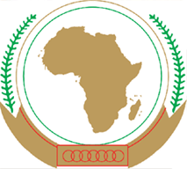
African Union Commission

GUIDANCE NOTE
Continental Annual Report of activities (CARA)
On the occasion of the first meeting of the Specialized Technical Committee Education-Science, Technology and Innovation and in the framework of monitoring and evaluating SCE 16-25, it is hereby recognized that the Continental Annual Report of activities (CARA) serves the purpose of reporting on consolidated basis at the continental level in the evolution of education in relation to the continental strategies of education, STISA-2024 and TVET strategy.
Each country will be responsible of consolidating information related to the school population and the budgetary effort in favor of the ESTI and Youth.
The CARA features five chapters
- HRST Report (AUC)
- Reports of member countries
- Reports of RECs
- Reports of partners and other stakeholders
- Continental Synthesis and Orientations
Elements from all member countries of the AU and stakeholders must reach the AUC (HRST) by 20 October of each year to allow the HRST Department of the AUC to submit the report to the team of ten (10) Heads of State and Government of the ESTI defenders in Africa at the AU summit in January.
At the Assembly meeting, a team of 10 Heads of State and Government will then disclose to their peers, the state of the ESTI and the progress of the implementation of continental strategies STISA -2024, SC-TVET and SCE: 16-25.
Therefore, all member states and all stakeholders are requested to prepare for the 2015 edition of this report. The information will be collected during the session of the CTS-I / ST.

Annual Activity Report of the Department
HRST

2015

Summary of Country Activities
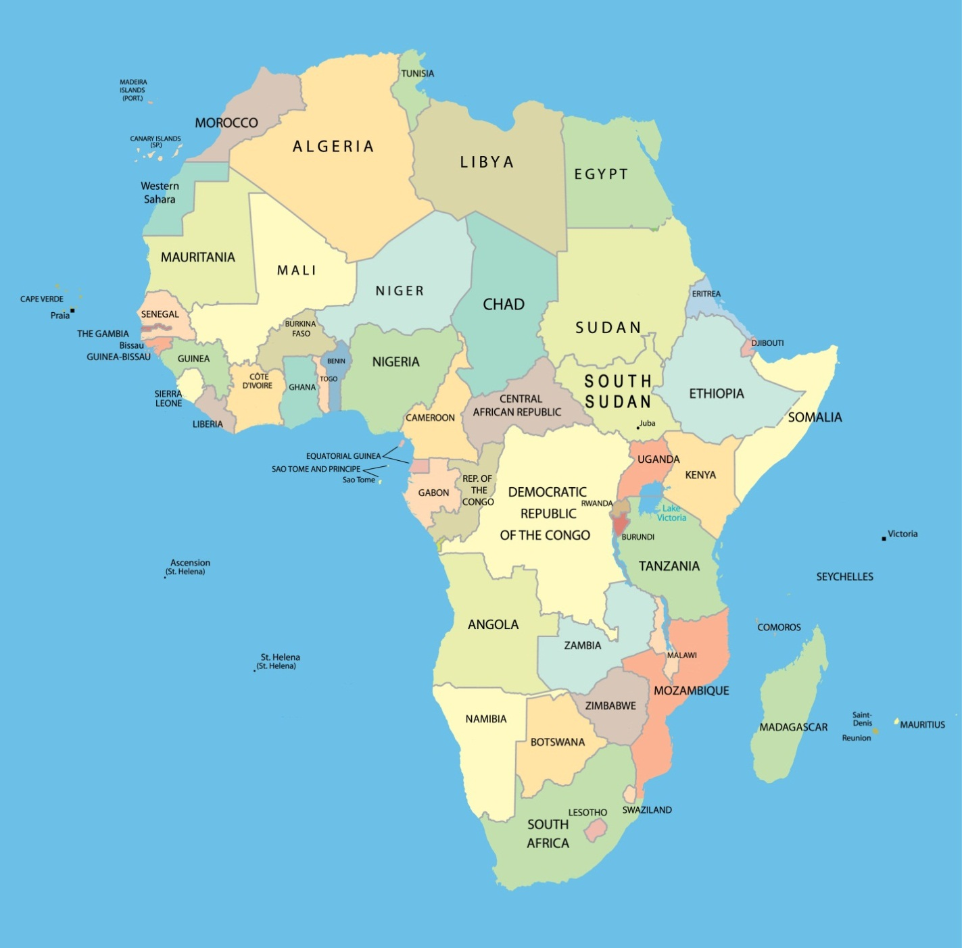
Each Member State of the African Union has been asked to present on an A4 size page, its main activities in the sectors of Education (primary, secondary and higher). TVET(Technical and Vocational Education and Training), Science, Technology and Innovation, and Youth in relation to African Union Continental Strategies and Programs.
The information published here remains the responsibility of the respective governments.
Countries marked have answered our call.

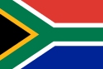 | SOUTH AFRICA | Southern Africa  SADC | area  1.221.037 km²
 | Pretoria | population 51.593.000 inhabitants | Annual Budget
General Information
Population % |  |  |  |  |  | Budget
Age | General Distribution |  | Enrolled by cycle |  |  | School Cycle | %
 | M | F | M | F
0 - 3 |  |  |  |  |  | Pre-primairy
3 - 6 |  |  |  |  |  | Primary
6 - 12 |  |  |  |  |  | Secondary
12 - 18 |  |  |  |  |  | Higher
18 - 25 |  |  |  |  |  | TVET
25 - 35 |  |  |  |  |  | STI

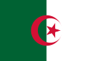 | ALGERIA | North Africa  UMA | area  2.381.741 km²
 | Alger | population  39.500.000  inhabitants | Annual Budget
General Information
Population % |  |  |  |  |  | Budget
Age | General Distribution |  | Enrolled by cycle |  |  | School Cycle | %
 | M | F | M | F
0 - 3 |  |  |  |  |  | Pre-primairy
3 - 6 |  |  |  |  |  | Primary
6 - 12 |  |  |  |  |  | Secondary
12 - 18 |  |  |  |  |  | Higher
18 - 25 |  |  |  |  |  | TVET
25 - 35 |  |  |  |  |  | STI

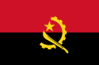 | ANGOLA | Southern Africa  SADC, ECCAS | area  1.246.700 km²
 | Luanda | population  24.383.000  inhabitants | Annual Budget
General Information
Population % |  |  |  |  |  | Budget
Age | General Distribution |  | Enrolled by cycle |  |  | School Cycle | %
 | M | F | M | F
0 - 3 |  |  |  |  |  | Pre-primairy
3 - 6 |  |  |  |  |  | Primary
6 - 12 |  |  |  |  |  | Secondary
12 - 18 |  |  |  |  |  | Higher
18 - 25 |  |  |  |  |  | TVET
25 - 35 |  |  |  |  |  | STI

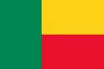 | BENIN | West Africa  ECOWAS, CENSAD | area  114.763 km²
 | Porto-Novo | population  10.323.000  inhabitants | Annual Budget
General Information
Population % |  |  |  |  |  | Budget
Age | General Distribution |  | Enrolled by cycle |  |  | School Cycle | %
 | M | F | M | F
0 - 3 |  |  |  |  |  | Pre-primairy
3 - 6 |  |  |  |  |  | Primary
6 - 12 |  |  |  |  |  | Secondary
12 - 18 |  |  |  |  |  | Higher
18 - 25 |  |  |  |  |  | TVET
25 - 35 |  |  |  |  |  | STI

 |  |  |  | BOTSWANA |  |  |  |  | Southern Africa  SADC |  | area  581.730 km²
 |  |  |  | Gaborone |  |  |  |  | population  2.156.000  inhabitants |  | Annual Budget
General Information
Population % |  |  |  |  |  |  | Budget
Age | General Distribution |  | Enrolled by cycle |  |  |  | School Cycle | %
 | M | F | M |  | F
0 - 3 |  |  |  |  |  |  | Pre-primairy
3 - 6 |  |  |  |  |  |  | Primary
6 - 12 |  |  |  |  |  |  | Secondary
12 - 18 |  |  |  |  |  |  | Higher
18 - 25 |  |  |  |  |  |  | TVET
25 - 35 |  |  |  |  |  |  | STI

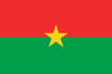 | BURKINA FASO | West Africa  ECOWAS, CENSAD | area  274.200 km²
 | Ouagadougou | population  17.323.000  inhabitants | Annual Budget
General Information
Population % |  |  |  |  |  | Budget
Age | General Distribution |  | Enrolled by cycle |  |  | School Cycle | %
 | M | F | M | F
0 - 3 |  |  |  |  |  | Pre-primairy
3 - 6 |  |  |  |  |  | Primary
6 - 12 |  |  |  |  |  | Secondary
12 - 18 |  |  |  |  |  | Higher
18 - 25 |  |  |  |  |  | TVET
25 - 35 |  |  |  |  |  | STI

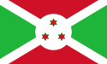 | BURUNDI | Central Africa  ECCAS, CEA, COMESA | area  27.834 km²
 | Bujumbura | population  10.396.000  inhabitants | Annual Budget
General Information
Population % |  |  |  |  |  | Budget
Age | General Distribution |  | Enrolled by cycle |  |  | School Cycle | %
 | M | F | M | F
0 - 3 |  |  |  |  |  | Pre-primairy
3 - 6 |  |  |  |  |  | Primary
6 - 12 |  |  |  |  |  | Secondary
12 - 18 |  |  |  |  |  | Higher
18 - 25 |  |  |  |  |  | TVET
25 - 35 |  |  |  |  |  | STI

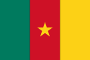 | CAMEROON | Central Africa  ECCAS | area  475.442 km²
 | Yaoundé | population  22.535.000  inhabitants | Annual Budget
General Information
Population % |  |  |  |  |  | Budget
Age | General Distribution |  | Enrolled by cycle |  |  | School Cycle | %
 | M | F | M | F
0 - 3 |  |  |  |  |  | Pre-primairy
3 - 6 |  |  |  |  |  | Primary
6 - 12 |  |  |  |  |  | Secondary
12 - 18 |  |  |  |  |  | Higher
18 - 25 |  |  |  |  |  | TVET
25 - 35 |  |  |  |  |  | STI

 | CAPE VERDE | West Africa  ECOWAS , CENSAD | area  4.033 km²
 | Praia | Population  525.000  inhabitants | Annual Budget
General Information
Population % |  |  |  |  |  | Budget
Age | General Distribution |  | Enrolled by cycle |  |  | School Cycle | %
 | M | F | M | F
0 - 3 |  |  |  |  |  | Pre-primairy
3 - 6 |  |  |  |  |  | Primary
6 - 12 |  |  |  |  |  | Secondary
12 - 18 |  |  |  |  |  | Higher
18 - 25 |  |  |  |  |  | TVET
25 - 35 |  |  |  |  |  | STI

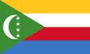 | COMORES | East Africa  COMESA, CENSAD | area  1.862 km²
 | Moroni | population  798.000  inhabitants | Annual Budget
General Information
Population % |  |  |  |  |  | Budget
Age | General Distribution |  | Enrolled by cycle |  |  | School Cycle | %
 | M | F | M | F
0 - 3 |  |  |  |  |  | Pre-primairy
3 - 6 |  |  |  |  |  | Primary
6 - 12 |  |  |  |  |  | Secondary
12 - 18 |  |  |  |  |  | Higher
18 - 25 |  |  |  |  |  | TVET
25 - 35 |  |  |  |  |  | STI

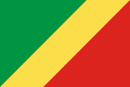 | CONGO | Central Africa  ECCAS | area  342.000 km²
 | Brazzaville | population  4.000.000  inhabitants | Annual Budget
General Information
Population % |  |  |  |  |  | Budget
Age | General Distribution |  | Enrolled by cycle |  |  | School Cycle | %
 | M | F | M | F
0 - 3 |  |  |  |  |  | Pre-primairy
3 - 6 |  |  |  |  |  | Primary
6 - 12 |  |  |  |  |  | Secondary
12 - 18 |  |  |  |  |  | Higher
18 - 25 |  |  |  |  |  | TVET
25 - 35 |  |  |  |  |  | STI

 |  |  |  | IVORY COAST |  |  |  |  | West Africa  ECOWAS, CENSAD |  | area  322.463 km²
 |  |  |  | Abidjan |  |  |  |  | population  23.919.000  inhabitants |  | Annual Budget
General Information
Population % |  |  |  |  |  |  | Budget
Age | General Distribution |  | Enrolled by cycle |  |  |  | School Cycle | %
 | M | F | M |  | F
0 - 3 |  |  |  |  |  |  | Pre-primairy
3 - 6 |  |  |  |  |  |  | Primary
6 - 12 |  |  |  |  |  |  | Secondary
12 - 18 |  |  |  |  |  |  | Higher
18 - 25 |  |  |  |  |  |  | TVET
25 - 35 |  |  |  |  |  |  | STI

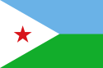 | DJIBOUTI | East Africa  COMESA, CENSAD, IGAD | area  23.200 km²
 | Djibouti | population  810.200  inhabitants | Annual Budget
General Information
Population % |  |  |  |  |  | Budget
Age | General Distribution |  | Enrolled by cycle |  |  | School Cycle | %
 | M | F | M | F
0 - 3 |  |  |  |  |  | Pre-primairy
3 - 6 |  |  |  |  |  | Primary
6 - 12 |  |  |  |  |  | Secondary
12 - 18 |  |  |  |  |  | Higher
18 - 25 |  |  |  |  |  | TVET
25 - 35 |  |  |  |  |  | STI

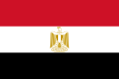 | EGYPT | North Africa  CENSAD, COMESA | area  1.010.407 km²
 | Cairo | population  88.918.000  inhabitants | Annual Budget
General Information
Population % |  |  |  |  |  | Budget
Age | General Distribution |  | Enrolled by cycle |  |  | School Cycle | %
 | M | F | M | F
0 - 3 |  |  |  |  |  | Pre-primairy
3 - 6 |  |  |  |  |  | Primary
6 - 12 |  |  |  |  |  | Secondary
12 - 18 |  |  |  |  |  | Higher
18 - 25 |  |  |  |  |  | TVET
25 - 35 |  |  |  |  |  | STI

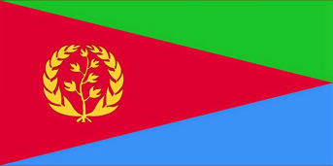 | ERITREA | East Africa  COMESA, CENSAD IGAD | area  125.000 km²
 | Asmara | population  3.6 million inhabitants | Annual Budget
General Information
Population % |  |  |  |  |  | Budget
Age | General Distribution |  | Enrolled by cycle |  |  | School Cycle | %
 | M | F | M | F
0 - 3 |  |  |  |  |  | Pre-primairy
3 - 6 |  |  |  |  |  | Primary
6 - 12 |  |  |  |  |  | Secondary
12 - 18 |  |  |  |  |  | Higher
18 - 25 |  |  |  |  |  | TVET
25 - 35 |  |  |  |  |  | STI

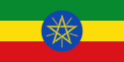 | ETHIOPIA | East Africa  COMESA, IGAD, CENSAD | area  1.104.300 km²
 | Addis Ababa | population  98.942.000 inhabitants | Annual Budget
General Information
Population % |  |  |  |  |  | Budget
Age | General Distribution |  | Enrolled by cycle |  |  | School Cycle | %
 | M | F | M | F
0 - 3 |  |  |  |  |  | Pre-primairy
3 - 6 |  |  |  |  |  | Primary
6 - 12 |  |  |  |  |  | Secondary
12 - 18 |  |  |  |  |  | Higher
18 - 25 |  |  |  |  |  | TVET
25 - 35 |  |  |  |  |  | STI

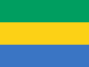 | GABON | Central Africa  ECCAS | area  267.667 km²
 | Libreville | population  1.475.000 inhabitants | Annual Budget
General Information
Population % |  |  |  |  |  | Budget
Age | General Distribution |  | Enrolled by cycle |  |  | School Cycle | %
 | M | F | M | F
0 - 3 |  |  |  |  |  | Pre-primairy
3 - 6 |  |  |  |  |  | Primary
6 - 12 |  |  |  |  |  | Secondary
12 - 18 |  |  |  |  |  | Higher
18 - 25 |  |  |  |  |  | TVET
25 - 35 |  |  |  |  |  | STI

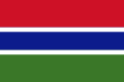 | GAMBIA | West Africa  ECOWAS, CENSAD | area  10.689 km²
 | Banjul | population  1.882.500 inhabitants | Annual Budget
General Information
Population % |  |  |  |  |  | Budget
Age | General Distribution |  | Enrolled by cycle |  |  | School Cycle | %
 | M | F | M | F
0 - 3 |  |  |  |  |  | Pre-primairy
3 - 6 |  |  |  |  |  | Primary
6 - 12 |  |  |  |  |  | Secondary
12 - 18 |  |  |  |  |  | Higher
18 - 25 |  |  |  |  |  | TVET
25 - 35 |  |  |  |  |  | STI

 | GHANA | West Africa  ECOWAS, CENSAD | area  238.535 km²
 | Accra | population  27.000.000 inhabitants | Annual Budget
General Information
Population % |  |  |  |  |  | Budget
Age | General Distribution |  | Enrolled by cycle |  |  | School Cycle | %
 | M | F | M | F
0 - 3 |  |  |  |  |  | Pre-primairy
3 - 6 |  |  |  |  |  | Primary
6 - 12 |  |  |  |  |  | Secondary
12 - 18 |  |  |  |  |  | Higher
18 - 25 |  |  |  |  |  | TVET
25 - 35 |  |  |  |  |  | STI

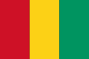 | GUINEE | West Africa  ECOWAS, CENSAD | area  245.836 km²
 | Conakry | population  11.474.383 inhabitants | Annual Budget
General Information
Population % |  |  |  |  |  | Budget
Age | General Distribution |  | Enrolled by cycle |  |  | School Cycle | %
 | M | F | M | F
0 - 3 |  |  |  |  |  | Pre-primairy
3 - 6 |  |  |  |  |  | Primary
6 - 12 |  |  |  |  |  | Secondary
12 - 18 |  |  |  |  |  | Higher
18 - 25 |  |  |  |  |  | TVET
25 - 35 |  |  |  |  |  | STI

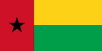 | GUINEA- BISSAU | West Africa  ECOWAS, CENSAD | area  36.125 km²
 | Bissau | population  1.704.000 inhabitants | Annual Budget
General Information
Population % |  |  |  |  |  | Budget
Age | General Distribution |  | Enrolled by cycle |  |  | School Cycle | %
 | M | F | M | F
0 - 3 |  |  |  |  |  | Pre-primairy
3 - 6 |  |  |  |  |  | Primary
6 - 12 |  |  |  |  |  | Secondary
12 - 18 |  |  |  |  |  | Higher
18 - 25 |  |  |  |  |  | TVET
25 - 35 |  |  |  |  |  | STI

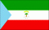 | EQUATORIAL GUINEA | Central Africa  ECCAS | area  36.125 km²
 | Malabo | 28.050 inhabitants | Annual Budget
General Information
Population % |  |  |  |  |  | Budget
Age | General Distribution |  | Enrolled by cycle |  |  | School Cycle | %
 | M | F | M | F
0 - 3 |  |  |  |  |  | Pre-primairy
3 - 6 |  |  |  |  |  | Primary
6 - 12 |  |  |  |  |  | Secondary
12 - 18 |  |  |  |  |  | Higher
18 - 25 |  |  |  |  |  | TVET
25 - 35 |  |  |  |  |  | STI

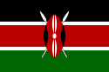 | KENYA | East Africa  COMESA, EAC, CENSAD, IGAD | area  581.309 km²
 | Nairobi | population  45.010.000 inhabitants | Annual Budget
General Information
Population % |  |  |  |  |  | Budget
Age | General Distribution |  | Enrolled by cycle |  |  | School Cycle | %
 | M | F | M | F
0 - 3 |  |  |  |  |  | Pre-primairy
3 - 6 |  |  |  |  |  | Primary
6 - 12 |  |  |  |  |  | Secondary
12 - 18 |  |  |  |  |  | Higher
18 - 25 |  |  |  |  |  | TVET
25 - 35 |  |  |  |  |  | STI

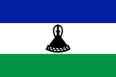 | LESOTHO | Southern Africa  SADC | area  30.355 km²
 | Maseru | population  2.067.000 inhabitants | Annual Budget
General Information
Population % |  |  |  |  |  | Budget
Age | General Distribution |  | Enrolled by cycle |  |  | School Cycle | %
 | M | F | M | F
0 - 3 |  |  |  |  |  | Pre-primairy
3 - 6 |  |  |  |  |  | Primary
6 - 12 |  |  |  |  |  | Secondary
12 - 18 |  |  |  |  |  | Higher
18 - 25 |  |  |  |  |  | TVET
25 - 35 |  |  |  |  |  | STI

 | LIBERIA | West Africa  ECOWAS, CENSAD | area  111.369 km²
 | Monrovia | population  4.092.000 inhabitants | Annual Budget
General Information
Population % |  |  |  |  |  | Budget
Age | General Distribution |  | Enrolled by cycle |  |  | School Cycle | %
 | M | F | M | F
0 - 3 |  |  |  |  |  | Pre-primairy
3 - 6 |  |  |  |  |  | Primary
6 - 12 |  |  |  |  |  | Secondary
12 - 18 |  |  |  |  |  | Higher
18 - 25 |  |  |  |  |  | TVET
25 - 35 |  |  |  |  |  | STI

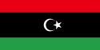 | LIBYA | North Africa  UMA, COMESA, CENSAD | area  1.759.541 km²
 | Tripoli | population  6.244.000 inhabitants | Annual Budget
General Information
Population % |  |  |  |  |  | Budget
Age | General Distribution |  | Enrolled by cycle |  |  | School Cycle | %
 | M | F | M | F
0 - 3 |  |  |  |  |  | Pre-primairy
3 - 6 |  |  |  |  |  | Primary
6 - 12 |  |  |  |  |  | Secondary
12 - 18 |  |  |  |  |  | Higher
18 - 25 |  |  |  |  |  | TVET
25 - 35 |  |  |  |  |  | STI

 | MADAGASCAR | East Africa  SADC, COMESA | area  587.041 km²
 | Antananarivo | population  22.095.000 inhabitants | Annual Budget
General Information
Population % |  |  |  |  |  | Budget
Age | General Distribution |  | Enrolled by cycle |  |  | School Cycle | %
 | M | F | M | F
0 - 3 |  |  |  |  |  | Pre-primairy
3 - 6 |  |  |  |  |  | Primary
6 - 12 |  |  |  |  |  | Secondary
12 - 18 |  |  |  |  |  | Higher
18 - 25 |  |  |  |  |  | TVET
25 - 35 |  |  |  |  |  | STI

 | MALAWI | Southern Africa  SADC, COMESA | area  118.484 km²
 | Lilongwe | Population  16.407.000 inhabitants | Annual Budget
General Information
Population % |  |  |  |  |  | Budget
Age | General Distribution |  | Enrolled by cycle |  |  | School Cycle | %
 | M | F | M | F
0 - 3 |  |  |  |  |  | Pre-primairy
3 - 6 |  |  |  |  |  | Primary
6 - 12 |  |  |  |  |  | Secondary
12 - 18 |  |  |  |  |  | Higher
18 - 25 |  |  |  |  |  | TVET
25 - 35 |  |  |  |  |  | STI

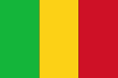 | MALI | West Africa  ECOWAS, CENSAD | area  1.240.192 km²
 | Bamako | population  15.371.000 inhabitants | Annual Budget
General Information
Population % |  |  |  |  |  | Budget
Age | General Distribution |  | Enrolled by cycle |  |  | School Cycle | %
 | M | F | M | F
0 - 3 |  |  |  |  |  | Pre-primairy
3 - 6 |  |  |  |  |  | Primary
6 - 12 |  |  |  |  |  | Secondary
12 - 18 |  |  |  |  |  | Higher
18 - 25 |  |  |  |  |  | TVET
25 - 35 |  |  |  |  |  | STI

 |  |  |  | MAURITIUS |  |  |  |  |  | East Africa  SADC, COMESA | area  2.040 km²
 |  |  |  | Maurice |  |  |  |  |  | population  1.331.155 inhabitants | Annual Budget
General Information
Population % |  |  |  |  |  |  | Budget
Age | General Distribution |  | Enrolled by cycle |  |  |  | School Cycle | %
 | M | F | M |  | F
0 - 3 |  |  |  |  |  |  | Pre-primairy
3 - 6 |  |  |  |  |  |  | Primary
6 - 12 |  |  |  |  |  |  | Secondary
12 - 18 |  |  |  |  |  |  | Higher
18 - 25 |  |  |  |  |  |  | TVET
25 - 35 |  |  |  |  |  |  | STI

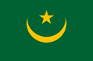 | MAURITANIA | North Africa  UMA, CENSAD | area  1.030.700 km²
 | Nouakchott | population  3.517.000 inhabitants | Annual Budget
General Information
Population % |  |  |  |  |  | Budget
Age | General Distribution |  | Enrolled by cycle |  |  | School Cycle | %
 | M | F | M | F
0 - 3 |  |  |  |  |  | Pre-primairy
3 - 6 |  |  |  |  |  | Primary
6 - 12 |  |  |  |  |  | Secondary
12 - 18 |  |  |  |  |  | Higher
18 - 25 |  |  |  |  |  | TVET
25 - 35 |  |  |  |  |  | STI

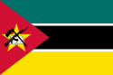 |  |  |  | MOZAMBIQUE |  |  |  |  |  | Southern Africa  SADC | area  801.590 km²
 |  |  |  | Maputo |  |  |  |  |  | population  24.692.144 inhabitants | Annual Budget
General Information
Population % |  |  |  |  |  |  | Budget
Age | General Distribution |  | Enrolled by cycle |  |  |  | School Cycle | %
 | M | F | M |  | F
0 - 3 |  |  |  |  |  |  | Pre-primairy
3 - 6 |  |  |  |  |  |  | Primary
6 - 12 |  |  |  |  |  |  | Secondary
12 - 18 |  |  |  |  |  |  | Higher
18 - 25 |  |  |  |  |  |  | TVET
25 - 35 |  |  |  |  |  |  | STI

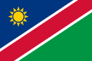 | NAMIBIA | Southern Africa  SADC | area  825.615 km²
 | Windhoek | population  2.198.500 inhabitants | Annual Budget
General Information
Population % |  |  |  |  |  | Budget
Age | General Distribution |  | Enrolled by cycle |  |  | School Cycle | %
 | M | F | M | F
0 - 3 |  |  |  |  |  | Pre-primairy
3 - 6 |  |  |  |  |  | Primary
6 - 12 |  |  |  |  |  | Secondary
12 - 18 |  |  |  |  |  | Higher
18 - 25 |  |  |  |  |  | TVET
25 - 35 |  |  |  |  |  | STI

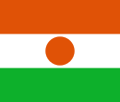 | NIGER | West Africa  ECOWAS, CENSAD | area  1.267.000 km²
 | Niamey | population  19.380.000 inhabitants | Annual Budget
General Information
Population % |  |  |  |  |  | Budget
Age | General Distribution |  | Enrolled by cycle |  |  | School Cycle | %
 | M | F | M | F
0 - 3 |  |  |  |  |  | Pre-primairy
3 - 6 |  |  |  |  |  | Primary
6 - 12 |  |  |  |  |  | Secondary
12 - 18 |  |  |  |  |  | Higher
18 - 25 |  |  |  |  |  | TVET
25 - 35 |  |  |  |  |  | STI

 | NIGERIA | West Africa  ECOWAS, CENSAD | area  923.768 km²
 | Abuja | population  180.298.000 inhabitants | Annual Budget
General Information
Population % |  |  |  |  |  | Budget
Age | General Distribution |  | Enrolled by cycle |  |  | School Cycle | %
 | M | F | M | F
0 - 3 |  |  |  |  |  | Pre-primairy
3 - 6 |  |  |  |  |  | Primary
6 - 12 |  |  |  |  |  | Secondary
12 - 18 |  |  |  |  |  | Higher
18 - 25 |  |  |  |  |  | TVET
25 - 35 |  |  |  |  |  | STI

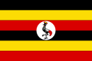 | UGANDA | East Africa  COMESA, EAC, IGAD | area  241.038 km²
 | Kampala | population  38.845.000 inhabitants | Annual Budget
General Information
Population % |  |  |  |  |  | Budget
Age | General Distribution |  | Enrolled by cycle |  |  | School Cycle | %
 | M | F | M | F
0 - 3 |  |  |  |  |  | Pre-primairy
3 - 6 |  |  |  |  |  | Primary
6 - 12 |  |  |  |  |  | Secondary
12 - 18 |  |  |  |  |  | Higher
18 - 25 |  |  |  |  |  | TVET
25 - 35 |  |  |  |  |  | STI

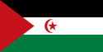 | SAHRAWI ARAB DEMOCRATIC REPUBLIC (SADR) | North Africa | area  266.000 km²
 | Laayoune | population  513.000 inhabitants | Annual Budget
General Information
Population % |  |  |  |  |  | Budget
Age | General Distribution |  | Enrolled by cycle |  |  | School Cycle | %
 | M | F | M | F
0 - 3 |  |  |  |  |  | Pre-primairy
3 - 6 |  |  |  |  |  | Primary
6 - 12 |  |  |  |  |  | Secondary
12 - 18 |  |  |  |  |  | Higher
18 - 25 |  |  |  |  |  | TVET
25 - 35 |  |  |  |  |  | STI

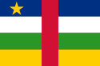 | CENTRAL AFRICAN REPUBLIC | Central Africa  ECCAS, CENSAD | area  622.984 km²
 | Bangi | population  4.709.000 inhabitants | Annual Budget
General Information
Population % |  |  |  |  |  | Budget
Age | General Distribution |  | Enrolled by cycle |  |  | School Cycle | %
 | M | F | M | F
0 - 3 |  |  |  |  |  | Pre-primairy
3 - 6 |  |  |  |  |  | Primary
6 - 12 |  |  |  |  |  | Secondary
12 - 18 |  |  |  |  |  | Higher
18 - 25 |  |  |  |  |  | TVET
25 - 35 |  |  |  |  |  | STI

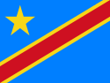 | DEMOCRATIC REPUBLIC OF CONGO | Central Africa  ECCAS, SADC, COMESA | area  2.345.409 km²
 | Kinshasa | population  77.434.000 inhabitants | Annual Budget
General Information
Population % |  |  |  |  |  | Budget
Age | General Distribution |  | Enrolled by cycle |  |  | School Cycle | %
 | M | F | M | F
0 - 3 |  |  |  |  |  | Pre-primairy
3 - 6 |  |  |  |  |  | Primary
6 - 12 |  |  |  |  |  | Secondary
12 - 18 |  |  |  |  |  | Higher
18 - 25 |  |  |  |  |  | TVET
25 - 35 |  |  |  |  |  | STI

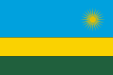 | RWANDA | East Africa  COMESA, CEA | area  26.338 km²
 | Kigali | population  12.587.000 inhabitants | Annual Budget
General Information
Population % |  |  |  |  |  | Budget
Age | General Distribution |  | Enrolled by cycle |  |  | School Cycle | %
 | M | F | M | F
0 - 3 |  |  |  |  |  | Pre-primairy
3 - 6 |  |  |  |  |  | Primary
6 - 12 |  |  |  |  |  | Secondary
12 - 18 |  |  |  |  |  | Higher
18 - 25 |  |  |  |  |  | TVET
25 - 35 |  |  |  |  |  | STI

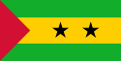 | SAO TOME AND PRINCIPE | Central Africa  ECCAS, CENSAD | area  1.001 km²
 | Sao Tome | population  201.635 inhabitants | Annual Budget
General Information
Population % |  |  |  |  |  | Budget
Age | General Distribution |  | Enrolled by cycle |  |  | School Cycle | %
 | M | F | M | F
0 - 3 |  |  |  |  |  | Pre-primairy
3 - 6 |  |  |  |  |  | Primary
6 - 12 |  |  |  |  |  | Secondary
12 - 18 |  |  |  |  |  | Higher
18 - 25 |  |  |  |  |  | TVET
25 - 35 |  |  |  |  |  | STI

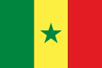 | SENEGAL | West Africa  ECOWAS, CENSAD | area  196.712 km²
 | Dakar | population  14.962.000 inhabitants | Annual Budget
General Information
Population % |  |  |  |  |  | Budget
Age | General Distribution |  | Enrolled by cycle |  |  | School Cycle | %
 | M | F | M | F
0 - 3 |  |  |  |  |  | Pre-primairy
3 - 6 |  |  |  |  |  | Primary
6 - 12 |  |  |  |  |  | Secondary
12 - 18 |  |  |  |  |  | Higher
18 - 25 |  |  |  |  |  | TVET
25 - 35 |  |  |  |  |  | STI

 |  |  |  | SEYCHELLES |  |  |  |  |  | East Africa  COMESA, SADC | area  459 km²
 |  |  |  | Victoria |  |  |  |  |  | population  91.000 inhabitants | Annual Budget
General Information
Population % |  |  |  |  |  |  | Budget
Age | General Distribution |  | Enrolled by cycle |  |  |  | School Cycle | %
 | M | F | M |  | F
0 - 3 |  |  |  |  |  |  | Pre-primairy
3 - 6 |  |  |  |  |  |  | Primary
6 - 12 |  |  |  |  |  |  | Secondary
12 - 18 |  |  |  |  |  |  | Higher
18 - 25 |  |  |  |  |  |  | TVET
25 - 35 |  |  |  |  |  |  | STI

 | SIERRA LEONE | West Africa  ECOWAS, CENSAD | area  71.740 km²
 | Freetown | population  6.451.000 inhabitants | Annual Budget
General Information
Population % |  |  |  |  |  | Budget
Age | General Distribution |  | Enrolled by cycle |  |  | School Cycle | %
 | M | F | M | F
0 - 3 |  |  |  |  |  | Pre-primairy
3 - 6 |  |  |  |  |  | Primary
6 - 12 |  |  |  |  |  | Secondary
12 - 18 |  |  |  |  |  | Higher
18 - 25 |  |  |  |  |  | TVET
25 - 35 |  |  |  |  |  | STI

 | SOMALIA | East Africa  IGAD, CENSAD | area  637.657 km²
 | Mogadishu | population  10.766.082 inhabitants | Annual Budget
General Information
Population % |  |  |  |  |  | Budget
Age | General Distribution |  | Enrolled by cycle |  |  | School Cycle | %
 | M | F | M | F
0 - 3 |  |  |  |  |  | Pre-primairy
3 - 6 |  |  |  |  |  | Primary
6 - 12 |  |  |  |  |  | Secondary
12 - 18 |  |  |  |  |  | Higher
18 - 25 |  |  |  |  |  | TVET
25 - 35 |  |  |  |  |  | STI

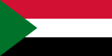 | SUDAN | East Africa  COMESA, CENSAD, IGAD | area  1.886.068 km²
 | Khartoum | population  40.447.000 inhabitants | Annual Budget
General Information
Population % |  |  |  |  |  | Budget
Age | General Distribution |  | Enrolled by cycle |  |  | School Cycle | %
 | M | F | M | F
0 - 3 |  |  |  |  |  | Pre-primairy
3 - 6 |  |  |  |  |  | Primary
6 - 12 |  |  |  |  |  | Secondary
12 - 18 |  |  |  |  |  | Higher
18 - 25 |  |  |  |  |  | TVET
25 - 35 |  |  |  |  |  | STI

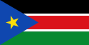 | SOUTH SUDAN | East Africa  IGAD | area  619.745 km²
 | Juba | Population  11.784.837 inhabitants | Annual Budget
General Information
Population % |  |  |  |  |  | Budget
Age | General Distribution |  | Enrolled by cycle |  |  | School Cycle | %
 | M | F | M | F
0 - 3 |  |  |  |  |  | Pre-primairy
3 - 6 |  |  |  |  |  | Primary
6 - 12 |  |  |  |  |  | Secondary
12 - 18 |  |  |  |  |  | Higher
18 - 25 |  |  |  |  |  | TVET
25 - 35 |  |  |  |  |  | STI

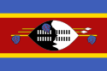 | SWAZILAND | Southern Africa  SADC, COMESA | area  17 .364 km²
 | Lobamba / Mbabane | population  1.282.500 inhabitants | Annual Budget
General Information
Population % |  |  |  |  |  | Budget
Age | General Distribution |  | Enrolled by cycle |  |  | School Cycle | %
 | M | F | M | F
0 - 3 |  |  |  |  |  | Pre-primairy
3 - 6 |  |  |  |  |  | Primary
6 - 12 |  |  |  |  |  | Secondary
12 - 18 |  |  |  |  |  | Higher
18 - 25 |  |  |  |  |  | TVET
25 - 35 |  |  |  |  |  | STI

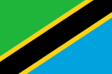 | TANZANIA | East Africa  COMESA, EAC | area  947.303 km²
 | Dar es Salaam | population  49.137.000 inhabitants | Annual Budget
General Information
Population % |  |  |  |  |  | Budget
Age | General Distribution |  | Enrolled by cycle |  |  | School Cycle | %
 | M | F | M | F
0 - 3 |  |  |  |  |  | Pre-primairy
3 - 6 |  |  |  |  |  | Primary
6 - 12 |  |  |  |  |  | Secondary
12 - 18 |  |  |  |  |  | Higher
18 - 25 |  |  |  |  |  | TVET
25 - 35 |  |  |  |  |  | STI

 | CHAD | Central Africa  ECCAS, IGAD, CENSAD, | area  1.284.000 km²
 | N’Djamena | population  10.329.208 inhabitants | Annual Budget
General Information
Population % |  |  |  |  |  | Budget
Age | General Distribution |  | Enrolled by cycle |  |  | School Cycle | %
 | M | F | M | F
0 - 3 |  |  |  |  |  | Pre-primairy
3 - 6 |  |  |  |  |  | Primary
6 - 12 |  |  |  |  |  | Secondary
12 - 18 |  |  |  |  |  | Higher
18 - 25 |  |  |  |  |  | TVET
25 - 35 |  |  |  |  |  | STI

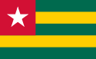 | TOGO | West Africa  ECOWAS, CENSAD | area  56.785 km²
 | Lome | population  6.993.000 inhabitants | Annual Budget
General Information
Population % |  |  |  |  |  | Budget
Age | General Distribution |  | Enrolled by cycle |  |  | School Cycle | %
 | M | F | M | F
0 - 3 |  |  |  |  |  | Pre-primairy
3 - 6 |  |  |  |  |  | Primary
6 - 12 |  |  |  |  |  | Secondary
12 - 18 |  |  |  |  |  | Higher
18 - 25 |  |  |  |  |  | TVET
25 - 35 |  |  |  |  |  | STI

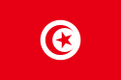 | TUNISIA | North Africa  UMA, CENSAD | area  163.610 km²
 | Tunis | population  11.117.000 inhabitants | Annual Budget
General Information
Population % |  |  |  |  |  | Budget
Age | General Distribution |  | Enrolled by cycle |  |  | School Cycle | %
 | M | F | M | F
0 - 3 |  |  |  |  |  | Pre-primairy
3 - 6 |  |  |  |  |  | Primary
6 - 12 |  |  |  |  |  | Secondary
12 - 18 |  |  |  |  |  | Higher
18 - 25 |  |  |  |  |  | TVET
25 - 35 |  |  |  |  |  | STI

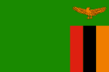 | ZAMBIA | Southern Africa  SADC, COMESA | area  52.618 km²
 | Lusaka | population  15.021.000 inhabitants | Annual Budget
General Information
Population % |  |  |  |  |  | Budget
Age | General Distribution |  | Enrolled by cycle |  |  | School Cycle | %
 | M | F | M | F
0 - 3 |  |  |  |  |  | Pre-primairy
3 - 6 |  |  |  |  |  | Primary
6 - 12 |  |  |  |  |  | Secondary
12 - 18 |  |  |  |  |  | Higher
18 - 25 |  |  |  |  |  | TVET
25 - 35 |  |  |  |  |  | STI

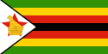 |  |  |  | ZIMBABWE |  |  |  |  | Southern Africa  SADC, COMESA |  | area  390.757 km²
 |  |  |  | Harare |  |  |  |  | population  14.599.000 inhabitants |  | Annual Budget
General Information
Population % |  |  |  |  |  |  | Budget
Age | General Distribution |  | Enrolled by cycle |  |  |  | School Cycle | %
 | M | F | M |  | F
0 - 3 |  |  |  |  |  |  | Pre-primairy
3 - 6 |  |  |  |  |  |  | Primary
6 - 12 |  |  |  |  |  |  | Secondary
12 - 18 |  |  |  |  |  |  | Higher
18 - 25 |  |  |  |  |  |  | TVET
25 - 35 |  |  |  |  |  |  | STI

Summary of Regional Economic Communities’ activities

Each Regional Economic Community (REC) was asked to present on an A4 size page, its main activities in the sectors of Education (primary, secondary and higher), TVET (Technical and Vocational Education and Training), Science, Technology and Innovation, and Youth in relation to the continental strategies and the programs of the African Union.
The information published here remains the responsibility of the Regional Economic Communities.
The RECs not represented did not respond to our appeal.

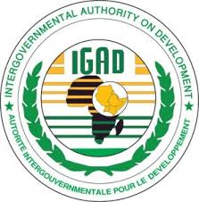 | IGAD | Member Countries (8):  * Djibouti * Eritrea * Ethiopia * Kenya * Uganda * Somalia * Sudan *South Sudan
 | Djibouti | Population of IGAD  253 343 000 inhab. | Global budget of IGAD Members States:
 |  |  | Budget of IGAD:
General Information
Population % |  |  |  |  |  | Budget
Age | General Distribution |  | Enrolled by cycle |  |  | School Cycle | %
 | M | F | M | F |  |  | REC MS overview | REC
0 – 3 |  |  |  |  |  | Pre-primairy
3 - 6 |  |  |  |  |  | Primary
6 - 12 |  |  |  |  |  | Secondary
12 - 18 |  |  |  |  |  | Higher
18 - 25 |  |  |  |  |  | TVET
25 - 35 |  |  |  |  |  | STI

 | SADC | Member Countries (15) : * South Africa *Angola *Botswana *Lesotho *Madagascar *Malawi *Maurice *Mozambique *Namibia *D. R. Congo *Seychelles *Swaziland *Tanzania *Zambia *Zimbabwe
 | Gaborone | Population of SADC  304 485 000 inhab. | Global budget of SADC Members States:
 |  |  | Budget of SADC:
General Information
Population % |  |  |  |  |  | Budget
Age | General Distribution |  | Enrolled by cycle |  |  | School Cycle | %
 | M | F | M | F |  |  | REC MS overview | REC
0 – 3 |  |  |  |  |  | Pre-primairy
3 - 6 |  |  |  |  |  | Primary
6 - 12 |  |  |  |  |  | Secondary
12 - 18 |  |  |  |  |  | Higher
18 - 25 |  |  |  |  |  | TVET
25 - 35 |  |  |  |  |  | STI

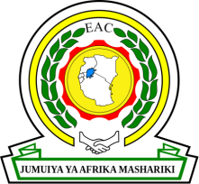 | EAC | Member Countries (5) : *Burundi *Kenya *Uganda  *Rwanda *Tanzania
 | Dar es Salaam | Population of EAC  155 975 000 inhab. | Global budget of EAC Members States:
 |  |  | Budget of EAC:
General Information
Population % |  |  |  |  |  | Budget
Age | General Distribution |  | Enrolled by cycle |  |  | School Cycle | %
 | M | F | M | F |  |  | REC MS overview | REC
0 – 3 |  |  |  |  |  | Pre-primairy
3 - 6 |  |  |  |  |  | Primary
6 - 12 |  |  |  |  |  | Secondary
12 - 18 |  |  |  |  |  | Higher
18 - 25 |  |  |  |  |  | TVET
25 - 35 |  |  |  |  |  | STI

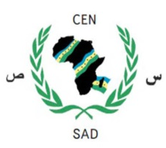 | CEN-SAD | Member Countries (29) : *Benin *Burkina Faso *Cape Verde *Comoros *Ivory Coast *Djibouti *Egypt *Eritrea *Gambia *Ghana *Guinea *Guinea-Bissau *Kenya *Liberia *Libya *Mali *Mauritania *Morocco *Niger *Nigeria *Central African Republic *Sao Tome and Principe *Senegal *Sierra Leone *Somalia *Sudan *Chad *Togo *Tunisia
 | Tripoli | Population of CEN-SAD  589 886 000 inhab. | Global budget of CEN-SAD Members States:
 |  |  | Budget of CEN-SAD:
General Information
Population % |  |  |  |  |  | Budget
Age | General Distribution |  | Enrolled by cycle |  |  | School Cycle | %
 | M | F | M | F |  |  | REC MS overview | REC
0 – 3 |  |  |  |  |  | Pre-primairy
3 - 6 |  |  |  |  |  | Primary
6 - 12 |  |  |  |  |  | Secondary
12 - 18 |  |  |  |  |  | Higher
18 - 25 |  |  |  |  |  | TVET
25 - 35 |  |  |  |  |  | STI

 | ECCAS | Member Countries (10) : *Angola *Burundi *Cameroon *Congo *Gabon *Equatorial Guinea * Central African Republic *D. R. of Congo *Sao Tome and Principe *Chad
 | Libreville | Population of ECCAS  155 743 000 inhab. | Global budget of ECCAS Members States:
 |  |  | Budget of ECCAS:
General Information
Population % |  |  |  |  |  | Budget
Age | General Distribution |  | Enrolled by cycle |  |  | School Cycle | %
 | M | F | M | F |  |  | REC MS overview | REC
0 – 3 |  |  |  |  |  | Pre-primairy
3 - 6 |  |  |  |  |  | Primary
6 - 12 |  |  |  |  |  | Secondary
12 - 18 |  |  |  |  |  | Higher
18 - 25 |  |  |  |  |  | TVET
25 - 35 |  |  |  |  |  | STI

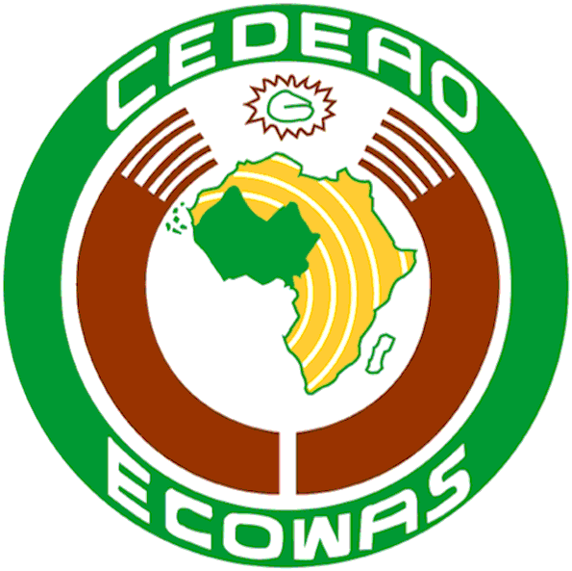 | ECOWAS | Member Countries (15) : *Benin *Burkina Faso *Cape Verde *Ivory Coast *Gambia *Ghana *Guinea *Guinea-Bissau *Liberia *Mali *Niger *Nigeria *Senegal *Sierra Leone *Togo
 | Abuja | Population of ECOWAS  327 778 000 | Global budget of ECOWAS Members States:
 |  |  | Budget of ECOWAS:
General Information
Population % |  |  |  |  |  | Budget
Age | General Distribution |  | Enrolled by cycle |  |  | School Cycle | %
 | M | F | M | F |  |  | REC MS overview | REC
0 – 3 |  |  |  |  |  | Pre-primairy
3 - 6 |  |  |  |  |  | Primary
6 - 12 |  |  |  |  |  | Secondary
12 - 18 |  |  |  |  |  | Higher
18 - 25 |  |  |  |  |  | TVET
25 - 35 |  |  |  |  |  | STI

 | COMESA | Member Countries (19) : *Burundi *Comoros *Djibouti *Egypt *Eritrea *Ethiopia *Kenya *Libya *Madagascar *Malawi *Mauritius *Uganda *D. R. of Congo *Rwanda *Seychelles *Sudan *Swaziland *Zambia *Zimbabwe
 | Lusaka | Population of COMESA  492 706 000 inhab. | Global budget of COMESA Members States:
 |  |  | Budget of COMESA:
General Information
Population % |  |  |  |  |  | Budget
Age | General Distribution |  | Enrolled by cycle |  |  | School Cycle | %
 | M | F | M | F |  |  | REC MS overview | REC
0 – 3 |  |  |  |  |  | Pre-primairy
3 - 6 |  |  |  |  |  | Primary
6 - 12 |  |  |  |  |  | Secondary
12 - 18 |  |  |  |  |  | Higher
18 - 25 |  |  |  |  |  | TVET
25 - 35 |  |  |  |  |  | STI

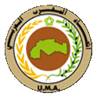 | UMA | Member Countries (5) : *Algeria *Libya *Morocco *Mauritania *Tunisia
 | Tripoli | Population of UMA  93 028 000 inhab. | Global budget of UMA Members States:
 |  |  | Budget of UMA:
General Information
Population % |  |  |  |  |  | Budget
Age | General Distribution |  | Enrolled by cycle |  |  | School Cycle | %
 | M | F | M | F |  |  | REC MS overview | REC
0 – 3 |  |  |  |  |  | Pre-primairy
3 - 6 |  |  |  |  |  | Primary
6 - 12 |  |  |  |  |  | Secondary
12 - 18 |  |  |  |  |  | Higher
18 - 25 |  |  |  |  |  | TVET
25 - 35 |  |  |  |  |  | STI

Summary of Partners’ activities

Each Partner was asked to present on an A4 size page, its main activities in the sectors of Education (primary, secondary and higher). TVET (Technical and Vocational Education and Training), Science, Technology and Innovation, and Youth in relation to the continental strategies and programs of the African Union.
The information published here remains the responsibility of the Partners.

 | PAU | Yaoundé, Cameroon

 | CEMESTEA | Nairobi, Kenya

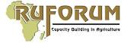 | RUFORUM | Kampala, Uganda

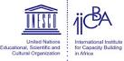 | IICBA | Addis Ababa, Ethiopia

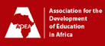 | ADEA | Abidjan, Ivory Coast

 | ANCEFA | Dakar, Senegal

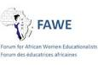 | FAWE | Nairobi, Kenya

 | UNESCO | Paris, France

 | UNICEF | New York, USA

 | UNISA | Johannesburg, South Africa

 | AAU | Accra, Ghana

 | AAS | Yaoundé, Cameroun

 | UVA | Nairobi, Kenya

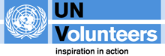 | UN Volunteers | Bonn, Germany

 | USAID | Washington, USA

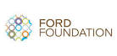 | FORD FOUNDATION | New York, USA

 | FNUAP | New York, USA

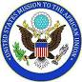 | US Mission to AU | New York, USA

 | JOCA | Tokyo, Japan

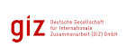 | GIZ | Bonn, Germany

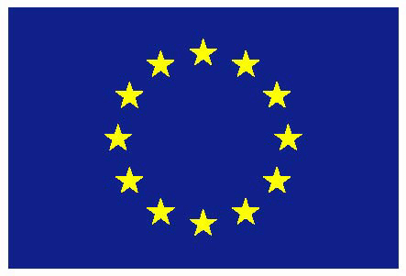 | EUROPEAN UNION | Brussels, Belgium

