MEDIA EQUIPMENT FORM

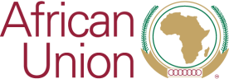

37th ORDINARY SESSION OF THE SUMMIT
OF THE AFRICAN UNION
and 44th Ordinary Session of the Executive Council
AU HQ: Addis Ababa: Ethiopia
14-18 February 2024

List of equipment for Mr. / Mrs. / Ms. / other (please specify)

__________________________________________________

Name of Media Organization: ___________________________________

NO | TYPE OF EQUIPMENT | SERIAL NUMBER | ESTIMATED VALUE (USD)

