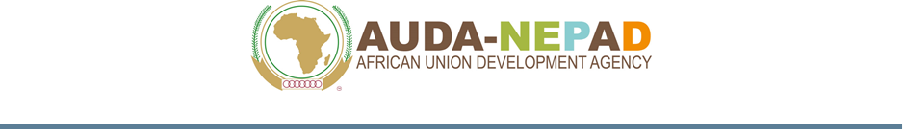
DECLARATION OF UNDERTAKING

{Location, Date}

To: The Chairperson Internal Procurement Committee (IPC)
AUDA-NEPAD
230, 15th Road, P. O. Box 218 Midrand,
1685 Johannesburg, South Africa

Attention of: Head of Procurement Division

- We, the undersigned, offer to provide the services/goods for {Title and Procurement Number} in accordance with your Request for Quotation dated {Date}

- We declare that:
- All the information and statements made in this quotation are true and we accept that any misinterpretation or misrepresentation contained in the quotation may lead to our disqualification and/or may be sanctioned by AUDA-NEPAD;
- We have no conflict of interest in relationship to performance of this assignment;
- We confirm our understanding of our obligation to abide by the AU Ethics policy regarding corrupt and fraudulent practices;
- We, along with any of our sub-consultants, subcontractors, suppliers, or service providers for any part of the contract, are not subject to, and not controlled by any entity or individual that is subject to, a temporary suspension or a debarment imposed by the World Bank or any other multilateral development bank and being listed on the website http://www.worldbank.org/debarr or respectively on the relevant list of any other multilateral development bank. Further, we are not ineligible under the South African laws or official regulations or pursuant to a decision of the United Nations Security Council;
- We have not been convicted by a final judgement or a final administrative decision or subject to financial sanctions by the United Nations or Country for involvement in a criminal organisation, money laundering, terrorist-related offences, child labour or trafficking in human beings; this criterion of exclusion is also applicable to legal Persons, whose majority of shares are held or factually controlled by natural or legal Persons which themselves are subject to such convictions or sanctions;
- We are not a shell company nor has our company been created specifically for this bid and confirm we are legally registered to operate a business under the Laws of {insert country of registration} since {insert year of registration}; and
- We are not being bankrupt, wound up or ceasing our activities, having our activities administered by courts, having entered receivership, reorganisation or being in any analogous situation;
- We commit ourselves to complying with and ensuring that our Subcontractors and major suppliers under the Contract comply with international environmental and labour standards, consistent with laws and regulations applicable in the country of implementation of the Contract and the fundamental conventions of the International Labour Organisation (ILO) and international environmental treaties. Moreover, we shall implement environmental and social risks mitigation measures when specified in the relevant environmental and social management plans or other similar documents provided by AUDA-NEPAD and, in any case, implement measures to prevent sexual exploitation and abuse and gender-based violence;
- We undertake to bring to the attention of AUDA-NEPAD, any change in situation regarding points 2 and 3 here above.

We remain,

Yours sincerely,

Authorised Signature:
Name and Title of Signatory:
Name of Firm:
Address:

