AFRICAN UNION |  | UNION AFRICAINE
 |  | UNIÃO AFRICANA

Addis Ababa, ETHIOPIA P. O. Box 3243 Telephone 517 700 Fax: +251-1-517844

AU CONFERENCE OF MINISTERS OF TRADE
6TH ORDINARY SESSION
29 OCTOBER - NOVEMBER, 2010

KIGALI, RWANDA

A Decade of African-US Trade under the African Growth and Opportunity Act (AGOA): Challenges, Opportunities and a Framework for Post-AGOA Engagement

A Decade of African-US Trade under the African Growth and Opportunity Act (AGOA): Challenges, Opportunities and a Framework for Post-AGOA Engagement

Introduction

- Africa remains a small player in global commerce, accounting for a meagre 3.2% share of international trade. Generally, SSA countries have been characterized by weak export growth, poor diversification and low foreign investment levels. The US, which purchases nearly a quarter of Africa’s exports, has been the region’s largest single country market.

- In an effort to help the continent overcome its trade and investment constraints, the African Growth and Opportunity Act (AGOA) was signed into law on May 18, 2000 as part and parcel of the US Trade and Development Act of 2000. Since then, AGOA has been the centerpiece of U.S. trade relations with Sub-Saharan Africa (SSA), providing SSA exports with duty-free and largely quota-free access to US markets. The legislation, which was to expire in September 2008, has been amended several times, most recently extending until September 2015. With just five years left prior expiration, concerns have been raised as to the extent to which AGOA has met its objectives of increasing African-US trade, diversifying African exports and facilitating Africa’s integration into the global economy.

- By granting duty free and largely quota-free access to African exports, AGOA is expected to promote exports to the US, as well as attract investments to Africa, thereby helping stimulate economic growth. Touted as a transition path from development assistance to economic self-reliance, it was hoped that AGOA would exemplify a ‘trade-not-aid’ approach, fostering long-term economic development.

- AGOA places a heavy emphasis on Africa’s emerging textile and apparel industry as the primary sector for trade benefits. This sector is considered to hold the highest potential of fostering Africa’s export competitiveness and export led pro-poor growth by generating greater employment due to its relative labor-intensiveness. Currently, 38 SSA nations are AGOA eligible of which 27 have eligibility for textile and apparel benefits. The Act also provides for technical assistance to promote firm-to-firm business relationships, assist African states with market-based economic reforms and encourage greater African participation in WTO negotiations (notably, with an emphasis on deepening services trade liberalization, a sector where Africa countries have liberalized less than developed country members of the WTO). Finally, AGOA also seeks to encourage more US investments by establishing a more reciprocal partnership based on bilateral agreements with African countries (i.e. BITs, TIFAs and TIDCAs).

- This issues paper seeks to provide an assessment of the experience with AGOA over the last 10 years. It evaluates the extent to which the key objectives of the initiative, namely increased exports, greater export diversification and increased FDI flows have been met. The paper also discusses the main challenges faced by African exporters within the context of AGOA, taking into account impediments such as compliance with standards and SPS, supply-side constraints and lack of export diversification, which currently impede a full reaping of the benefits from this preferential scheme. Finally, the paper seeks to contribute to the discussions in the context of the latest AGOA Forum held in Washington in August 2010, proposing a set of policy recommendations for debate and consideration by the African Union Ministers. It is hoped that these recommendations will help to map out a way forward towards maximizing the use of AGOA trade preferences in order to meet Africa’s long-term economic growth and development needs through a more balanced trade-led strategy.

- This paper is structured as follows: Section 2 assesses overall AGOA achievements, analyzing its impact on trade performance, FDI levels and employment creation. Section 3 reviews some of the challenges of AGOA as well as a post-AGOA framework beyond 2015. Section 4 discusses some of the issues which need to be addressed if AGOA is extended beyond 2015 in addition to possible post-AGOA scenarios. Finally, Section 5 concludes by highlighting some of the policy recommendations for African member States participating in AGOA, with a view to improve current preferences so as to make them more inclusive, accessible and permanent.

ASSESSING THE AGOA FRAMEWORK

- AGOA has had a measurable and sizeable impact on African trade with the US since its entry into force. Overall, total US imports have increased almost five-fold since the entry into force of the Act, from $5 billion to over $25 billion in 2005. During 2005-2010, imports have been fluctuating significantly, decreasing markedly between 2005 and 2006 to $21.2 billion, on account of the expiration of the Multi-Fibre Agreement (MFA) and a fall in world commodity prices, the latter which determine almost all of the trade of AGOA countries, due to a heavy commodities export bias (see Table 1).

- 2009 registered an even sharper decline in US imports at $12.7 billion, as a result of the financial crisis and the possible impact of stimulus packages for US producers to the detriment of AGOA beneficiaries, to be followed by a modest recovery in 2010. Import growth has not seen similar rates since the first five years: 2001-2005 recorded a 500% year-to-year growth in total US AGOA imports. Further, it is evident that utilization rates vary significantly among beneficiaries with only a handful of countries such as Nigeria, South Africa, Angola, Lesotho, Kenya, Madagascar, Mauritius, Congo and Swaziland primarily reaping the benefits of AGOA preferences.

- With regards to leading US imports from AGOA-eligible countries (see Annex, Table 2), energy related products account for almost 90% of imports, valued at $30 billion, followed by transportation equipment (valued at $1.4 billion, accounting for 4.2%), textiles and apparel (valued at $918 million, accounting for 2.7%) and minerals and metals (valued at $413 million, accounting for 1.2%). Other chief imports include: agricultural products ($290 million), chemicals and related products ($263 million), miscellaneous manufactures ($43 million), machinery ($23 million), electronic products ($21 million) and footwear ($494 thousand). These statistics portray that diversification still remains an enduring challenge for Africa.

- Notwithstanding the prominence of energy, mineral and related products in overall US imports, the textile and apparel sector represents a rising share of US AGOA imports. In terms of value added and structural transformation, this sector had been touted as the primary conduit of growth in a group of countries.

- In terms of overall textiles and apparel imports, there has been a significant supply response during the years 2001 and 2004, from $355 million to $1.6 billion, amounting to an over 400% increase. There has been an evident economic payoff for countries such as Kenya, Lesotho, Madagascar, Mauritius, South Africa, Swaziland, Botswana, and to a lesser extent Ghana, Ethiopia, Malawi, Tanzania, Uganda and Cape Verde. In 2005 there was a sharp decline down to $1.4 billion, as the effects of the MFA expiration began to be felt. Since then, textile and apparel imports have been gradually declining to reach a low of $914 million in 2009. More importantly, additional preferences (through the special rules that apply for textile and apparel eligibility) are essentially limited to thirteen countries, less than half of textile and apparel beneficiaries.

- In terms of increased sector value added under AGOA, the expansion has primarily been observed in the apparel sector and to a lesser extent in the sugar-related sectors. However, the benefits to African economies should not be overstated. For instance, although Kenya appears as a major beneficiary in the sense that clothing exports to the US rose four-fold, this was from a minimal pre-AGOA base. The majority of firms involved in this rise are recent non-Kenyan entrants, located in export processing zones. Another example is that of Lesotho where clothing exports under AGOA are ‘cut, make and trim’ by subsidiaries of (primarily Asian) multinationals which provide all the inputs. There are limited linkages to the local economy and exports are susceptible to changes in AGOA rules of origin. Almost half of South Africa’s clothing exports to the US do not avail themselves of AGOA preferences because producers find it more cost-efficient to import Asian textiles (primarily from China) and hence do not meet stringent rules of origin. By some estimates, benefits of AGOA for Africa would be approximately five times greater if exporting countries were not subject to restrictive rules of origin. Although AGOA has helped to increase exports, it is far from evident that is has helped to establish a viable, sustainable and competitive export sector in SSA, not least due to its limited and uncertain ‘window of opportunity’ faced by investors.

- On the investment front, it is a challenge to attribute FDI flows specifically to AGOA. However, in its early days, as benefiting countries built small industrial base especially for textiles and apparel, there are figures that indicate that more than US$1 billion FDI flows stemming from the US were directly related to AGOA. An increase in export-oriented FDI linked to AGOA has certainly taken place (see Box 1).

- Comparisons of pre-AGOA and post-AGOA demonstrated an increase of FDI inflows by up to 77% in the AGOA countries rising from $7.1 billion (1999-2000 average) to $12.5 billion (2004-2005 average). UNIDO notes that, between 2003 and 2005, developing country investors doubled their employment in Africa. In addition, there is also evidence of Southeast Asian FDI in garment manufacturing factories seeking to benefit from AGOA. Transnational corporations from mainland China, Hong Kong, Singapore and Taiwan have been among the most active investors, underscoring the importance of AGOA in galvanizing FDI from emerging economies and strengthening South-South trade.

Box 1: Some examples of AGOA related FDI
- In Malawi, AGOA has led to FDI in two garment factories by European and Taiwanese companies, creating at least 4,350 jobs. It was estimated that total employment would increase by 10,000, leading to a total of 20,000 workers.
- In Mauritius, FDI worth $78 million took place. Prospects of Asian and European companies building cotton-yarn spinning mills were strong.
- In Senegal, a leading Senegalese apparel and textiles company planned to enter into a partnership with a US textile manufacturer and a Malaysian firm to export to the US with a potential creation of 1,000 jobs.
- In Tanzania, a textile mill was expanded in partnership with a US firm involving 1,000 jobs.
- In Cape Verde, a fish-processing company was acquired by a US company, and two new Portuguese investments in the garment industry were announced.
- In South Africa, the establishment of a new $100 million clothing facility by Malay investors was expected to employ 13,000 workers.
Source: UNCTAD (2002)

- Beyond trade and investments and the requisite improvements in the socio-economic and political framework necessary for these objectives to be attained, the main overarching goal of AGOA remains that of helping African countries reduce poverty. Yet poverty reduction is only possible if trade and investment lead to higher growth (and hence increased income) and/or reduce inequality through an improved redistribution of wealth.

- A key factor to the growth and inequality nexus in achieving the poverty reduction goal is employment creation. Therefore, any discussion on AGOA needs to consider job creation as a result of the various investments. In the lead up to the AGOA Forum of 2009, it was estimated that since the initiative has been in place (i.e. since 2000), over 300,000 new jobs have been created in Africa. This has meant an average of over 30,000 new jobs per year.

- An illustrative example of this trend has been Lesotho. In the first two years of AGOA certification, Lesotho experienced a 36 per cent increase in employment from 29,000 to 45,000, due to the establishment of new companies seeking to take advantage of the AGOA preferences. Most of these companies set up operations in textiles, clothing and footwear, sectors that tend to be labor-intensive and female-workers friendly. Therefore, though not envisaged, AGOA in Lesotho has not only fostered new investments and employment, but also helped empower women by affording them access to a regular income.

- In turn, AGOA has credited with the creation of more than 30,000 jobs in Kenya by 2004 as previously idle capacity in textiles and clothing manufacturing was brought back into operation. In Zimbabwe, 2003 estimates pointed to AGOA supporting 28,000 jobs in the export sector. Swaziland and Malawi have also experienced similar job creation, particularly on account of the textile and apparel sector expansion.

CHALLENGES

AGOA

Short Time Horizon Undercutting Investments
- As mentioned in the introduction, AGOA was initially envisaged to last eight years but was later extended until 2015, in order to furnish beneficiaries with sufficient time to develop capacities and upgrade their competitiveness. However, AGOA’s temporary nature discouraged long-term investment as the ten year ‘window of opportunity’ dissuaded investors in light of the difficulty of recouping capital prior to the expiry of the Act, thus lowering potential benefits significantly. Hence, it may be argued that uncertainty with regards to AGOA’s time horizon has undercut related investments significantly.

Competitive Environment Increasing
- With the expiry of the Multi-Fibre Agreement in 2005, the textile and apparel sector was opened up to competition, particularly from Asia. Consequently, exports plummeted from $1 billion in 2004 to $0.9 billion in 2009, contrary to the general perception that it would ensure Africa market access to those countries which had protected their markets through ‘grandfather clauses’, highlighting that preferences remain crucial for the nascent textile and apparel sector in SSA. Furthermore, there have been recent proposals by the US Congress to extend AGOA-like benefits to countries such as Cambodia and Bangladesh, which, if extended, would lead to an erosion of preferences granted to African countries, and a subsequent loss in market share in favor of the more competitive Asian beneficiaries.

Agricultural Exports Remain Low
- Agricultural commodities account for less than 1% of AGOA exports. AGOA adds 541 products to the 519 which already benefit under the US GSP. Hence, the preference margin on half of these goods is permeated since preferential treatment is thereby afforded to other non-African developing countries. Adding to this preference erosion, AGOA also has important exclusions on specific agricultural products, such as sugar, peanuts, dairy and tobacco, which are among the main revenue generating exports sustaining many African countries. In addition, US subsidies for domestic producers, such as the cotton subsidies, eliminate any competitive advantages of Africa’s agriculture sector under AGOA. These subsidies artificially lower world cotton prices, thereby reducing revenues of African cotton exporters and curtailing the development of a textiles and apparel sector in Africa. Further, more than 200 tariff lines, representing 17% of the total number of dutiable agriculture tariff lines, do not enjoy preferences neither under AGOA nor the US GSP. Products under this last group are also subject to considerable tariff escalation, eliminating virtually any market access opportunities for African agricultural products. Finally, non-tariff barriers such as standards and SPS impose additional demands on exporters, further undermining agricultural market access for African countries.

AGOA-Eligibility Revocation Impacting on Regional Integration
- Integrating Africa’s economies locally to compete globally is vital to Africa’s long-term economic success. AGOA eligibility is reviewed annually by the US, which has the option of unilaterally revoking benefits if certain economic, political and human right conditions are not meet by the beneficiaries. The suspension of s AGOA benefits in on beneficiary country can have important ripple effects on its regional trading partners if. For instance, Madagascar’s recent ineligibility (on account of an undemocratic coup) has affected several countries which are also AGOA beneficiaries, as Madagascar’s apparel sector uses denim fabric from Lesotho, zippers from Swaziland, and cotton yarn from Zambia, Mauritius and South Africa.

Trade Logistics Hampering AGOA Utilization
- Africa’s major supply side constraint is trade logistics, which determines the cost of getting goods from the factory gate to end consumers. Infrastructure deficiencies, coupled with poor public institutions and lack of competition among service providers, hamper the efficient movement of goods. For instance, in East Africa, the average cost of trade logistics is equivalent to a tax of between 25 and 40 percent on value-added, which impedes entering markets with competitive prices.

Post-AGOA Scenarios
- Given its temporary, unilateral and conditional nature, three key questions require critical thought as the possibility of a post-AGOA scenario arises. What are the main challenges the expiry of such preferences may pose on the African continent? What could be reasonably expected beyond 2015 if AGOA is not renewed? How would Africa fare under this scenario?

Risk of Preference Margin Erosion
- The margin of preference currently afforded to African countries under AGOA is of 7.7%, while the average duty on excluded products is above 30%. These preference margins are rather low, given that products liberalized under AGOA already enjoy duty and largely quota-free access under the US GSP, which washes down any preferences for African nations as they compete with other beneficiaries, such as Cambodia and Bangladesh in the particular case of textiles. Moreover, preference-receiving countries do not fully reap the preference margins under AGOA due to the presence of intermediaries such as transport and logistics companies, importers with market power and administration costs.

- Furthermore, some countries which have played a significant part in creating value chains and promoting regional integration by promoting S-S trade and FDI under AGOA preferences would see their gains fade away. This could be the case of cotton exports from Tanzania to Kenya for textile production, or South African and Mauritian FDI in the textile sector of other African countries.

- It is in the light of these examples, a phase-out of AGOA calls for reflection. Countries which have not benefited from AGOA so far (approximately 50% of SSA beneficiaries) will not harness trade, FDI and job creation opportunities afforded by AGOA if it is not renewed. Equally, SSA beneficiaries already benefiting from AGOA will most likely lose both traditional and newly gained markets to competitors once preferences expire.

FDI Diversion and Specialization a Concern
- FDI-driven specialization in textiles and apparel raises a major concern, especially if AGOA preferences are to expire in 2015. FDI in this sector is very mobile and can be quickly dismantled, which could replay a MFA scenario of market loss to Asian competitors leading to de-industrialization as during the MFA phase-out. This would also mirror the short-lived experience of Caribbean countries under a parallel preferential scheme known as the Caribbean Basin Initiative, which experienced a dismantling of their incipient textile industry once exposed to NAFTA and later on, Chinese competition. If FDI is not accompanied by skills creation and technology transfer, the opportunity to foster economic development, competition and greater specialization may be lost.

Employment and Gender Equality Gains to be Lost
- Most of the textile manufacturing companies have established themselves in export processing zones (EPZs), attracted by tax exemptions and other incentives. As already mentioned, these types of “maquila” industries have the particularity of quick dismantling. They generally fail to promote the much sought industrialization and economies of scope in the host country, as they are part of a vertically integrated value chain of multinational enterprises, which rely on the sourcing of inputs from their international suppliers and respond to a global strategy defined by the mother company. Further, there have been reports of sweatshop conditions violating basic human rights of workers.

- With the Special Rule which allows for the use of third-country yarn and textiles in LDCs, it is most likely that foreign textile manufacturers in EPZs merely become centers for re-export with very little value addition in the countries where they are located, especially in the presence of very lax rules of origin. Though there is evidence of some skills creation under AGOA, as is the case of Lesotho, training so far has been limited to basic production needs. If AGOA is to meaningfully contribute to improving the human conditions relating to trade, greater emphasis on skills development, decent working conditions and enhancing the gender equality dimension are necessary.

WAY FORWARD
- As 2015 approaches, Africa faces two alternatives: the renewal of AGOA or the definite phase-out of this trade preferences scheme. Either alternative poses important concerns for the continent, which need to be weighed out carefully.

An Extension of AGOA Beyond 2015
- In the event AGOA is extended beyond 2015, several issues need to be addressed in order to improve the participation of African countries in the scheme, as exports to the US benefiting under the current scheme are highly concentrated in a handful of countries and goods, whilst FDI portrays a heavy bias towards the textiles and apparel sector.

Preferences Still Play a Role
- Renewal should take into account major shortcomings to render AGOA more inclusive, accessible and permanent. Preferences ought to be strengthened, enhanced and improved so that trade and investment which so far rely on transient preferential market access may be channeled towards sectors with export potential in a durable manner. This is crucial, especially since of the 38 beneficiary countries, only a half have been able to seize opportunities under AGOA.

Requirements, Standards & SPS Compliance in Export Markets
- One of major constraints impinging on African exports to US markets relates to non-tariff measures (NTMs). Though these measures are not a direct tax on trade, they come in the form of standards, sanitary and phyto-sanitary measures and administrative requirements, which pose additional capacity and financial demands on trade. This is one of the main reasons why many African countries fail to export to US markets under AGOA, despite the largely quota-free and duty-free access. Indeed, market access opportunities under GSPs such as AGOA are foregone due to restrictive rules of origin and administrative costs, which explains why many countries fail to benefit from these preferential schemes.

- In the case of SPS, in addition to having the knowledge and being able to produce animal and vegetable products which fulfill these measures, a certifying body with high-level expertise is required. In many African countries, such bodies lack the sufficient physical and human capacities to be recognized as certifying institutions or may not be able to fulfill the rigorous accreditation procedures of the US. In other countries, such institutions may not even exist; meaning exporters wishing to access US markets will be subject to additional costs when sending samples to certifying bodies outside their country, which requires time and money.

- In the particular case of labeling requirements, additional production costs may result from differentiated labeling, as is the case of labels reflecting environmental standards, which imply additional production costs as a result from differentiated labels. These standards may also require considerable interventions in processes and production methods (PPM) which demand technological and financial resources. This is particularly relevant for the textiles sector, where eco-and/or bio-labeling requirements are on the surge.

- Other requirements, such as special documentary requirements, also put considerable strains on African exports to the US. For example, such is the case of the certificate of origin for textiles and apparel under AGOA, where eligible countries must undergo a visa verification system for transshipment, from which LDCs are exempted under the “Special Rule”.

- In all the cases portrayed above, technical assistance and capacity building are crucial to obtain the necessary expertise, infrastructure facilities, as well as capacity to respond to these requirements. AGOA already serves as a framework under which such expertise may be afforded through the TIDCAs, which address issues such as customs and trade facilitation, technical barriers to trade and SPS. However, since these agreements are negotiated on a bilateral basis, they are not offered to all SSA beneficiaries as a group. Currently, only members of the Southern African Customs Union (SACU) have a TIDCA in place, which calls for greater engagement and inclusiveness in affording such technical assistance in the continent.

- Finally, AGOA may have a greater impact if it undertakes a simplification of rules and requirements. In conjunction with capacity building activities delivered by the US under the Act, SSA beneficiaries may be able to implement such simplified rules for textiles and apparel, as well as other sectors which are of interest to several African nations.

Supply-Side Constraints to be Eliminated
- Structural constraints within Africa, such as weak distribution networks and communications and transport infrastructure, are the main challenges of African trade. Therefore, market access to the US which is not accompanied by measures addressing African supply-side constraints is unlikely to result in a substantial expansion of exports or develop the backward linkages which are necessary for economic development.

- The African Global Competitiveness Initiative (AGCI) has had some positive contribution to the improvement of trade-related infrastructure and productive capacity, for countries such as Botswana, Uganda, South Africa and Rwanda and some sub-regions such as East and Central Africa. Such assistance should be further extended to all SSA countries and be brought under the regional economic commissions (RECs), as these may be more familiar with their respective sub-region’s supply-side constraints and more able to channel funding towards developing intra-African trade. It is through the RECs that opportunities for value-chain creation across countries may be best provided, because these are aware of the complementarities of the different economies in their region. Such an approach would foster the inclusion of those countries which so far have not been able to take advantage of AGOA.

Export Production and Destinies Diversification Necessary
- African countries are characterized by poor export diversification, as the great majority still depend on few commodities. Though AGOA has greater export diversification as one of its key objectives, product coverage remains insufficient as preferences are not far-reaching enough because of the current product exclusion of rice, sugar and peanuts (products where many African countries have a comparative advantage). In addition, AGOA preferences are being permeated by other GSP arrangements, as well as subsidies, which in addition to restraining access to the US, severely affect export revenue of African producers in the global market as is the case of cotton subsidies previously discussed.

- Even though AGOA has afforded FDI and job creation opportunities in the textiles and apparel sector, there is little value added linked to these activities. However, value addition may afford African countries the opportunity to penetrate niche markets with growth prospects such as those of “fair” and “organic” trade. This will also require adequate technical assistance and capacity building.

Sectoral Carve-Outs of National Treatment and MFN Treatment Key
- In the years when the MFA quota system (2000-2004) was in place, AGOA textile exports remained stable. It was the temporary protection of AGOA during this last trench of the MFA phase-out that enabled African countries such as Mauritius, Kenya and South Africa to develop their textile industries. In combination with the AGOA general rule which required the non-LDC countries to either use local, African or US inputs in their textile production (as opposed to the third-country fabric option under the Special Rule for LDCs), this fostered the creation and strengthening of their local industry. In light of these examples, AGOA should include sectoral carve-outs for sectors such as textiles, to afford continued protection to those countries which have not yet been able to solidify their industrial base, or who are facing de-industrialization as Asian textile and apparel exporters penetrate the US markets. In this sense, a careful balance and sequencing between this option and that of relaxing the “Special Rule” for LDCs must be struck, since evidence points to their apparel exports to the US having increased 7-fold in the first 5 years.

Post-AGOA Scenarios
- There could be three scenarios shaping US-African relations under a post-AGOA framework. A first scenario entails the US wanting to opt for deepening the implementation of the BITs, TIFAS and TIDCAs which are already in place with some African countries and RECs. This scenario, which is highly likely even if AGOA is renewed, begs the question of what will happen to those SSA countries which are currently beneficiaries of AGOA but are not part of any of these arrangements. For these countries, prospects of leveraged agreements with the US may be meek if they engage in bilateral negotiations, such as those which the US undertook with some Central American countries under the Bush administration, when the project of a hemispheric Free Trade Area of the America (FTAA) lost ground in 2004.

- A second scenario may comprise the US’s interest of wanting to consolidate gains through regional BITs, TIFAS and TIDCAs at a sub-regional level. This will demand greater coordination on behalf of the countries engaged in regional negotiations, and may pose considerable challenges – as is the case with some of the current Economic Partnership Agreement (EPAs) being negotiated with the EU – if such negotiations end up cutting across the existing RECs structure in the regions.

- A third scenario, which is probable and equally challenging for African countries, relates to the US seeking that these bilateral agreements go deeper than the EPAs reciprocal treatment. In other words, if these agreements require African counterparts to make greater commitments, countries may lose out on the opportunities of having adequate policy space for their development needs and considerations. In addition, concerns similar to those of current EPAs negotiations, such as burdening regional integration efforts, trade diversion in favor of US suppliers, loss of export earnings and further dismantling of their local industry could arise.

- In the event of any of these scenarios, African beneficiaries need to define possible actions and weigh out the advantages and challenges such agreements may pose to their international trade, regional integration and national development objectives. Finally, in parallel to this exercise, SSA countries also need to review the policy options which are available to them as a group in order to improve AGOA, given that the framework has not been phased out yet.

CONCLUSIONS

- This issues paper reviews the main achievements, challenges and opportunities of the African Growth Opportunities Act (AGOA). It also elaborates on how AGOA may be improved to address the issues that are at the heart of African trade and economic diversification and discusses the implications of a post-AGOA scenario. In retrospect, AGOA has fostered US-Africa trade. In addition, non-oil exports have grown and greater FDI and employment have been witnessed in the continent. However, the benefits have been unevenly distributed and there is uncertainty pertaining to AGOA’s future, which makes the consolidation of the gains a major challenge.
- If the goal of AGOA is to promote lasting growth and development, then it needs to be reformed into a more inclusive, accessible and permanent framework. Relevant policy recommendations which may help define an extension of AGOA beyond 2015 and contribute to shaping a more meaningful US-Africa trade and investment relationship are:
- African countries should advocate for a longer time horizon, as there is need for AGOA certainty beyond 2015.
- There needs to be a better linkage of the Aid for Trade Initiative with AGOA to address identified constraints being faced by SSA.
- The US should work on simplifying the rules of origin for African beneficiaries under AGOA, conducive to greater value addition at national and regional level.
- A greater focus on enhancing the regional dimension of the AGOA framework is also required, especially in the context of the regional integration agenda of the RECs.
- Trade and FDI partnerships between governments and foreign interests should condition enjoyment of AGOA benefits on capacitating local employees and firms, so that lasting innovation and skills creation may take place in the beneficiary country. This will enable AGOA beneficiaries to move up the value chain for the purposes of penetrating more competitive markets in the future.
- Industrial and FDI policies should foster domestic investments. If local interests are also embedded in FDI which comes as a result of AGOA, durability and stability of such interests may render more sustainable investments, and reduce the risk of a quick dismantling of the industrial base.

Issues for discussion:
  - What can African countries do, in terms of strategies and resources, to address supply-side constraints, improve infrastructure and trade logistics so as to increase their trade performance and AGOA-related FDI? How can public-private partnerships be galvanized to increase investments and improve operating efficiency?
  - What are the lessons learned from the experiences and responses of African countries that have been able to utilize AGOA preferences to their advantage?
  - What measures can African countries undertake to mitigate the effect of an increased competitive environment in the aftermath of the MFA expiration and rising preference erosion?
  - How can AGOA rules of origin be modified in the event of unilateral AGOA-ineligibility so as not to hamper the development of regional value chains?
  - How can RECs be more involved in AGOA to boost the regional facet of the AGOA framework?
  - With the possibility of AGOA-expiration in 2015, what actions can be taken up to raise inter-African and S-S trade?

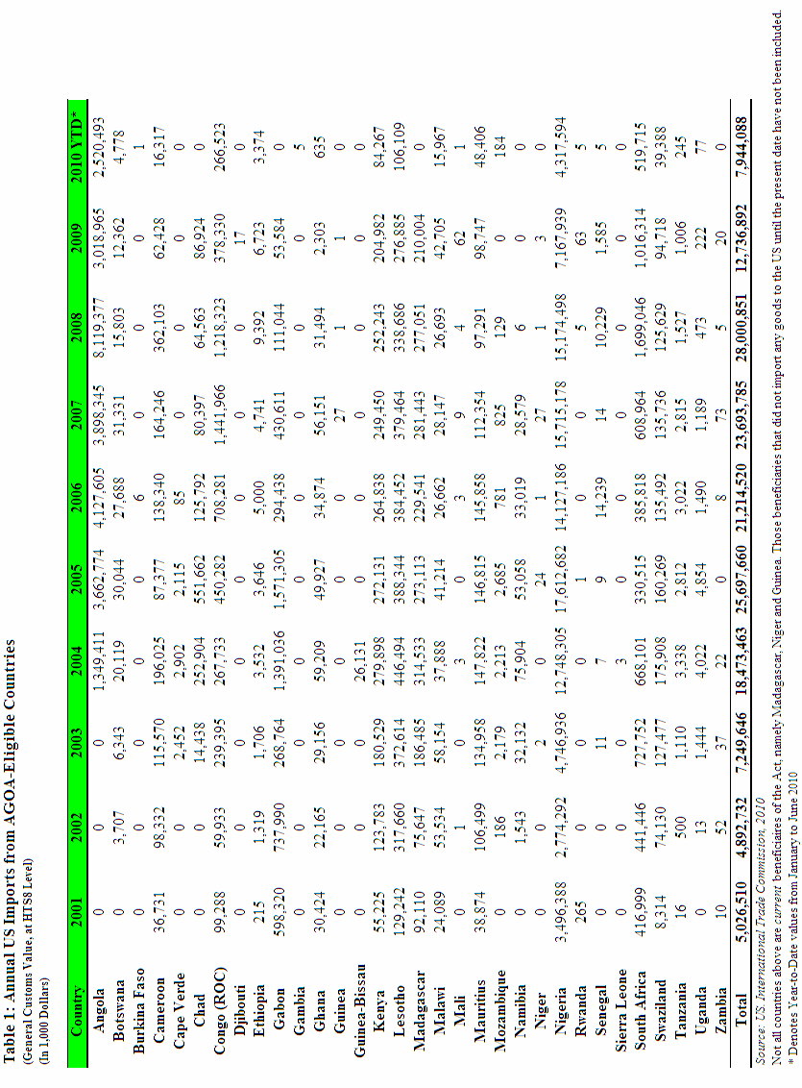

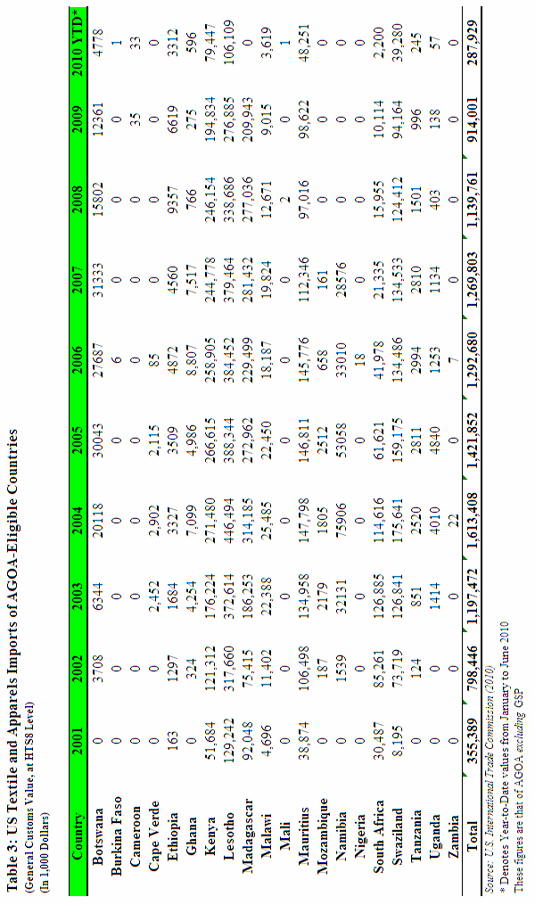

AGOA eligible countries currently include: Angola, Benin, Botswana, Burkina Faso, Burundi, Cameroon, Cape Verde, Chad, Comoros, Republic of Congo, Democratic Republic of Congo, Djibouti, Ethiopia, Gabon, The Gambia, Ghana, Guinea-Bissau, Kenya, Lesotho, Liberia, Malawi, Mali, Mauritania, Mauritius, Mozambique, Namibia, Nigeria, Rwanda, Sao Tome and Principe, Senegal, Seychelles, Sierra Leone, South Africa, Swaziland, Tanzania, Togo, Uganda, Zambia.
BITs are Bilateral Trade Agreements; TIFAs are Trade and Investment Framework Agreements and TIDCAs are Trade, Investment and Development Cooperative Agreements.
Table 3 in the Annex illustrates trade flows from all AGOA-eligible countries regarding textiles and apparel (excluding GSP) at the HS 8-digit level, throughout the life of the Act to date. Recently non-eligible countries such as Madagascar have been included in the analysis to provide an overall assessment of benefits reaped since AGOA’s inception.
According to the US Department of Commerce (2009), major destinies of FDI stocks from the US in 2007 were South Africa, which received 36.5%, followed by Mauritius (21.9%), Equatorial Guinea (16.2%) and Angola (6.6%), Liberia (3.4%) and Gabon (3.2%). The rest of AGOA beneficiaries received the remaining 12.2% of FDI stock.
This resulted from the AGOA III Amendment.
Failure to comply with these conditions has led to the recent removal of Madagascar, Guinea and Niger from AGOA-eligibility.
The MFA’s expiry at the beginning of 2005 had an adverse impact on employment levels in the textile industry. In the aftermath of the quotas lapse, numerous Asian firms attracted by AGOA preferences uprooted their investments. Thousands of jobs have been cut in Malawi, Lesotho, South Africa and Swaziland. In Malawi, which registered nine textile companies under AGOA as of 2005 employing more than 11,000 workers faced a cut of 2,511 jobs between January and March of 2005 when a Taiwanese firm, relocated to Taipei. This same company rendered 10,000 textile workers jobless in Lesotho in 2004. In Swaziland, where AGOA products constituted 83% of the country's exports, 30,000 jobs were at stake according to a March 2005 survey conducted by the Common Market for Eastern and Southern Africa (COMESA). Further, in South Africa, over 300,000 textile workers were vulnerable to the cheaper influx of Chinese goods after the expiry.

