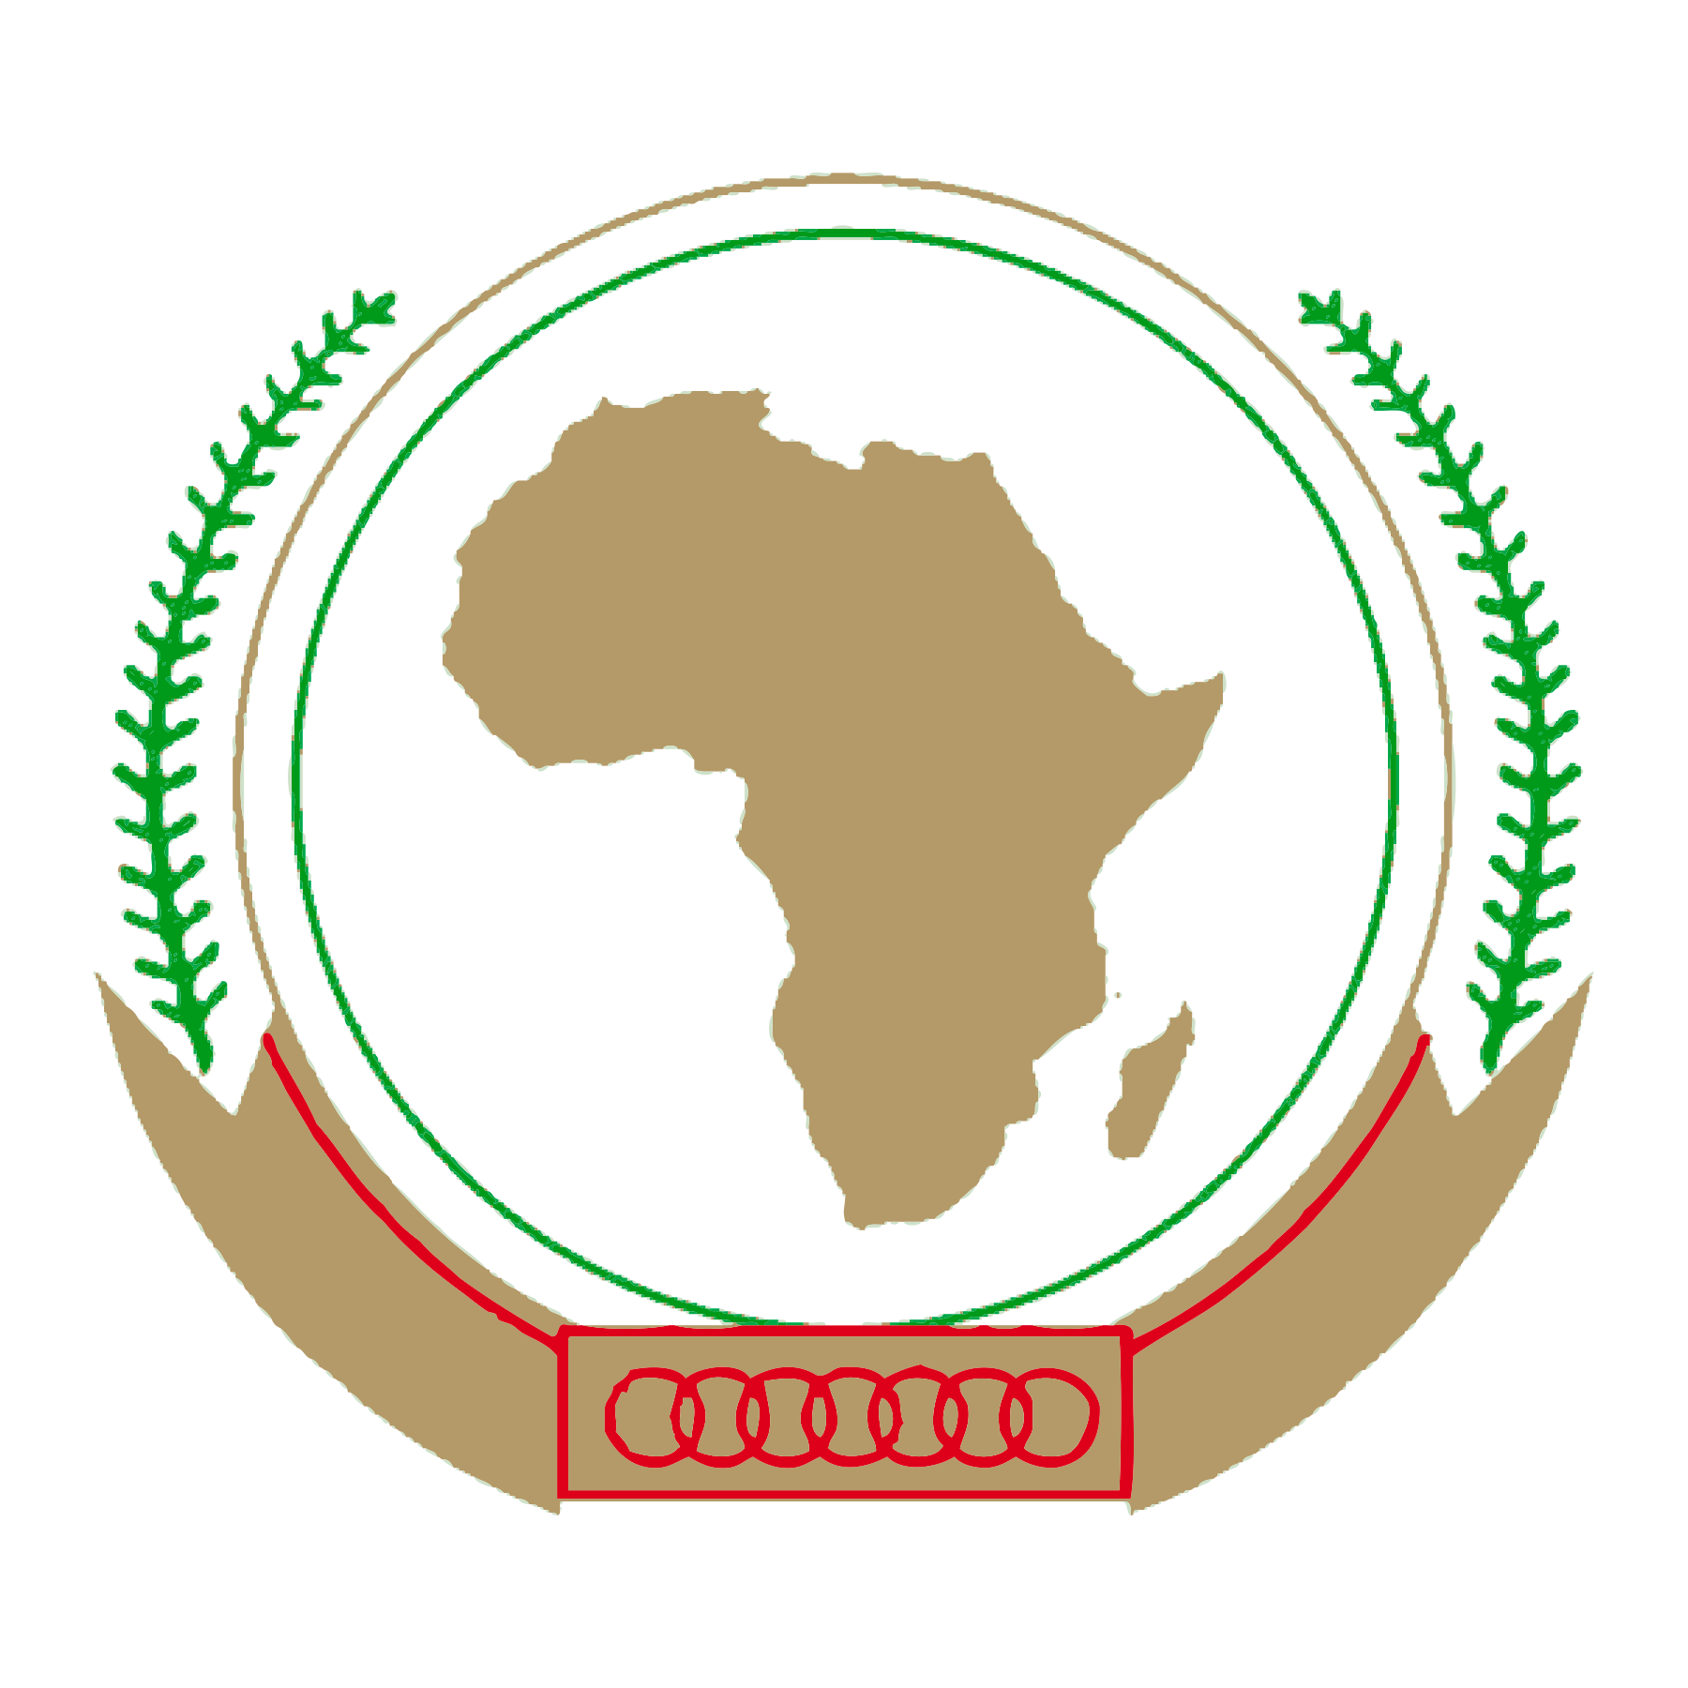
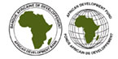
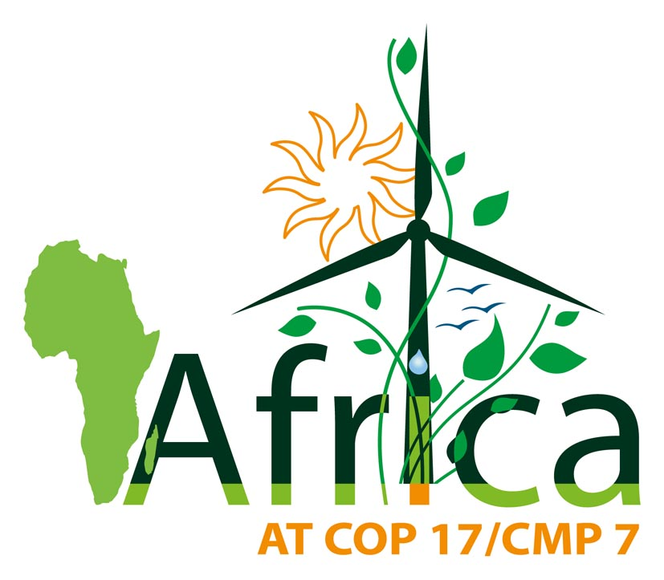

09 December 2011

Africa Pavilion Daily

This Summary Brief is intended for media representatives. Published by the Joint Communication Sub-committee (AU, AfDB and UNECA) in partnership with Dalberg, with financial support from AfDB. The Brief summarizes the daily discussion sessions taking place in the African Pavilion, capturing key discussion points, key implications, and key action items from selected sessions.
The Africa Pavilion, located within the precincts of the UNFCCC, is serving as a platform to have Africa’s voice heard. To demonstrate Africa’s ability to be part of the solution to the challenges of climate change on the continent, the Pavilion is hosting a full program of roundtables and events during the UN climate conference.
All the events organized in the Africa Pavilion are open to media representatives, who can ask questions to the panelists (interpretation English / French available).

PACJA Event – AMCEN and Africa Group Feedback and Consultation with Africa Civil Society
African Pavilion (13.50-14.20)
- On Friday, the final day of Africa Pavilion activities, Seyni Nafo, the African Groups Spokesperson led a discussion on Africa’s position in climate change negotiations. The session was titled PACJA Event – AMCEN and Africa Group Feedback and Consultation with African Civil Society
- The session took place in the main room of the African Pavilion.

Key Takeaways from the session
- The African position in negotiations is clear in that it asks for the second commitment of the Kyoto Protocol and securing necessary climate finance.
- It is imperative that delegates find common ground around the Kyoto Protocol and the need to cut greenhouse gas emissions.
- Africa has 54 states, over 1 billion people, and has one common position.
- Seyni Nafo stated that Africa needs to put pressure on developed countries as well as on African leaders to take action.
- Seyni Nafo encouraged the civil society to be visible.

Fresh and Young Brains Development Initiative
African Pavilion (15.30-17.30)
- On Friday, the final day of Africa Pavilion activities, the Fresh and Young Brains Development Initiative hosted a three hour session, following up on key recommendations from the meeting of African Heads of State in Malabo, July 2011.
- The session took place in the main room of the African Pavilion.

Key Takeaways from the session
- The issue of climate injustice between generations was emphasized given that the most vulnerable group to climate change is the youth.
- The idea of intergenerational responsibility is not yet reflected in climate change policies or debate.
- There is a desperate need to amplify the voice of those who will bear the brunt of climate change – women and children. The solutions that have been put forward to combat climate change will benefit people disproportionately.
- The youth have the passion, the energy and the innovation to help solve the problems associated with climate change. It was stated that the type of thinking that has created the problems faced today, cannot provide the solutions.
- By educating the youth on climate change now, they will not make the same mistakes that the past generations have made. People need to change their attitudes in the way they lead their lives. Emphasis needs to be placed on sustainable living.
- This is the time for Africa to get financial value from its natural resources. Food security is a major concern and it was acknowledged that countries around the world have helped with food aid. It is now time to empower countries so they do not rely on this aid but instead gain the capacity to sustain themselves.

----------------------------------------------------------------------------------------------------------------------------------------------------
Interview Requests

A wide array of senior officials from the African Union Commission, the African Development Bank and the UN Economic Commission for Africa are attending the COP17/CMP7 discussions in Durban.
Interview requests can be sought from the communications officers listed below by mail or telephone.

African Union Commission
Mr. Olushola Olayide
Department of Rural Economy and Agriculture
Te. +251 115 17700
Email: OlusholaO@africa-union.org

Mr. Molalet Tsedeke
Directorate of Information and Communication
Tel. +27 7 49 52 93 08
Email:molalett@africa-union.org

African Development Bank
Mr. Chawki Chahed
Media Relations
Mobile: +27 7 66 97 99 90
Email: c.chahed@afdb.org

Mr. Senvy Maistry
Audiovisual
Mobile: +27 7 61 70 40 27
Email: s.maistry@afdb.org

United Nations Economic Commission for Africa
Mr. Aloysius Fomenky
African Climate Policy Centre
Economic Commission for Africa
Tel. +27 7 22 94 74 05
Email: fomenkya@un.org

Mr. Andrew Allimadi
Communications Officer
Tel: +27 8 15 90 49 18
Email: AAllimandi@uneca.org

Partnership
The summaries are done by the Dalberg Team:

Angela Hansen
Martin Mbaya
Mabohlale Addae
Stig Tackmann
Kelly Cathryn Glen
Zukisa Sogoni
Jared Denis Jones
For more information, please contact Stig Tackmann at: +27 08 22 62 667.

