AFRICAN UNION | 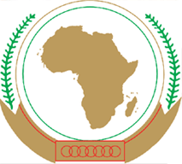 | UNION AFRICAINE
 |  | UNIÃO AFRICANA

INFORMATION NOTE on the transition from ANALOGUE to DIGITAL TERRESTRIAL TElevision

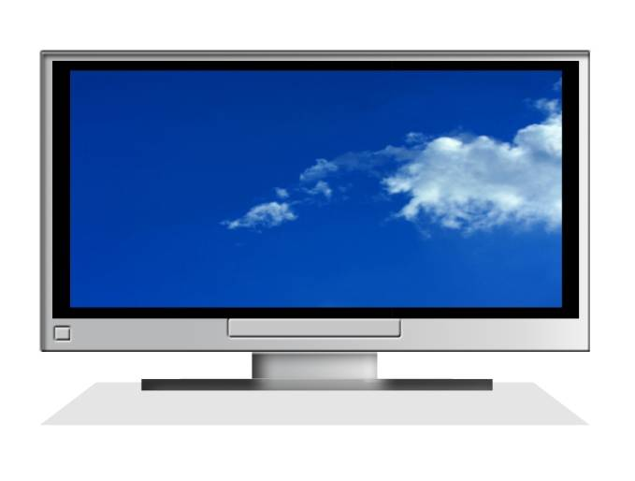

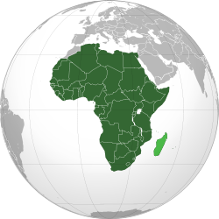

May, 2012

Table of Contents

Contents
1. Introduction 3
2 Background 6
2.1 Analogue Television Broadcasting 6
2.2 Standards of Analog terrestrial television broadcasting 7
3 Digital television broadcasting 8
3.1 Standards of terrestrial digital television broadcasting 9
3.2 Advantages of Digital Television Broadcasting 10
3.3 Why transition to the digital television should take before/on June 17, 2015 13
3.4 The challenges of the digital transition 14
4 Status of African countries towards the transition 14
5 Glossary and abbreviations 17
6 References 17

Introduction

- Analogue terrestrial television switch-off is a process of ceasing of broadcasting television signal in analogue form and replacing it by the broadcasting of television signal in digital form. Digital television broadcasting offers many benefits: Efficient utilization of the radio spectrum (frequencies), better picture quality, more television services are few to mention. However, the analogue switch-off (ASO) and the digital switch-over(DSO) is a complex process that requires a substantial financial investment, full involvement of all stakeholders, effective coordination and commitment of the involved parties.

- The process of the digital switchover started around the world since 2000 and the Regional Radio Communication Conference held in Geneva in 2006 (RRC-06) approved the Regional Agreement for Region 1, where Africa belongs to, as shown in figure 1.

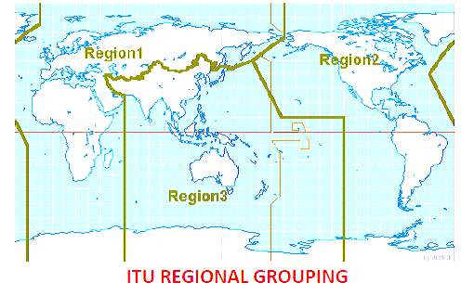

Figure 1: ITU Regional grouping

- The conference has set a deadline to switch-off the analog broadcasting service by 17 June 2015 in UHF band with the exception of some developing countries, for which the transition period shall end on 17 June 2020 for VHF band [1] , see figure 2 .

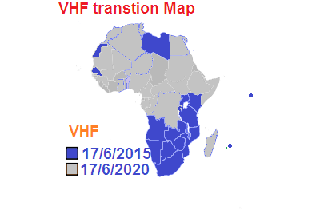
Figure 2: VHF transition Map

- Many developed countries have already fully switched-over to the digital and switched off their analog services completely. In Africa, however, among the 54 countries, Nine (9) countries launched the service, Six (6) countries are on the pilot phase and Seventeen (17) countries started the process. The status of the process in the remaining countries is not known officially/on public discussion or didn’t start the process [2],[3].

- In their 2010 Abuja Declaration, African Union (AU) Ministers in charge of Communication and Information Technologies have committed themselves to promote the transition from Analogue to Digital Terrestrial Broadcasting [4].

- Following the endorsement of the above declaration by the Executive Council, the African Union Commission (AUC) launched a project to promote the digital transition process. The project is implemented in two phases: The first phase is focused on awareness creation and status assessment of Member States and the second phase will deal with supporting Member States and producing policy framework mainly on harmonization of standard and utilization of the digital dividend at a continental level.

- Thus, this paper drafted as part of the first phase is aiming at :
- Recalling basic information regarding analogue and digital terrestrial television broadcasting;
- Highlighting the benefits and challenges of the digital television, and the reason for the transition.
- Recall the deadline set at RRC-06 to switch-off analogue terrestrial broadcasting services

- Together with this information note, a questionnaire is send to Member States in order to assess the current status of your country with regard to the digital transition and readiness to switch-off the analogue services before/on the deadline and preparation on how to use the released spectrum (digital dividend) after the analogue switch-off.

- We here by kindly request your active cooperation in replying the questionnaire later by End -June, 2012.

Background

Analogue Television Broadcasting

- Analogue television broadcasting is a telecommunication (communication over a distance) system whereby the television pictures and sound are sent from broadcasting transmitters as analogue signals. The analogue signal is made of continually varying radio waves. A transmitter modulates both picture and sound into analogue signal then sends this signal over the air (terrestrial) (see fig 3) via satellite, or through terrestrial network or a cable for a TV set to receive. The receiving antenna receives analogue signals and feeds it directly to TV set, which converts the signals into picture and sound for viewing.

- Terrestrial analogue television broadcasting can be received by an outdoor/indoor antenna and feed directly to the television set as presented hereunder on Fig 3.

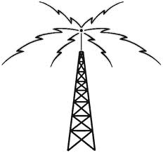
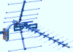
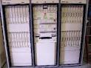

Content
Production
Reception
Transmission
Studio
Transmitter
Analog Signal
Indoor Antenna
Outdoor Antenna
Television
Set

Set



Figure 3: Analog terrestrial television broadcasting

Standards of Analog terrestrial television broadcasting
- There are three analog terrestrial television standards in the world. These are:

- NTSC (National Television Systems Committee) is a standard for television broadcasts in the United States, Japan, Canada, and Mexico.
- PAL (Phase Alternation Line) is the standard for television broadcasts in Germany.
- SECAM (Sequential Colure Avec Memoire) is the video format used in France, Eastern Europe, F.S.U (Former Soviet Union) and some Middle Eastern countries.

- Each standard is incompatible with one another. In addition, the equipment that demodulates the signal must be formatted for that signal. Fig .4 below shows the standard usage across the world. PAL is the dominant transmission standard in Africa though SECAM standard has also been deployed in western part of Africa.

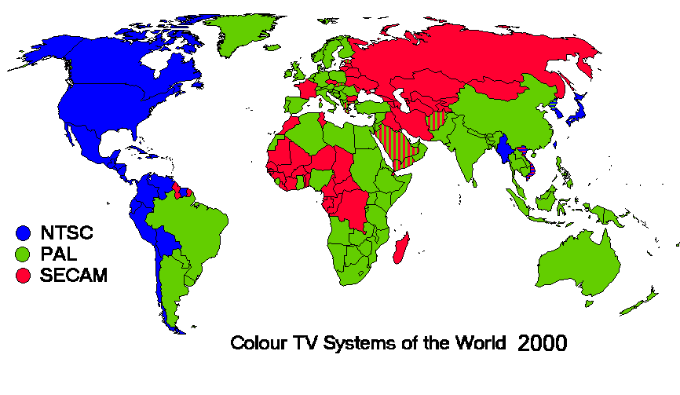

Figure 4: Analog standard usage across the globe (Source: encyclopedia)

Digital television broadcasting

- Digital TV (DTV) broadcasting is the advancement of analogue broadcasting system whereby the television pictures and sound are sent from broadcasting transmitters as digital signals to the Television Set (TV set), see figure 5. The digital signal is made of discreet bits (one and zero) of information.

- Digital television involves the compression of the digital data. The compression of the video and audio in digital television makes it possible to fit more than one television program into the same channel spacing occupied by one single analogue television program and releases spectrum i.e. the digital dividend. This is actually the main driver for the transition.

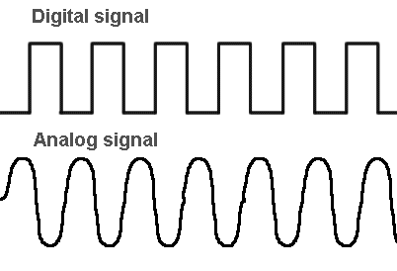
Content
Production

Reception
Transmission
Studio
Transmitter
Digital Signal
Television
Set

Set


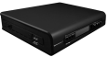

Analog TV
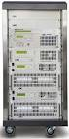
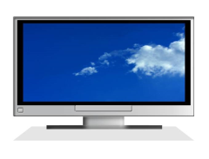
Set-of-Box

IDTV

Figure 5: Terrestrial Digital Television Broadcasting

- Terrestrial digital television broadcasting is also received by an outdoor/indoor antenna. The digital signal that has been received can be directly feed to digital television set with a built-in digital tuner (IDTV). However, in order to view digital signals with analog television set or digital television set that is labeled as ready (not full digital), requires a Set-of-Box (device used to decode and tune digital signals and convert them to a format that is understood by the analogue Television).

3.1 Standards of terrestrial digital television broadcasting

- The fig 6 thereafter shows the digital standards of the world, that are:
- DVB-T : (Digital Video Broadcasting – Terrestrial) is a standard developed by DVB project
- ATSC: (Advanced Television System Committee ) is a standard developed by the USA
- ISDB-T: (Integrated Service Digital Broadcasting – Terrestrial) is a standard developed by Japan: There is also a Brazilian version.
- DTMB: (Digital Terrestrial Multimedia Broadcast) is the TV standard developed by People's Republic of China. Fig 6 shows the standard usage across the world.

- Most of the African countries have adopted DVB-T or DVB-T2 as a transmission standard for the transmission of the digital television.

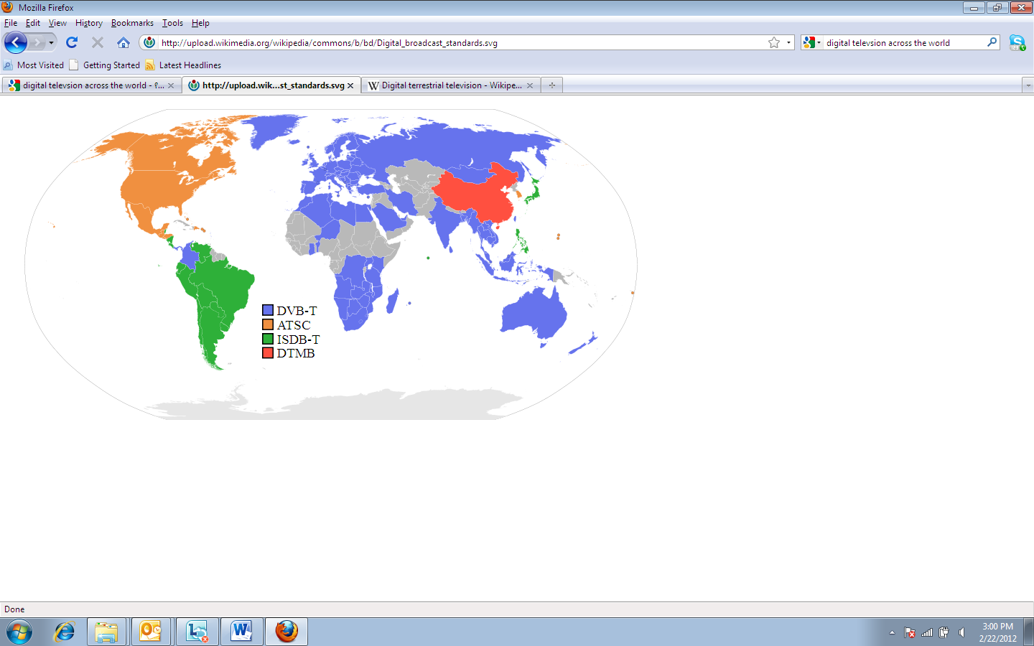
Figure 6: Digital television standard usage across the globe (source: encyclopedia)

3.2 Advantages of Digital Television Broadcasting

- Radio Spectrum efficiency

- The radio spectrum, see figure 7, is the portion of the electromagnetic spectrum that carries radio waves. The spectrum is a scarce resource in that it is both non-exhaustible and non-storable. Unlike oil and water, the spectrum will never run out, although it may become increasingly congested. Also, it cannot be accumulated for later use.

- The boundaries of the radio spectrum are defined by the frequencies of the transmitted signals, and are usually considered to range from 3 kHz (kilohertz; thousand cycles per second) to 3000 GHz (gigahertz; billion cycles per second). It is a resource used by applications like wireless telecommunication, broadcasting, marine, aeronautical, radio astronomy , and it also used by wide range of entities including public bodies such as defense or emergency services. The spectrum is administered internationally by International Telecommunication Union (ITU).

- The radio spectrum itself is subdivided in to a band. A band is a small section of the spectrum of radio communication frequencies, in which channels are usually used or set aside for the same purpose.

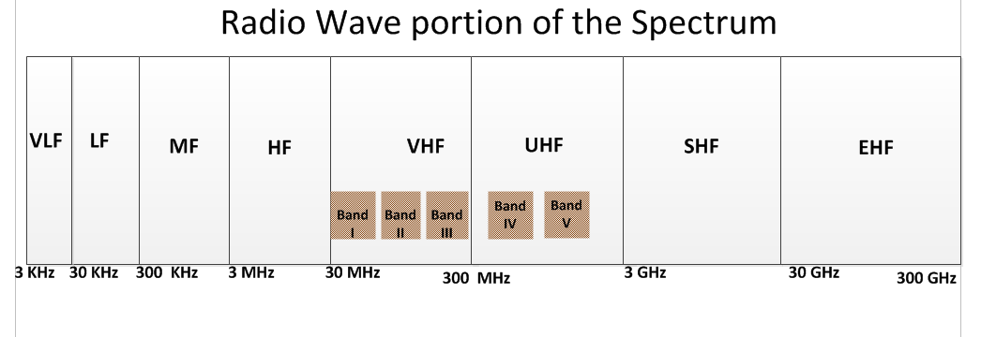
- The band are presented as indicted by fig 7
Figure 7: Radio spectrum band
V: Very, L: Low, M: Medium, H: High, U: Ultra, S: Super E: Extremely, F: Frequency
- In analogue terrestrial television broadcasting only one signal is transmitted on a given frequency channel. However, digital television broadcasting allows the transmission of 6 to 12 or more digital services in a single frequency channel, depending on the technical parameters used and the quality of services desired. These create the opportunity to bundle services and transmit in smaller amount of spectrum than is currently needed for analogue broadcasting.

- Hence, by converting the terrestrial television platform from analogue to digital technology, there will be a spectrum that will be released and the released spectrum is called digital dividend.

- As part of the digital dividend, the ITU WRC-07 allocated the UHF sub band 790-862 MHz for the mobile service and identified the same for IMT from June 17, 2015 in Region 1. The ITU WRC-12 further proposed to extend the digital dividend to 694–862 MHz. The new allocation (694 -790 MHz) is expected to come into force in 2015. The delay to 2015 is in order to enable the necessary technical studies to be concluded.

- In addition to the digital dividend, the White space in UHF band is becoming a focus topic that needs research on how to use it efficiently in African perspective. The white space is unused part of the spectrum that assigned between used radio bands or channels to avoid interference. This unused portion of the spectrum may be sufficiently large both in terms of bandwidth and coverage that can potentially be re-used for other services.

- A number of initiatives from developed countries have emerged proposing that UHF white space could be used for a range of applications. Many consider that white spaces will be suitable for the provision of wireless broadband services, particularly in rural areas, machine-to-machine applications and short-range, high-speed data links.

- Better Picture Quality and More channels

- Analog TV (ATV) was subject to interference, such as ghosting and snow, depending on the distance and geographical location of the TV receiving the signal. In DTV, in contrast to ATV, is that the viewer either sees an image or nothing at all. There is no gradual signal loss as distance from the transmitter increases as of analog transmission. If the viewer is too far from the transmitter or is in an appropriated location, there is nothing to see.

- The pictures of conventional analogue TV broadcasting provide a maximum of 720 (horizontal) x 576 (vertical) pixels (number of small dots used to form a picture on the TV screen). The usual format of conventional analogue TV pictures is square screen (aspect ratio 4:3). But the digital television is capable of transmitting High Definition quality images. Actually, digital TV supports both Standard Digital TV (SDTV) and High Definition TV (HDTV).

- SDTV broadcasting can be considered as the digitized version of the conventional analogue TV broadcasting, both of which have the same picture resolution and screen format. However, SDTV pictures are free from "ghosting" and "snowing", which are commonly found in analogue TV pictures. HDTV broadcasting doubles the resolution of conventional analog TV in both the horizontal and vertical directions. The geometry of the display is always in a 16:9 widescreen aspect ratio, more like a movie screen and closer to the natural field of vision. In addition, because of better compression techniques in the digital television, it will be possible to offer several channels of programming in spectrum that previously was only able to transmit a single analogue channel.

- Potential for creating local content

- The digital transition offers an opportunity to increase the production of local content. This in turn creates job opportunity and increase creativity and entrepreneurship.

- Creates the opportunity for convergence

- Broadcasting and telecommunications are in many countries treated as separate, vertical markets. But the digital technology creates the possibility of service convergence, infrastructure convergence, terminal and service provider convergence.

- It is the best opportunity to develop and strengthen the Information Society

- The digital dividend at the UHF band has a potential to provide mobile internet broadband services to the rural and that will help greatly to fulfill one of the millennium development goals of bridging the digital divide.

3.3 Why transition to the digital television should take before/on June 17, 2015

- Complying with the International commitment

- At the International level, the use of the radio spectrum is regulated within the framework of the International Telecommunication Union (ITU). Due to the scarcity of frequency spectrum, a need arose to free-up some frequencies in order to accommodate additional broadcasting and telecommunications services.

- In 2004, the first session of the Regional Radio communication Conference (RRC) met in Geneva to establish the planning parameters for an all-digital broadcast environment. The second session met in 2006 to develop the digital plan as well as the analogue plan based on revisions GE-89. It successfully concluded with the adoption of the Geneva 2006 (GE-06) agreement.

- The GE-06 agreement regulates frequency usage in the broadcast bands of Africa, Europe and parts of Asia. It establishes two separate plans for an analogue and digital environment in these regions of the world. It is a binding international treaty signed by national administrations of member states.

- The agreement sets 17 June 2015 (2020 has been set for the end of the transition period in some African and Arab countries for analogue services in Band III) as the date after which countries will no longer be required to protect the analogue services of neighboring countries against interference and be able to freely use frequencies assigned for digital services. This date is generally viewed as an internationally mandated analogue switch-off date, at least along national borders

- The end of the transition period does not necessarily signify that analogue switch-off will take place throughout a given country. It does, however, mean that analogue services will no longer be protected or available along the borders, and hence could serve as an impetus to switching off analogue services throughout a given country.

- In addition, in World Radio communication Conference 2007 (WRC-07) Final Acts the upper part of the UHF band (790–862 MHz) is allocated to the mobile service in Region 1 as from 2015, and allowed some countries of this region to use this allocation immediately, under certain conditions. These conditions include protection of the GE06 Agreement and all its future developments. Countries that wish to implement mobile services in the band 790–862 MHz are required to protect broadcasting services against harmful interference.

- To Prevent dumping of obsolete analogue TV equipment

- Many developed countries are already fully switched-over to the digital and switched off their analog services completely. Thus, lagging behind to switch off-analogue television broadcasting will result in investing on and importing obsolete analogue TV transmission and reception equipment.

- To enhance the quality and experience of most TV viewers

- In Africa where by the penetration of satellite and cable television service is very low, the terrestrial platform is the dominate means of broadcasting. Hence, delaying the analogue television switch-off will creates dissatisfaction on the limited low quality analogue television channels.

3.4 The challenges of the digital transition

- Though the digital transition is a reality, making the transition to digital broadcasting is a complex process that requires big investment, new policy, new licensing procedure, frequency plan coordination, rolling out digital transmission network, digital content, and digital studio equipment and consumer education. There is also a consumer side investment to receive the digital signal either purchase Set-top-box or digital television with built-in digital tuner.

- According to a report made by some African countries in the Digital Migration and Spectrum Policy Summit, , limited financial resources, lack of regulatory framework, lack of technical capacity, lack of attractive TV content and high competition from Free to Air satellite TV channels are the main challenges encountered by DTV transition.

Status of African countries towards the transition

- Africa belongs to region 1. Thus, all African countries need to switch-off their analogue services by June 17, 2015 for UHF band and June 20, 2020 for some African countries in VHF band Many developed countries have already fully switched-over to the digital and switched off their analog services completely. In Africa, however, according to a feasibility study done by ITU [2], and a report done by balancing act [3, 4], Nine (9) countries launched the service, six (6) countries are on the pilot phase and seventeen (17) countries started the process and the status of the remaining countries is not known officially or are on a public discussion or didn’t start the process, see Table 1, below.
Table 1. Status of Member States as per AU sub regions
Status of MS | Central Africa | East Africa | North Africa | Southern Africa | Western Africa | Total
Launched the Service | Gabon | Kenya  Mauritius  Rwanda  Uganda  Tanzania | Algeria  Tunisia |  | Nigeria | 9
Pilot phase | Burundi  CAR  DRC |  |  | Angola  South Africa | Guinea | 6
Started the Process | Cameroon  Congo-Brazzaville | Ethiopia  Seychelles  Sudan | Egypt  Mauritania | Botswana  Malawi  Mozambique  Namibia  Zambia | Benin  Ghana  Mali  Senegal  Niger | 17
On discussion/Status not known | Chad  Equatorial Guinea  Sao Tome & Principe | Comoros  Djibouti  Eritrea  Madagascar  Somalia  South Sudan | Libya  Saharawi Arab Democratic Republic | Lesotho  Swaziland  Zimbabwe | Burkina Faso  Cape Verdi  Côte d'Ivoire  Gambia  Guinea BissauLiberia  Sierra Leone  Togo | 22
Total | 9 | 14 | 6 | 10 | 15 | 54

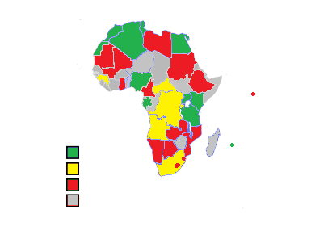
Launched the Service
Pilot phase
Started the process
Status not known/Public Consultation
Figure 8: Status of African Union Member States (MS)

- Note: the information indicated above adapted from ITU, and information collected during different workshops (ATU submit on the spectrum management Workshop on Roadmap for Digital Broadcasting Migration Implementation). The result might not give the current status.

- As it is indicated earlier in the document, a questionnaire will be sent to each Member State to assess the current status of each Member State and lay down strategic approach to meet the deadline and prepare a policy framework on the harmonization of standards and the use of the digital dividend.

Glossary and abbreviations

ASO | Analog-switch-off
ATSC | Advanced Television System Committee
ATU | African Telecommunication Union
AU | African Union
AUC | African Union Commission
DSO | Digital Switch-Over
DTTB | Digital Terrestrial Television Broadcasting
DTMB | Digital Terrestrial Multimedia Broadcast
DVB-T | Digital Video Broadcasting – Terrestrial
DVB-T2 | Digital Video Broadcasting – Terrestrial Version 2
GE06 | Geneva Agreement of 2006
HDTV | High Definition TV
IDTV | Integrated Digital TV set
ISDB-T | Integrated Service Digital Broadcasting – Terrestrial
ITU | International Telecommunication Union
NTSC | National Television Systems Committee
PAL | Phase Alternation Line
RRC | Regional Radio Communication Conference
SDTV | Standard Definition TV
VHF | Very High Frequency
WRC | World Radio Communication Conference

References

- FINAL ACTS of the Regional Radio Communication Conference for planning of the digital terrestrial broadcasting service in parts of Regions 1 and 3, in the frequency bands 174-230 MHz and 470-862 MHz (RRC-06)
- Project on the digital broadcasting transition roadmap in Africa : http://www.itu.int/ITU-D/tech/digital_broadcasting/project- dbafrica/db_afr_phase1.html
- Broadcast and Film Africa 2011 : http://aitec.usp.net/Broadcast 20& Film Africa, 5-6 July 2011, Nairobi/RussellSouthwood_BalencingAct_Broadcast&FilmAfrica_67July2011.pdf
Snapshot of progress of analogue to digital migration in Africa: http://www.fenceware.or.ke/~wwwatuu/images/eventlist/events/files/reportsfolder/ATUPresentation-RSouthwood.pdf, Nov 29 – Dec 01, 2011, Nairobi, Kenya
- 2010 Abuja Declaration , Third Conference of African Ministers In Charge Of Communication and Information Technologies , 03 - 07 August 2010 Abuja, Nigeria
AU/CITMC-3/Min/Decl.(III)

