 | MEDIA EQUIPMENT FORM
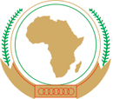 | MEDIA EQUIPMENT FORM | 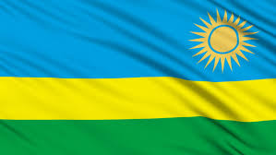

EXTRA-ORDINARY SESSION OF THE SUMMIT
OF THE AFRICAN UNION ON the AfCFTA
17 – 21 March 2018
Kigali, Rwanda

List of equipment for Mr. / Mrs. / Ms. / other (please specify)

__________________________________________________

Name of Media ___________________________________

NO | TYPE OF EQUIPMENT | SERIAL NUMBER | VALUE (USD)

