DOCUMENT FOR INFORMATION

THE SECOND ORDINARY SESSION OF THE
AFRICAN UNION SPECIALIZED TECHNICAL
COMMITTEE ON TRANSPORT,
INTERCONTINENTAL AND INTERREGIONAL
INFRASTRUCTURES, ENERGY AND TOURISM
Cairo, Egypt, 14th – 18th April 2019

THEME: DEVELOPING SMART INFRASTRUCTURE TO BOOST AFRICA’S CONTINENTAL TRANSFORMATION AND INTEGRATION

The Africa-EU Energy Partnership (AEEP)

Technical paper

The Technical Paper of the Africa-EU Energy Partnership (AEEP) at the STC

- Background Information
In-line with the UN’s decade for sustainable energy, reflected in Sustainable Development Goal (SDG) number 7, the Africa-EU Energy Partnership (AEEP) connects the two continents in three manifestations of one mission: to secure reliable and sustainable supply of energy; to enhance access to modern energy services, and to expand renewable energy and energy efficiency in Africa.

In 2017 the AEEP celebrated its ten-year anniversary, marking a decade of fruitful, effective and important cooperation between the two continents on sustainable energy. Over the past decade the energy landscape has developed significantly and continues to evolve in ways directly relevant to the work of the AEEP.

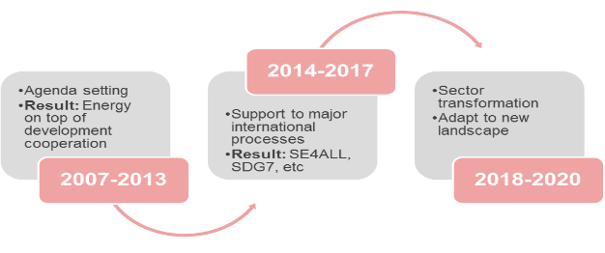  Evolution of the AEEP 2007-2020 | In that time the AEEP has been setting the agenda, providing a platform for high-level political dialogue and representing a shared voice for Africa and Europe, as well as providing key inputs to international initiatives.

Important recent policy frameworks which shape the AEEP’s context include the declaration of the 5th AU-EU Summit, held in Abidjan in November 2017, with resolutions that contribute to the implementation of the African Union’s Agenda 2063. The political declaration of the summit renewed joint commitment to the promotion and implementation of actions of the partnership "Mobilizing Investments for African structural sustainable transformation" which puts sustainable infrastructure at its heart. These have been augmented by recently launched initiatives, such as the Africa-Europe Alliance for Sustainable Investment and Jobs, and its Task Force on energy, the Africa-EU High Level Platform on Sustainable Energy Investments, which continue to make energy a central political priority for sustainable development.

The current Steering Group of the AEEP comprises the African Union (Department of Infrastructure and Energy), the Common Market for Eastern and Southern Africa (COMESA), Egypt (Ministry of Electricity and Renewable Energy) the European Union (European Commission, DG DevCo), Germany (Federal Ministry of Economic Cooperation and Development, BMZ) and Italy (Ministry of Foreign Affairs). The AEEP Steering Group provides political guidance to the Partnership, helping to foster effective and efficient African and European coordination for different initiatives.

The AEEP Secretariat assists the Partnership in its activities, including in the preparation of and participation in processes of the Joint Africa-EU Strategy, monitoring progress towards the AEEP’s 2020 political targets, mapping action on energy in Africa, and supporting information exchange and knowledge transfer.

Future Action Areas
In light of the changed landscape in which the AEEP now operates, the Steering Group has proposed that the future activities of the Partnership lead to more concrete actions. In its next phase the AEEP will therefore focus on three main action areas to ensure that the Partnership contributes coherently and strategically to major international processes and debates. These are:

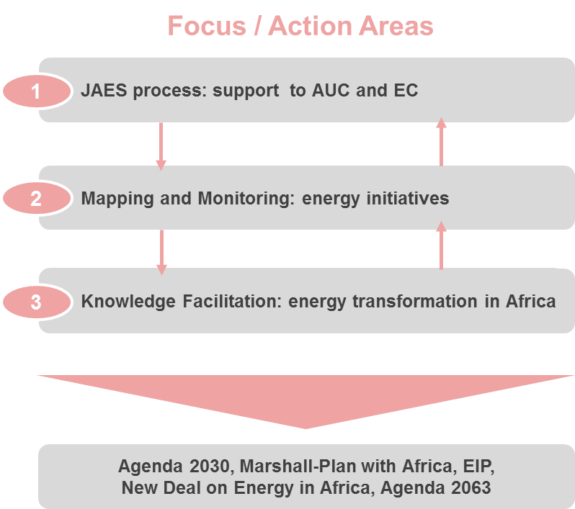 | - Action Area 1: Supporting the Joint Africa-EU Strategy (JAES) Processes and the Africa-Europe Alliance for Sustainable Investment and Jobs.  - Action Area 2: Strengthening coordination efforts through mapping and monitoring of energy initiatives and programmes in Africa.  - Action Area 3: Knowledge facilitation for the energy transition in Africa, in partnership with key pan-African and international institutions

These will contribute to energy transition for Agenda 2063 as well as major international discussions such as the European External Investment Plan, Marshall Plan with Africa and the NDC Partnership.
Furthermore, across its activities, the AEEP shall deal primarily with innovative and politically relevant topics such as: Investment in decentralised renewable energy (DRE) systems, digitisation, job creation and gender, in-line with the priority areas of African and European partners. | 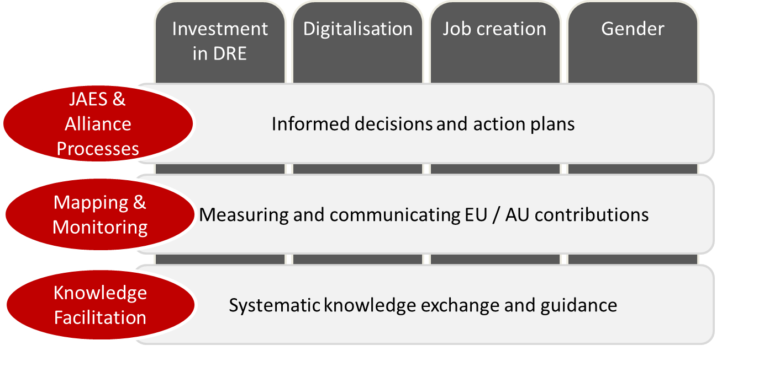

- Status of Implementation
One of the results of the 5th AU-EU Summit was the Abidjan Action Plan 2018-2020 as strategic roadmap and framework of cooperation for that period. Partners confirmed their joint commitment for contributing to the implementation of this framework in a coordinated, coherent and complementary manner within the existing partnerships and mechanisms.
The AEEP is supporting the AUC to plan, coordinate, monitor and evaluate existing and new regional, continental and international energy initiatives that add value to the energy sector in Africa, by contributing to sustainable energy access, energy security and energy efficiency in the African energy sector.
The African and European partners of the Reference Group for Infrastructure met in Addis Ababa 17-18 May 2018 to review the Abidjan Action Plan and came out with joint conclusions that informed the 6th African Union Commission-European Commission College-to-College Meeting that took place in Brussel the following week.
- Enhanced Coordination
In its drive to support coordination and the harmonisation of energy initiatives in Africa, the AEEP has continued to update its mapping of energy initiatives in Africa, and has designed a digital platform that will enable interactive access to information and dynamic updating to ensure current and up to date information always. This online version will be migrated to the AFREC website, helping to make it accessible to a wider group of stakeholders.
In 2018 the AEEP Secretariat supported AFREC in carrying out a study on how it could harmonise its energy data management system with the energy data and information systems of the Regional Centres for Renewable Energy and Energy Efficiency (RCREEEs) and Regional Power Pools (RPPs).

- Planning
To spearhead the response to the Lomé STC ministerial decision which places greater emphasis on infrastructure development in rural and remote areas, the AEEP has supported the AUC in conducting a study on small hydropower and on solar energy policy frameworks. The findings and recommendations have led to the AU programme to develop solar energy and small hydropower as described in a separate technical paper.

- Awareness Raising and Consultative Meetings
The AEEP has continued to support the AUC to create a platform for sharing best practices and experiences in the implementation of energy projects. This has taken the form of consultative workshops and meetings, and of validation meetings for ongoing projects. Such events have mainly engaged the RECs, regional centres, specialised institutions and key stakeholders from the policy and public sectors. They have included, for example, events at COP22, COP23, COP24, a G7 side-event under the Italian Presidency, and outreach workshops as part of international fora (e.g. on energy and job creation at the SEforALL Forum 2018).
At the 5th AU-EU Summit, the AEEP convened a high-level international event as part of the EU-Africa Business Forum to showcase its decade of contribution to energy development across the two continents. A high-level panel discussion among senior public and private sector representatives focused on the current trends and priorities for investing in sustainable energy in Africa, and saw the launch of the AEEP’s 4th Status Report.
Further, the AEEP Secretariat has increasingly engaged with the private sector with a series of dialogue events in Africa which have facilitated business-to-business partnerships and exchange. These include:
- A business forum at the High-Level Conference on Sustainable Energy and Development (as part of the Austrian Presidency of the EU) in Vienna in October 2018;
- A policy-makers’ round table on investment in decentralised renewable energy as part of the Zambia Off-Grid Investors’ Forum in Lusaka in June 2018;
- An exhibition and conference on “RE in Energy in East-Africa: New Frontiers”, implemented by RES4Africa with the support of the AEEP, held in Nairobi, Kenya in January 2018;
- The launch of RES4Africa’s Ethiopian programme, implemented with the support of the AEEP, as part of the conference “Fostering the deployment of renewable energy in Ethiopia: A sustainable roadmap”, held in Addis Ababa, Ethiopia in October 2017;

The Africa-EU Energy Partnership, through the thematic working group on energy efficiency carried out a series of workshops in 2017 leading to the elaboration of the Energy Efficiency Matrix as a tool for fostering collaboration among members and institutions, enhancing political dialogue and stakeholder engagement for expanding networks and outreach on energy efficiency and cooperation between Africa and the EU.

In conclusion, the work of the AEEP Secretariat is highly valued by those participating in its activities and events, as well as by recipients of specific support offered by the AEEP. Its contribution to policy dialogue and coordination are also held in very high regard and actively supports the work of decision- and policy-makers in both continents. Further, the Africa-EU Energy Partnership has actively addressed the changed landscape of energy in Africa – notably the increased focus by a plethora of players on energy and climate in Africa – and updated its activities and approach to ensure its continued relevance and value. This is greatly appreciated by both its Steering Group, whose work is directly supported by this, and by those working with the AEEP.

- Specific Activities in 2019-2021
During the period 2019-2021, the AUC, together with other AEEP Steering Group members and with the support of the AEEP Secretariat will manage the implementation of the following activities:
- Manage and support the Joint Africa-EU Strategy, and the Africa-Europe Alliance for Sustainable Investment and Jobs, including its taskforce on investment in energy;
- Provide technical assistance through secondment(s) to the AUC’s Department of Infrastructure and Energy and/or other key pan African institutions;
- Migrate the AEEP’s online mapping website onto the AFREC server, and periodically update the mapping of energy initiatives and programmes in Africa;
- In close collaboration with partners prepare bi-annual monitoring reports on European and African contributions to achieving SDG7 in Africa, including special statistical information on the AEEP’s focus topics of investments in DRE, digitalisation, gender and job creation;
- Support the development, dissemination and uptake of information and insights relevant for the African energy transition, and raise the profile of the AEEP through a high-impact partnership with key pan African institutions;
- In partnership with the regional centres for renewable energy and energy efficiency develop suitable products (reports, policy papers, toolkits etc.) for the integration of knowledge into policies in the regions, and amongst members of the regional economic communities.

