 | MEDIA EQUIPMENT FORM
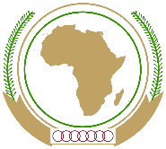 |  | 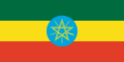

33rd ORDINARY SESSION OF THE SUMMIT
OF THE AFRICAN UNION
21st January – 10th February 2020
Addis Ababa, Ethiopia

List of equipment for Mr. / Mrs. / Ms. / other (please specify)

__________________________________________________

Name of Media: ___________________________________

NO | TYPE OF EQUIPMENT | SERIAL NUMBER | ESTIMATED VALUE (USD)

