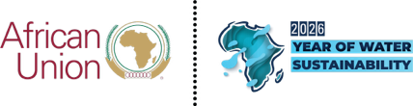 | MEDIA EQUIPMENT FORM

8th Mid-Year Coordination Meeting of the African Union, Regional Economic Communities and Regional Mechanisms

24th – 27th June 2026
El Alamein, the Arab Republic of Egypt

List of equipment for Mr. / Mrs. / Ms. / other (please specify)

Name of Media: ___________________________________

NO | TYPE OF EQUIPMENT | SERIAL NUMBER | ESTIMATED VALUE (USD)

____________________________________ ____________________
Full name and signature Date

