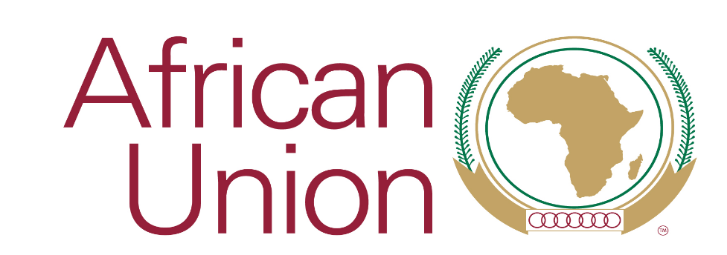

8th AFRICAN UNION ANNUAL HUMANITARIAN SYMPOSIUM

Building the Momentum on Achievements of 2019 AU Theme of Year on “Refugees, Returnees and Internally Displaced Persons: Towards Durable Solutions for Forced Displacement in Africa.”

13 November 2020, 15:00-17:00

CONCEPT NOTE

- INTRODUCTION

At its 29th Assembly in July 2017, the AU’s Executive Council called on the Union to declare 2019 the Year of Refugees, Returnees and IDPs: Towards Durable Solutions to Forced Displacement in Africa, and called on the AU to work with the Office of the Secretary General of the United Nations, UNHCR and others to organize a series of commemorative events ‘that will bring global visibility to forced displacements in Africa’ (Decision 968 (XXXI)). At its 31st summit in July 2018, the AU Assembly took note of Executive Council Decision 968 and declared 2019 as ‘the Year of Refugees, Returnees and Internally Displaced Persons: Towards Durable Solutions to Forced Displacement in Africa’ (Decision 707 (XXXI
The AU theme focused on addressing root causes and finding solutions for forced displacement in the continent. Within this overarching objective it has successfully implemented a range of activities in collaboration with its Member States, Regional Economic Communities (RECs) and partners. The AU also marked the 50th anniversary of the adoption of the 1969 Organization of African Unity Convention Governing the Specific Aspects of Refugee Problems in Africa as well as the 10th anniversary of the adoption of the 2009 AU Convention for the Protection and Assistance of Internally Displaced Persons in Africa in 2019. Thanks to a robust international collective advocacy, five countries namely Ethiopia, Equatorial Guinea, Mozambique, Somalia and South Sudan ratified the Kampala Convention. Many countries in Africa have also made important pledges in relation to the Global Compact on Refugees which aim to strengthen protection and solutions for refugees. The Commission also successfully organized a series of Continental Consultative Meetings (CCMs) which brought together member states, RECs, international partners, academia and research institutions, representatives of displaced persons and AU’s development partners. Some of the topics on which these important consultative meetings were organized include the implementation and supervision of the 1969 OAU Refugee Convention, implementation of the Kampala Convention and international and global solidarity and burden sharing. The AU also organized, in partnership with UNHCR, a dialogue on refugees, returnees and displaced women were organized whose outcome helped mainstream and integrated the rights and interests of women across various AU 2019 theme activities.
Despite these efforts, forced displacement in Africa presents a major challenge to countries peace and security and development. The continent faces staggering 19.2 internally displaced persons (IDPs) and 7.8 million refugees and asylum seekers. This displacement crisis is further compounded by natural disaster, COVId-19 and other health emergencies, locust infestations and army warm and effects of climate challenges.
- THEMATIC PRIORITIES
Among others, the Symposium will deliberate on the following thematic issues:

- Contextualize the operationalization and application of the 1969 OAU Refugee Convention to contemporary challenges such as effects of climate change by establishing stronger linkage with international instruments such as the Global Compact on Refugees,

- Supporting the implementation of the Kampala Convention including through international partnerships in support of the development of law and policy on internal displacement in all countries that have ratified the Kampala Convention. There are ongoing national initiatives in several countries including in Nigeria, South Sudan, Somalia and Mozambique which require coordinated support.

- Inclusion and participation of displaced groups particularly women, children and the youth in key AU process in the area of peace and security, development, human rights and humanitarian response. The outcome of the dialogue on displaced women organized in June 2019 can serve as best practice in showcasing the value of organizing opportunities and platform that create opportunities for displaced persons to engage.

- AU’s institutional reform efforts will contribute to enhancing the role of the AU and its institutions not only in the area of coordinating humanitarian assistance but also in facilitating solutions by strengthening humanitarian-development nexus. The operationalization of African Humanitarian Agency and the establishment of the African Development Agency is an important development.

- Human rights centred approach on protection and solutions for people who are affected by forced displacement play an important role in addressing structural barriers, stigmatization, discrimination and ultimately unblocking obstacles for access to livelihoods and solutions. Supporting the role and contribution of regional human rights mechanisms is therefore very crucial.

- OBJECTIVES AND OUTCOME
The Symposium will facilitate stock taking of achievements and progresses registered in realizing the goals and objectives of the 2019 theme of the year. More specifically, the Symposium will:
- Facilitate experience sharing in addressing challenges faced by Member States in the implementation of the 1969 OAU Refugee Convention and the Kampala Convention through the development of relevant law and policy instrument and enhance the awareness of Member States of available tools and resources that support such national implementation efforts,

- Advocate for a more robust inclusion and involvement of displaced persons in key processes of the AU and RECs and share practical lessons and tools that support inclusion agenda,

- Disseminate information and key findings of the study conducted on mainstreaming the rights and interests of women in AU peace and security architecture,

- Share information about some of the institutional reform initiatives at the AU including efforts to operationalize the African Humanitarian Agency in line with the AU humanitarian policy frameworks,

- Support and enhance the role and contribution of African regional human rights mechanisms particularly the African Commission on Human and Peoples’ Rights and the Special Rapporteur on Refugees, Asylum Seekers, Internally Displaced Persons and Migrants in Africa in implementing AU legal and policy frameworks.

- EXPECTED OUTPUT

Proceedings Report and Outcome Statement that will outline some of the key follow-up action from 2019 AU theme of the year on refugees, returnees and IDPs that the AUC, Member States and partners will work on,

- METHODOLOGY

The 2020 Webinar Humanitarian Symposium will be organized through a combination of methodologies, including facilitated and moderated panel discussions, presentation of researches, policy papers and guidelines.

- DATE
The 8th AU Annual Humanitarian Symposium “ Building the Momentum on the Achievements of 2019 AU Theme of Year on Refugees, Returnees and Internally Displaced Persons: Towards Durable Solutions for Forced Displacement in Africa” will take place on 13 November 2020, 15h00-17h00.

- DOCUMENTATION
The documentation for the Symposium including the report, key statements delivered, and the final outcome document will be shared electronically to all participants. Some of the main documents will be made available at www.au.int. Conversations can be followed on Twitter - @AU_DPA and @_AfricanUnion

- PARTICIPATION
Participants at the 8th African Union Annual Humanitarian Symposium will involve AU Member States AU organs, partners, media, representatives of displaced persons, civil society organizations, research organisations, Health oriented organisations, Regional Economic Communities, the higher education sector/youth organisations.

- WORKING LANGUAGES
The Symposium will be conducted in all African Union working languages i.e. English, Arabic, French and Portuguese, while official working documents will be made available in English and French.

