AFRICAN UNION | 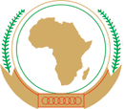 | UNION AFRICAINE
 |  | UNIÃO AFRICANA

Addis Ababa, Ethiopia. P. O. Box 3243 Telephone: 5517 700 Fax: 5511299 Website: www. au.int
DIRECTORATE OF COMMUNICATION AND INFORMATION

Press Release No. 1/CAMT 7th
7th Session of the Conference of African Ministers of Trade
Opening of Senior Officials’ Meeting
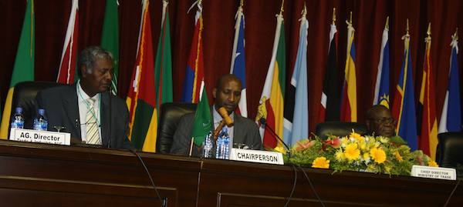
Accra 29 November 2011 – The meeting of Senior Officials representing African Union Member States Started at the Accra International conference Centre (AICC) in Accra, Ghana today within the framework of the Seventh Ordinary Session of the Conference of African Ministers of Trade.

The main items on the agenda of the Senior Officials Meeting for the consideration of the African Union Ministers of Trade Conference are as follows:
- Intra-African trade: Boosting Intra-African Trade/Fast tracking the Continental Free Area
- Review of Multilateral Trade Negotiations
- Report on the 3rd Global Review on Aid for Trade
- Presentation of a Proposal for Improved and Enhanced Trade Preferences System for LDCs and LICs
- Report on the 10th AGOA Forum

In his opening remarks the Acting Director of Trade and Industry of the African Union Commission, Mr. Jean Noël François, recalled the paradox of a resource-rich Africa and yet poor utilization of the same, due to numerous challenges such as trade infrastructure, a low industrial base and failure to maximise benefits from international trade. He further informed the meeting that the African Union Commission, the Regional economic Communities, the United Nations Economic Commission for Africa and other development partners had produced a Draft Policy Paper, Action Plan, Framework, Road Map, Architecture and a Monitoring and Evaluation Mechanism for the proposed Continental Free Trade Area. He called upon the meeting to consider these documents critically and enrich them for the consideration of the Ministers.

The senior officials will deliberate on the documents, to serve as an essential part of the background documentation for consideration by the aforementioned Conference of Ministers of Trade, which will eventually crystallize into appropriate policy recommendations for adoption and decisions by the AU Summit of Heads of State and Government in January 2012 on the theme of “Boosting Intra-African Trade”.

The Chief Director of the Ministry of Trade and Industry of Ghana, Mr. Nii Ansah-Adjaye, in his part said that trade among African countries is very much on the low side and the Continent has not put in place the necessary mechanisms to increase trade among African countries. He further said that Boosting intra-African trade requires a significant amount of investment in infrastructure, the removal of tariff and non-tariff barriers, training of human resource and putting in place mechanisms for the free convertibility of currencies among others.

Participants to the Senior Officials meeting are also drawn from high-level Officials of Regional Economic Communities (RECs) , United Nations Economic Commission for Africa, Multilateral Institutions, Inter-governmental Organizations, Civil Society, Non-Governmental Organizations and other development partners.

The Senior Officials Meeting will end on December 1.

For more information, please visit the African Union Website: www.au.int

