AFRICAN UNION |  | UNION AFRICAINE
 |  | UNIÃO AFRICANA

Addis Ababa, Ethiopia P. O. Box 3243 Tel; 5517 700 Fax: 5511299
Website: www. africa-union.org

DIRECTORATE OF INFORMATION AND COMMUNICATION

PRESS RELEASE N0. 03/ 2011

THE EIGHTH ORDINARY SESSION OF LABOUR AND SOCIAL AFFAIRS COMMISSION OF THE AFRICAN UNION, OPENS TOMOROW IN YAOUNDE

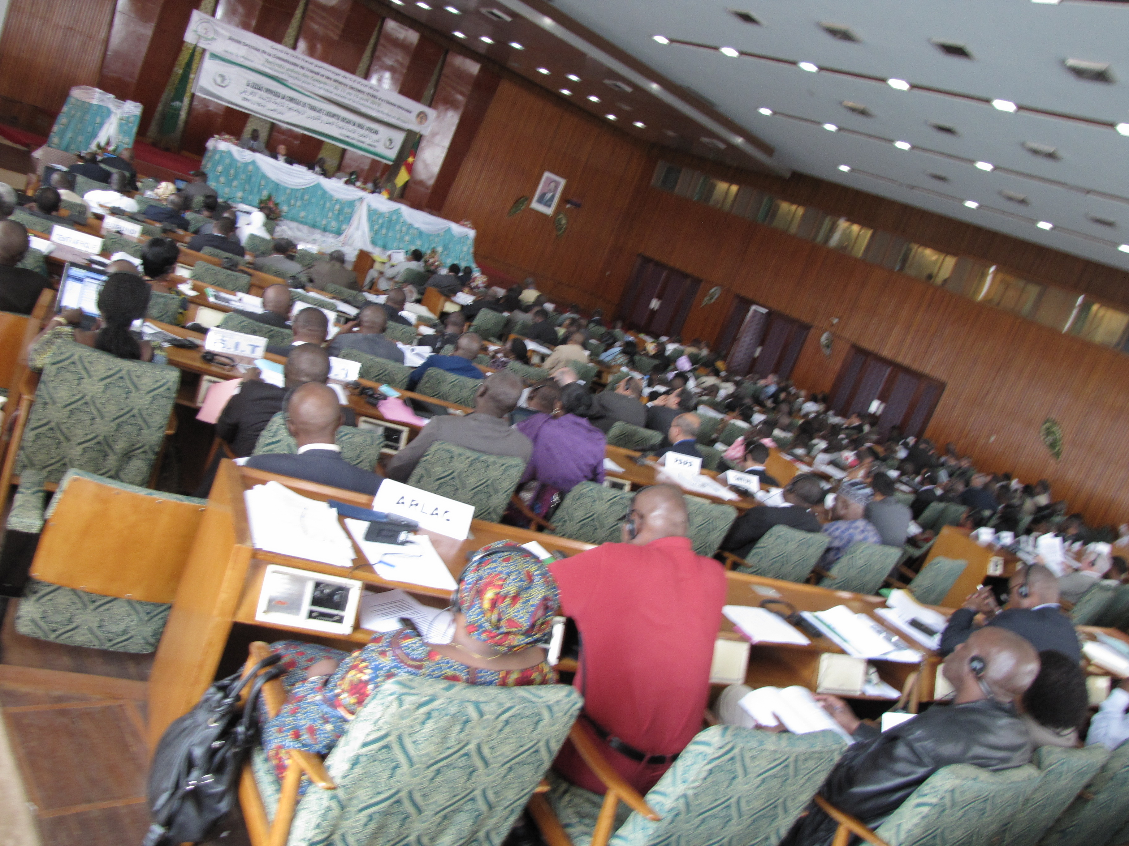
Yaoundé, 13 April 2011 – A tripartite Conference bringing together African Union Ministers of Labour and Social Affairs; representatives of Employers; and Trade Unionists, opens on 14 April 2011 at the Yaoundé Conference Center, Republic of Cameroun.

Holding under the theme: “Promoting Employment for Social Cohesion and Inclusive Growth”, the Eighth Ordinary Session of the Labour and Social Affairs Commission of the African Union (LSAC) was preceded by an Experts meeting from 11-13 April 2011. The ministerial conference will provide a forum for Ministers and Social Partners to share experiences and learn from each other on ongoing programmes and activities on labour and employment in Africa, and on Best practices in Social Dialogue. It will also provide opportunity to review progress made in labour and employment issues, particularly those contained in the 3rd Biennial Follow-up Report on the implementation of the Ouagadougou Declaration and Plan of Action.

Organised by the Department of Social Affairs of the African Union Commission (AUC), in collaboration with the Cameroon Government, the opening ceremony of the Conference is expected to take place in the presence of the President of the Republic of Cameroon, Mr. Paul Biya and the Commissioner for Social Affairs of the AUC, Advocate Bience Gawanas amongst other dignitaries.

The Ministers will exchange views on the Social Protection Plan for the Informal Economy and Rural Workers the employment in Post-Conflict Countries especially amongst the youth, as the Ministers are expected to make concrete proposals on Youth Employment to serve as input into the AU Summit in June 2011 in Malabo.

Participants at the Conference will include: Ministers of Labour/Employment and Experts/Officials from AU Member States, the Social Partners organizations, Representatives of Regional Economic Communities (RECs), Representatives of Non-AU Member States accredited to AU, UN and Other International Agencies, National and Regional NGOs, Regional Employment Organizations, Civil Society and Labour/Employment Professional Organizations, and AU Organs.

The Eighth Session of the AU LSAC will end on 15 April 2011.

For more information, visit the AU website: www.africa-union.org

JOURNALISTS ARE INVITED TO COVER THE EVENT

Interview requests should be directed to Mrs. Esther Azaa Tankou, Directorate of Information and Communication (DIC), African Union Commission, Tel. +237 94820964, E-mail: esthertankou@yahoo.com / yamboue@africa-union.org

