AFRICAN UNION |  | UNION AFRICAINE
 |  | UNIÃO AFRICANA

Addis Ababa, Ethiopia P. O. Box 3243 Tel; 5517 700 Fax: 5511299
Website: www. africa-union.org

DIRECTORATE OF INFORMATION AND COMMUNICATION

PRESS RELEASE N0. 04/ 2011

COMMISSIONER GAWANAS UNDERSCORES NEED TO ADDRESS YOUTH AND WOMEN EMPLOYMENT AT EIGHTH ORDINARY SESSION OF LABOUR AND SOCIAL AFFAIRS COMMISSION OF THE AFRICAN UNION.

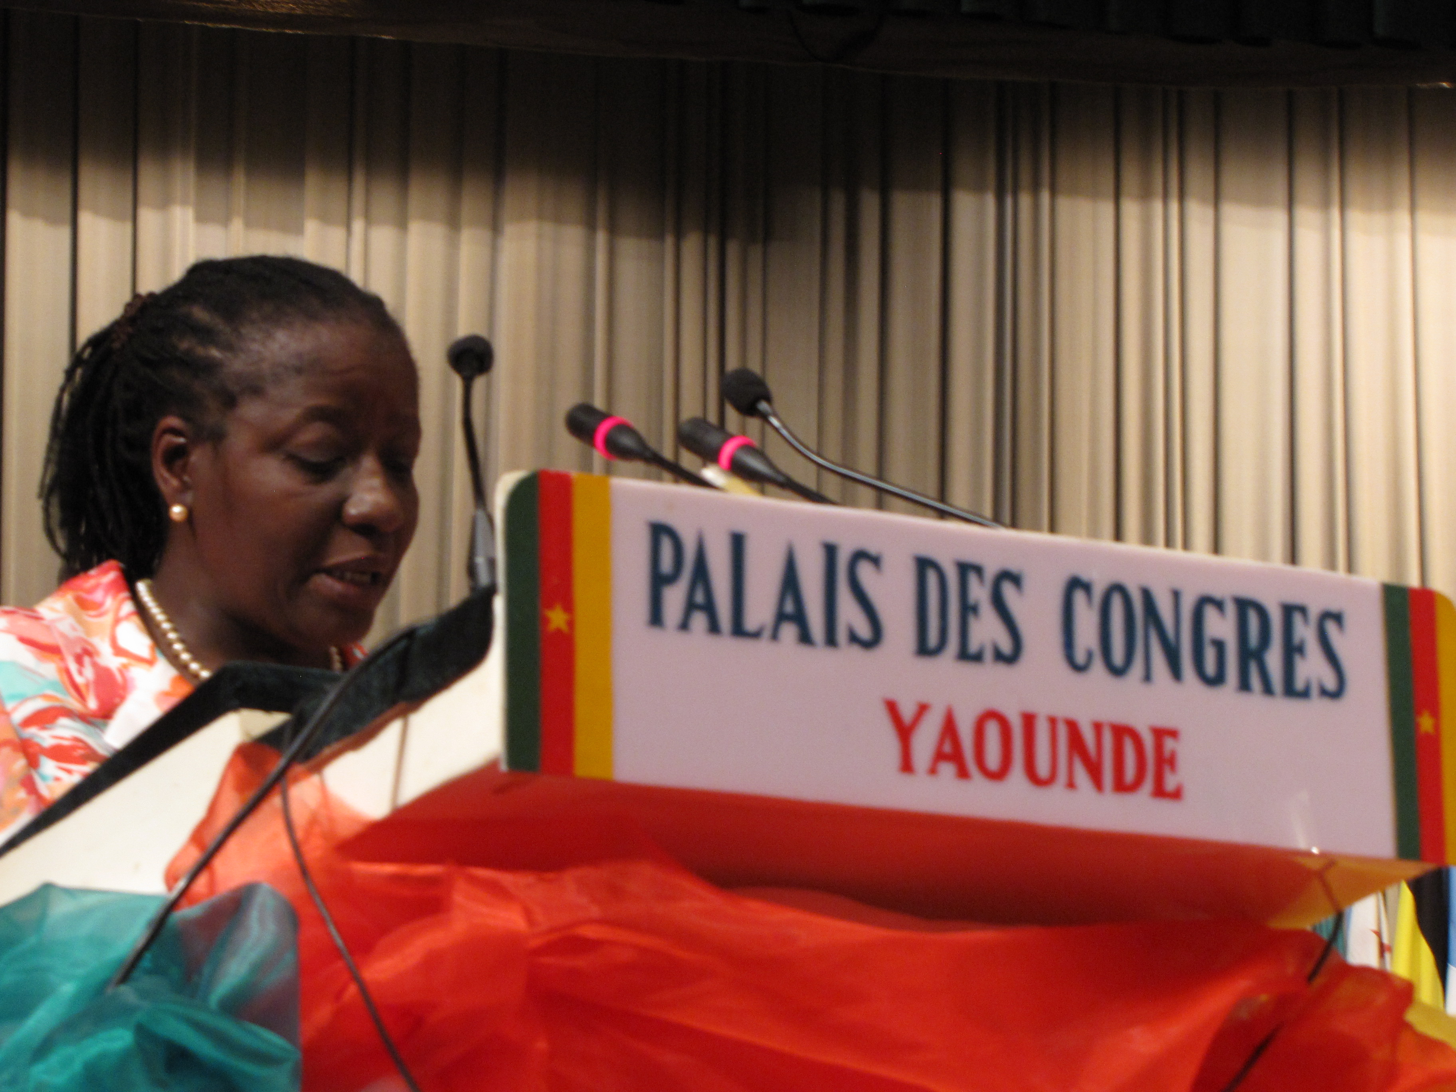
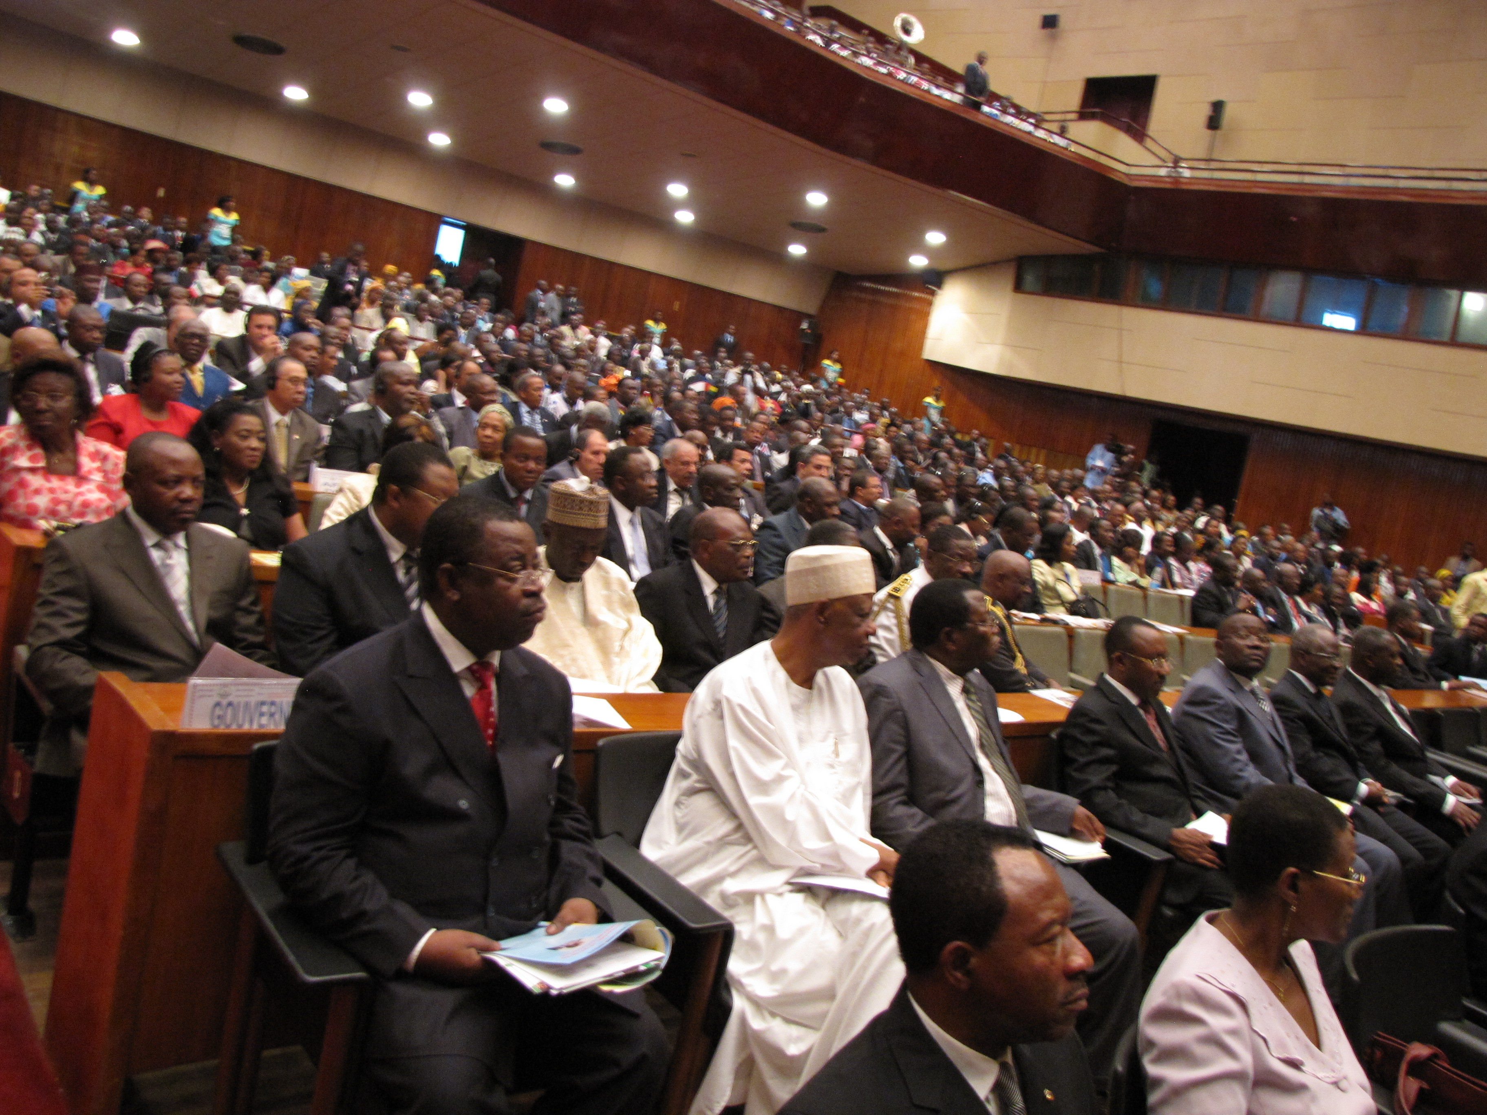
Yaoundé, 14 April 2011 – Advocate Bience Gawanas, Commissioner for Social Affairs of the African Union, today Thursday 14 April 2011, addressed the Eighth Ordinary Session of the Labour and Social Affairs Commission of the African Union (LSAC) holding in Yaoundé, Republic of Cameroon, under the theme: “Promoting Employment for Social Cohesion and Inclusive Growth”.
The opening ceremony took place in the presence of the Prime Minister of the Republic of Cameroon, Mr. Philémon Yang, who was representing the President of Cameroon, Mr. Paul Biya.
Also present at the ceremony was the Minister of Labour and Social Security, Mr. Robert Kili, some Members of the Cameroon Government, Diplomatic Corps, NGOs and the civil society.

Speaking during the ceremony, Commissioner Gawanas stressed that the key issues of youth employment, social protection for the informal economy and rural workers, resource mobilisation for the implementation of the Ouagadougou Plan of Action and coordination of the Labour Market Information System that will be discussed at this Ministerial Conference, are of paramount importance and relevance to the African Union. “The 8th session of LASC is therefore, taking place at a time of political volcano on our Continent that erupted due to chronic unemployment among the youth and women and inadequate social protection in the informal economy” she said, adding that forms of vulnerable employment have spread across the continent, affecting the youth, women, the informal economy and the rural working poor more severely.

To that effect, the Commissioner underscored the need to address youth and women unemployment, particularly the disconnect between our educational system and the demands of the labor market, as well as the plight of the workers in the informal economy. “If we are true to our human rights, and democratic principles”, she emphasized.

Speaking earlier, Prime Minister Yang stressed on the importance of the theme of the Conference, saying that, employment is at the centre of economic growth. He expressed appreciation to the African Union Commission for accepting Cameroon’s offer to host the Eighth Ordinary Session of the LSAC.
According to the Prime Minister, African youth are an invaluable asset and key to sustaining the continent’s gains in development. He recalled the efforts of the Government of Cameroon that has embarked on the recruitment of 25.000 youth into the public service in a bid to mitigate the problem of unemployment in the country.

The president of the panafrican Labour Organisation, Mr. Hassan Sunmonu, on his part called on the governments of the AU Member States to provide more social security and social protection to their citizens. He expressed the wish that the next General Manager of the International Labour Organisation (ILO) should come from the African continent.

The Eighth Session of the AU LSAC ends tomorrow Friday 15 April 2011.

For more information, visit the AU website: www.africa-union.org

JOURNALISTS ARE INVITED TO COVER THE EVENT

Interview requests should be directed to Mrs. Esther Azaa Tankou, Directorate of Information and Communication (DIC), African Union Commission, Tel. +237 94820964, E-mail: esthertankou@yahoo.com / yamboue@africa-union.org

