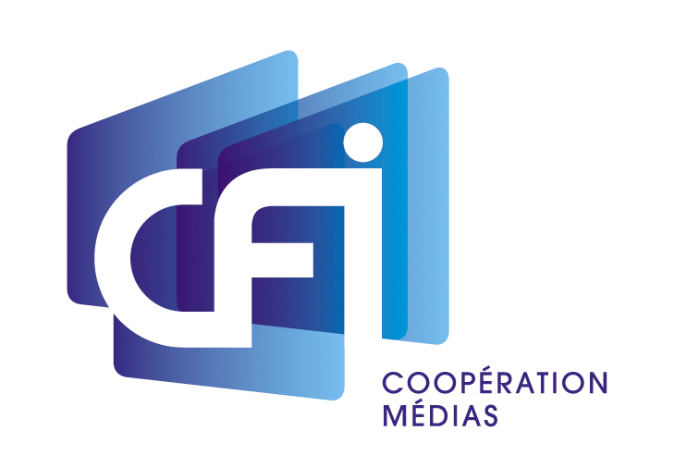
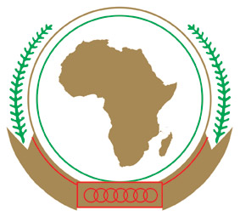

Joint Press Release

AUC DIRECTORATE OF INFORMATION AND COMMUNION AND CANAL FRANCE INTERNATIONAL HOST SEMINAR ON PRODUCTION AND DISSEMINATION OF NEWS

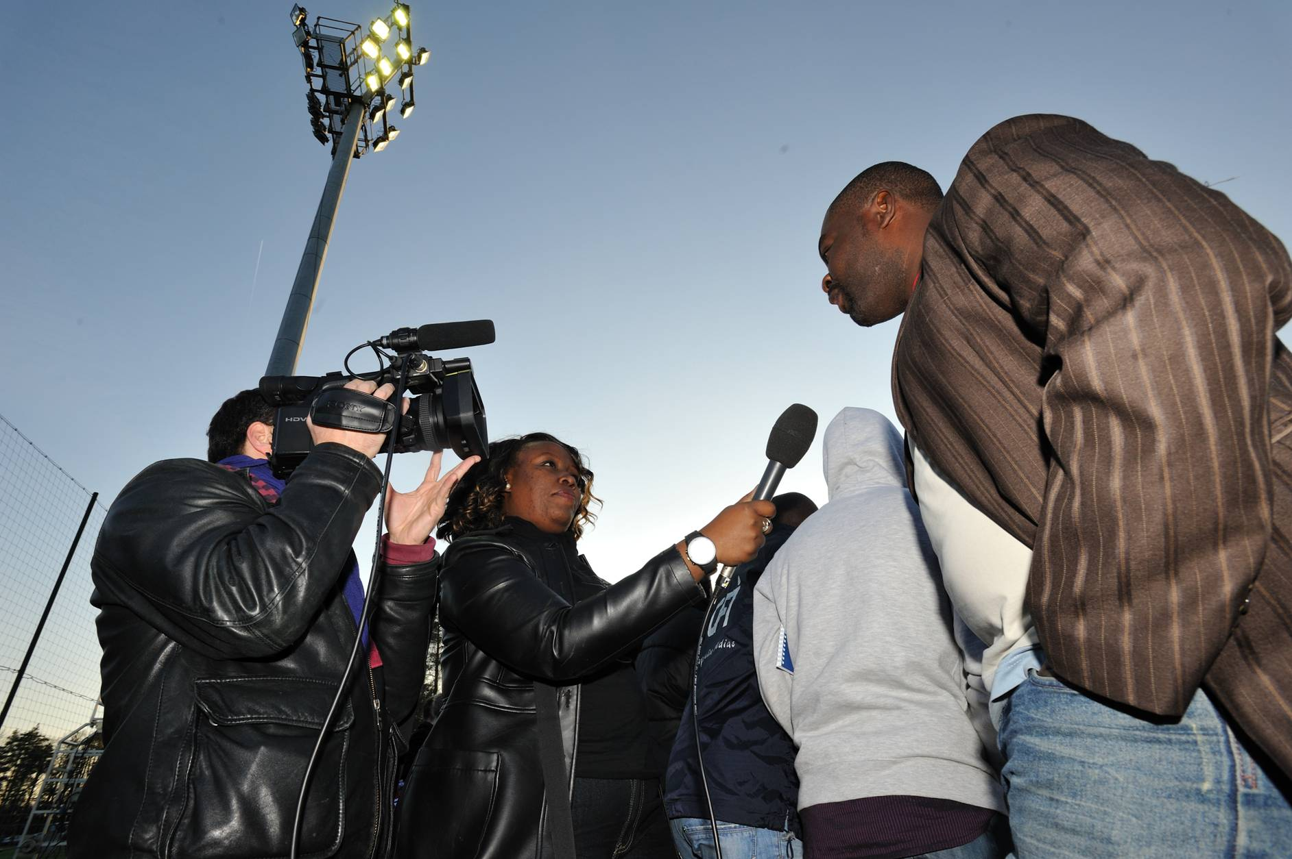
On January 27 and 28 in Addis Ababa, Canal France International (CFI) in partnership with the Information and Communication Directorate of the African Union Commission, will organize, on the margins of the 18th Summit of African Union Heads of States and Governments, a high level seminar targeting African Francophone and Anglophone public broadcast network top officials.

The workshop will be officially opened by AU Commission Chairperson Dr Jean Ping.

Thirty high level broadcasters will participate in this event. They are Director Generals, Directors, Controllers, Editors-in Chief, journalists and information agency directors, along with several experts selected by CFI. Among them will be the Assistant News Director at Ethiopian Television; Sidebie Yamouss, Director General at Group Evasion CIS, Guinea; Rias Muasses, editor in chief at Euronews; and Gilles Trenel, editor in chief at France Télévisions. AUC Director of Information and Communication Habiba Mejri Cheikh will deliver the welcome remarks.

The theme of the meeting will be the production and dissemination of news programmes in Africa. The following topics will be discussed:

The place occupied by news on today’s television
Focus on the work of African news agencies
The impact of new technologies on the production and dissemination of news
Disseminating news on and about Africa

Relations between the media and national and regional institutions

4 of the regions of Africa i.e. Southern, East, West and North will be represented during this seminar, which will be a platform to exchange and have discussions on the challenges and opportunities encountered daily by these stakeholders. In Africa, many of the stations are public broadcasters, but they are now facing growing competition from private networks, which are often more liberal in their opinions, as well as from websites and other new media. Modernization of television news is an important issue in terms of increase of diversity, improvement of information and education of the population.

The African Union Commission has been on a sustained programme to work with media and other stakeholders to build capacity and disseminate information more effectively. For example, the Commission has established a media center with facilities for writing and distributing information, it has an officer dedicated to receiving requests for interviews with the AU leadership and facilitating them; it participates in communication and media forums and addresses them on the work of the AU; it conducts training workshops with media on various topics; and it is establishing a Pan African Media Network and a Pan African Media Portal to increase networking, information flow and knowledge about media issues.

On the CFI side, support to production of information in Africa and its circulation throughout the continent is one of the organisation’s main intervention domains. In 2011, several training workshops were organized: regular journalist trainings, coaching in editing and help to improve television news. CFI also provides its 80 TV channel partners on the continent with a daily information and monitoring service. This service allows African news channels to enjoy daily features about the other countries on the continent.

To reflect on the main theme of the AU Summit: « Boosting Intra-African Trade », the participants will contemplate the possibility of intensifying the exchange of features and of South-South information exchange in general.

