AFRICAN UNION | 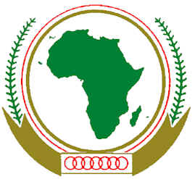 | UNION AFRICAINE
 |  | UNIÃO AFRICANA

THE COMMEMORATION OF THE 17TH ANNIVERSARY
OF THE RWANDA GENOCIDE
7TH APRIL 2011
AU PLENARY HALL

PROGRAMME OF THE EVENT

1100 Arrival of Staff and Guests

1120 Arrival of the Chairperson, Deputy Chairperson, Commissioners, Directors and Ambassadors

1125 Lighting of Candles/Song

1130 Prayers by Representatives of Catholic Community
Prayers by Representatives of Orthodox Community
Prayers by Representatives of Muslim Community
Prayers by Representatives of Protestant Community

1140 Address by the Chairperson of the AU Commission

1150 Musical Break

1155 Statement by the Minister of Foreign Affairs of the Federal Democratic Republic of Ethiopia

1205 Musical Break

1210 Statement by the Ambassador of the Republic of Rwanda

1220 Film Projection

1225 Observe one-minute of silence

1216 End of the Programme

