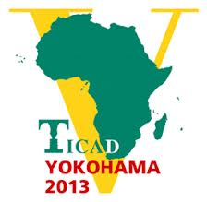
JOINT SECRETARIAT OF THE PREPARATORY COMMITTEE
(JAPAN-ETHIOPIA-AUC)
Media Equipment Form
for the TICAD V Ministerial Preparatory Meeting (16-17 March,2013)

List of Equipment for Mr./Mrs./Ms. other (Please specify)

Name of News Agency

No. | TYPE OF EQUIPMENT | SERIAL NUMBER | VALUE(USD)

