AFRICAN UNION  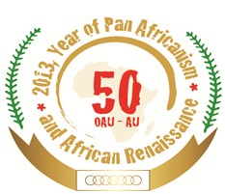 |  | UNION AFRICAINE
 |  | UNIÃO AFRICANA

AU-WESTERN Africa - Regional Internet Exchange and Regional Internet Carrier Workshop
16th - 20th June 2014 Abuja, Nigeria

SPONSORSHIP APPLICATION FORM

Please complete ALL fields in block letters

LAST (family) name
FIRST name
Prefix (Mr, Ms, etc)
Position/Title
Country
Organization
Department
Street address
Postal code
City
E-mail
Fixed telephone
Mobile
Fax
Passport details:
Nationality
Date of birth
Passport number
Valid from
Valid until

Please provide a brief description of your current functions:

Please describe your expectation from the Northern Africa Regional Internet Exchange and Regional Internet Carrier Workshop

I certify that the above information is correct.

Signature of applicant: | Date:

********************************************************
AUTHORISATION FROM NOMINEE’S ORGANIZATION
I certify representation of the Organization by the above nominee to the Western Africa Regional Internet Exchange and Regional Internet Carrier from 16-20 June 2014.

Name and title of Supervisor: | Signature:
Organization: | City and Date:

Official stamp:
Applicants must send this completed form, to the e-mail address –
BayinganaM@africa-union.org and JemalH@africa-union.org ,
no later than 06th June , 2014.

