AFRICAN UNION |  | UNION AFRICAINE
 |  | UNIÃO AFRICANA
Addis Ababa, ETHIOPIA P. O. Box 3243 Telephone: 251 11 5517 700 Fax: 251 11 5517844

Website: www.africa-union.org
DEPARTMENT OF HUMAN RESOURCES, SCIENCE AND TECHNOLOGY
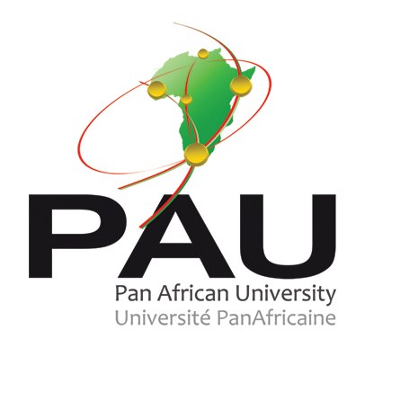

ESTABLISHMENT OF THE
PAN AFRICAN UNIVERSITY

THE PROJECT DOCUMENT

- JUSTIFICATION
The vision of the African Union is “an integrated, prosperous and peaceful Africa, an Africa driven and managed by its own citizens and representing a dynamic force in the international area”.

Education is the most important tool for equipping African peoples with the necessary knowledge, skills and attitude to be able to drive this vision. Quality Higher education in particular is imperative if Africa has to attain this vision, generate home-grown solutions to African challenges according to the NEPAD philosophy; and participate fully in the global knowledge economy.

Unfortunately, during the decades of the 80’s and 90’s, support for education in Africa was focused at primary and secondary levels, thus negating some of the gains that had been made in the late 60’s and 70’s in African higher education. Consequently, investments in the higher education sector have not been commensurate with the increasing enrollment, leading to many challenges especially in quality.

The quality of many African higher education institutions has been further adversely affected in recent years by harsh economic, social, political and even conflict situations on the continent. According to a UNESCO report ⁽¹⁾, African publications referenced in the Science Citation Index stagnated at 1.4 percent between 1981 and 2000 while research and development expenditures experienced a nose -dive from 1.3 to 0.8 percent.

In the meantime, higher education has also been hard hit by the endemic phenomenon of brain drain, which deprives the continent of some of its finest intellectual capital. Indeed, as a result of low salary scales and poor working conditions, many lecturers leave their universities for under qualified positions abroad and almost half of young persons who complete doctoral studies outside Africa do not return. Worse still, at the national level, the alarming rate at which lecturers leave universities for lucrative administrative positions in the central administration is glaring.

As pointed out in the African Union Strategic Vision document, universities and other educational and research institutions do not frequently exchange students or academic staff within the continent. Moreover, collaborative projects are often driven by external donors, and usually focused on problems which are of limited relevance to the continent. The last decade has seen a net increase in the mobility of lecturers between African universities, but this has been restricted to linguistic or geographic sub regions.

Fortunately, with the launching of NEPAD and the creation of the African Union, there is currently an “awareness by Africans that the Continent has arrived at a cross roads, and that it is absolutely necessary to change its future and infuse renewed hopes in the daughters and sons of Africa”. Africa’s children envision a continent whose people live without fear, and live sheltered from needs. In this regard, the African Union has set some strategic objectives whose realization strongly depends on the development of higher education.

After all, higher education is a fundamental tool for building consensus around a shared vision and agenda in the continent, promoting the emergence of an African society based on the principles of law, good governance and human security, addressing the structural causes of poverty and under-development, and enhancing the dynamism of African culture and creativity.

This is the reason why the Summit of Heads of State and Government of the African Union launched the Second Decade of Education for Africa EX/CL/224 (VIII) Rev.2 which identifies tertiary level education as one of the seven priorities to be focused on for the time period 2006-2015. Note that the worldwide programmes and projects such as the Millennium Development Goals (MDGs) and Education for All (EFA) only emphasized on basic education, on Universal primary education.

In the Addis-Ababa Declaration 2007, Assembly/AU/Decl.5(VIII), the Conference of Heads of State and Government made themselves more explicit by calling for ‘’the revitalization of African Universities’’ in their decision adopting the Consolidated Plan of Action for Science and Technology in Africa (2008-2013).
Higher education and research in Africa therefore need to be resuscitated, rehabilitated and strengthened. But the renewal process must be purpose-driven and anchored in the collective vision of the African Union, including the Plan of Action for the Second Decade of Education for Africa.

One way to meet those preoccupations of the Assembly is to develop a continent-wide network of high standard universities and research institutions: this approach is clearly corroborated by the Plan of Action for the Second Decade of Education for Africa and the Consolidated Plan of Action for Science and Technology in Africa (CPA), that call for enhanced collaboration amongst higher institutions of learning and research in order to create a global pool of knowledge and innovation; and better links with industry in order to enhance relevance and contribute to addressing local challenges.

It is for these reasons that the African Union Commission proposed in 2008 the creation of the Pan African University (PAU). The PAU involves the promotion, networking and development of programs and research centers within selected existing high quality universities in the five geographic sub-regions, namely Northern, Western, Eastern, Central Northern and Southern Africa. Each sub-region will host a thematic component of the PAU which will be committed to select and to network high quality centers developing similar programs and to serve as a coordinating hub for those institutions.

- VISION

The strategic vision of the Pan African University is to develop institutions of excellence in science, technology, innovation, social sciences and governance, which would constitute the bedrock for an African pool of higher education and research. This would usher in a new generation of leaders properly trained to take the best advantage of African human and material resources, imbued with a common vision of a peaceful, prosperous and integrated Africa.

- MISSION AND SCOPE

To realise the strategic vision, six missions have been defined for the Pan-African University:

- Develop continental-wide and world-class graduate and post-graduate programmes in science, technology, innovation, human and social sciences;

- Stimulate collaborative, internationally competitive, cutting-edge fundamental and development oriented research, in areas having a direct bearing on the technical, economic and social development of Africa;

- Enhance the mobility of students, lecturers, researchers and administrative staff between African universities to improve on teaching, leadership, and collaborative research;

- Contribute to the capacity building of present and future African Union stakeholders;

- Enhance the attractiveness of African higher education and research institutions for effective development and retention of young African talent, while attracting the best intellectual capital from across the globe, including the African Diaspora;

- Invigorate dynamic and productive partnership with public and private sectors

- PRINCIPLES

The Pan African University is based on the following guiding principles:

- excellence and international partnerships in academic and research activities;

- academic freedom, autonomy, quality assurance and accountability;

- strengthening capacity of existing African institutions;

- encouraging intra-African mobility of students, academic and research staff;

- Offering the African Diaspora an innovative continental framework to contribute towards the development of higher education and research in Africa;

- promoting inter-disciplinary and multidisciplinary research programmes integrated into development policy at continental and national levels;

- Enhancing and optimizing use of Information and Communication Technologies for pedagogy, research and management;

- Promoting innovation through technology incubation and patenting to ensure value addition.

- PAN AFRICAN UNIVERSITY STRUCTURE

The Fourth Ordinary Session of the Conference of Ministers of Education of the African Union (COMEDAF IV) held in Mombasa in November 2009, endorsed the PAU as an academic network of already existing post-graduate and research institutions.

The structure of the PAU includes one Rectorate as overall coordinating office; five Institutes, one in each geographic region, as coordinating hubs for each thematic area; up to ten Centres from around Africa in each thematic area, networked to the relevant thematic Institute or hub.

  - Thematic areas

The following five areas constitute the thematic areas of PAU:
- Space sciences
- Water and Energy Sciences (including climate change)
- Basic Sciences, Technology and Innovation
- Life and Earth Sciences (including health and agriculture)
- Governance, Humanities and Social Sciences;

  - Selection of Institutes and Centers

As one hallmark of the Pan African University is excellence, selection of an Institute or Center is based on terms of reference taking into account the quality of curricula, teaching and research as well as related staffing, facilities and infrastructure. Furthermore, since the PAU has to be embedded in African ownership, another major criterion is commitment of the host country to mobilize up to one third of the cost of establishment and implementation.

The selection criteria therefore include the following:
- excellence in teaching and research;
- adequate, high caliber and available academic staff;
- quality infrastructure and scientific equipment;
- relevance of curriculum to the thematic areas;
- facilities for supporting foreign students, academic and administrative staff;
- Quality and quantity of scientific publications and patents
- experience in international partnerships, and joint research projects;
- Willingness of host country to support the PAU as a continental programme

  - Location of PAU Institutes and Centers:

The Summit of Heads of State and Government of the African Union in July 2010 took the decision to allocate the themes to the five geographic regions as follows:

- Basic Sciences, Technology and Innovation to the eastern African Region, to be hosted by Kenya. The Jomo Kenyatta University of Agriculture and Technology was subsequently selected competitively as the host Institute
- Life and Earth Sciences to the Western Africa Regions, to be hosted by Nigeria. The University of Ibadan was selected as the host Institute
- Governance, Humanities and Social Sciences to the Central African Region, hosted by Cameroon. The host institute selected is University of Yaounde I
- Water and Energy Sciences to the North African Region. The host country will be Algeria. The host institute will be determined in 2011
- Space Sciences to the southern African Region. The host country and Institute will be identified in 2011

- MANAGEMENT

The PAU shall be managed by the following three organs:

- The PAU Council: This council shall be the governing body responsible for PAU and its functions. The members of the Council shall include representatives of major stakeholders, among them academics, community leaders, and representatives of the Regional Economic Communities and of the private and industrial sectors. The Association of African Universities and the African Academy of Sciences will also play a major role. The Council shall be responsible for ensuring adherence to the vision of the African Union, and to the imperatives of excellence, quality and relevance of PAU's policy and practice

- The Rectorate: The Rectorate shall be the executive body of PAU and shall be responsible for the overall planning, monitoring and coordination of the Institutes and Centers. The Rectorate shall be headed by a Rector/ Vice Chancellor who shall exercise a supervisory role over internal and external university communication and co-operation, and shall report to the Conference of Ministers of Education of the African Union through the Commission of the African Union.
- The Senate: The Senate shall have primary responsibility for all academic affairs of PAU. The composition of the Senate shall include, among others representatives of Vice Chancellors and Directors of Institutes and Centres; and representatives of Privileged Partners and students. The Senate shall be convened and chaired by the PAU Rector/Vice Chancellor

- Organigram of PAU

The structure of Pan African University is illustrated in the following organization chart:

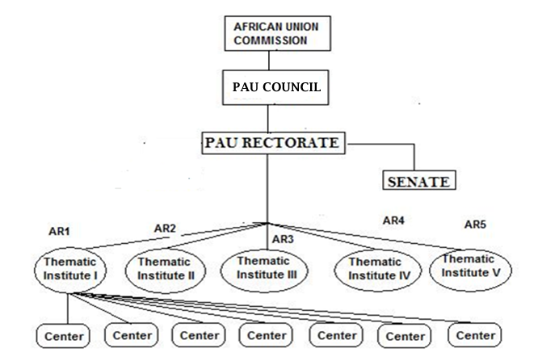

AR: African Region

- FUNDING

Mobilization of resources for the PAU shall comply with the following principles:
- Sufficiency and sustainability of financing;
- Reliability of availability of funds as and when due;
- Ensuring attractive remuneration for staff;
- Ensuring sustained quality of infrastructure and facilities;
- Accommodating support for academic mobility;
- Adherence to sound financial management policy;
- Possibility of internal generation of resources

PAU resourcing, including finances will be drawn from the following:

- Assessed contributions from AUC;
- Assessed contributions from the host Countries of Institutes and Centers;
- Assessed contributions from Lead Thematic Partners and other partners
- Voluntary contributions from Member States and development partners;
- Internally generated funds including research activities and tuition fees
- Voluntary contributions from industry and the private sector.

An Endowment Fund shall be established to streamline resource mobilization and to ensure sustainability.

- STAFFING

The personnel of the PAU shall comprise the following categories:

- Permanent academic and administrative staff from host countries
- Permanent academic staff from Member States
- Temporary academic and administrative staff from host countries,
- Temporary and visiting academic staff from Member States, African Diaspora and Partners

- PARTNERSHIP

Participation of Diaspora will be sought at every level.
Each Thematic network of PAU Institute and Centers shall have a team of dedicated partners, to be coordinated by a Lead Thematic Partner, committed to nurturing and providing substantial technical support and mobilizing resources for the particular thematic network. The Lead Thematic Partners may be invited to participate in the activities of the PAU Project Management. In particular, they will participate to provide technical support in the development and implementation of technical and academic programmes.

- CONCLUDING REMARKS

The PAU is a priority Education project of the Commission of the African Union, and since 2008, endorsed at the highest political levels in recommendations of the Conference of Ministers of Education of the African Union (COMEDAF) and decisions of the Summit of Heads of State and Government of the African Union. Development of the project concept was through engagement with a wide range of stakeholders, from representatives of African academic Institutions and governments; international partners; the Africa Roundtable of the World Conference on Higher Education (WCHE), among others.

A High Level Panel (HLP) composed of leading African intellectuals was appointed by the Chairperson of the AUC to support the implementation of the PAU.

There will be ongoing engagement with stakeholders for publicity and building ownership, and to address risks and potential challenges in order to ensure sustainability. A communication strategy has been developed, and resource mobilization underway, to ensure strong support from stakeholders and partners.

The Pan African University project is set within the context of a number of parallel continental programmes managed by the Commission of the African Union. This include the process of harmonization of African higher education; implementation of the African quality rating mechanism; and the Mwalimu Nyerere Scholarship scheme. These initiatives will directly benefit the PAU and contribute to its long term success.

