AFRICAN UNION |  | UNION AFRICAINE
 |  | UNIÃO AFRICANA
DIRECTORATE OF INFORMATION AND COMMUNICATION

DRAFT AGENDA
THEME: PREPARATION FOR LAUNCHING THE PAN AFRICAN UNIVERSITY

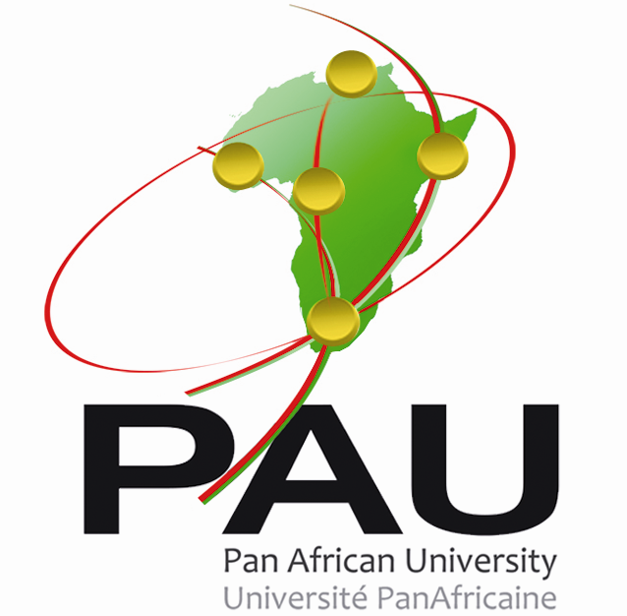

DAY 1: 11TH MAY

- 0830 hrs to 1400 hrs: COMEDAF IV BUREAU STEERING COMMITTEE MEETING (meeting of Senior Officials)
- Opening session
  - Welcome remarks – Director HRST
  - Opening remarks- Representative of Raporteur of COMEDAF IV
  - Opening remarks- Representative of Chair of COMEDAF IV
- Presentation and adoption of Agenda- Raporteur
- Presentation of report of last COMEDAF Bureau meeting
- Pan African University (PAU) Project
4.1 Presentation of progress report of the PAU Project
  - Consideration of PAU Policy Documents
  - Statutes
  - Act
  - Research Policy
  - Curriculum
  - Host Agreements
  - Establishment of an African Accreditation Agency
- Arusha Convention: Consideration of recommendations on Revised African Regional Convention for Mutual Recognition of Degrees and Qualifications
- Adoption of Agenda for COMEDAF IV Bureau (Meeting of Ministers)
- Adoption of Steering Committee Report

- 1600 hrs to 1830 hrs: COMEDAF IV BUREAU MEETING (meeting of Ministers)
- Opening Session
  - Welcome remarks- Commissioner HRST
  - Opening remarks- COMEDAF IV Raporteur
  - Opening Remarks- COMEDAF IV Chair
- Consideration of report of COMEDAF IV Steering Committee
- Consideration and adoption of Agenda for the First Extra-Ordinary Session of COMEDAF IV
- Consideration and adoption of Recommendations of COMEDAF IV Bureau meeting
- Closing remarks- COMEDAF IV Chair
DAY 2- 12TH MAY
EXTRA-ORDINARY SESSION OF COMEDAF IV (meeting of senior officials)

- Opening Session
  - Welcome remarks- Director, HRST
  - Opening remarks- Raporteur, COMEDAF IV
  - Opening Remarks- Chair of COMEDAF IV
- Presentation and adoption of Agenda
- Presentation of progress report on Pan African University Project
- Consideration of recommendations of COMEDAF IV Bureau on the following:
  - PAU Statutes
  - PAU Act
  - PAU Research Policy
  - PAU Curriculum
  - PAU Hosting agreements
  - Establishment of an African Accreditation Agency
  - Africa Regional Convention for the Mutual Recognition of Degrees and Qualifications
- Consideration of Agenda for meeting of COMEDAF IV Ministers
- Adoption of Report of Senior Officials
- Closing session

DAY 3: 13TH MAY
EXTRAORDINARY SESSION OF COMEDAF IV (Meeting of Ministers)

- Opening session
  - Welcome remarks- Commissioner HRST
  - Opening Remarks- COMEDAF IV Raporteur
  - Opening Remarks- COMEDAF IV Chair
- Presentation and adoption of agenda
- Presentation of progress report of Pan African University Project
- Consideration of report of senior officials of COMEDAF IV
- Presentation and adoption of recommendations of first extra-ordinary session of COMEDAF IV
- Closing remarks

(For more information kindly contact Education Division; Ms Caroline Okello carolineo@africa-union.org)

