The Monitoring and Evaluation Framework

Monitoring and Evaluation Procedures

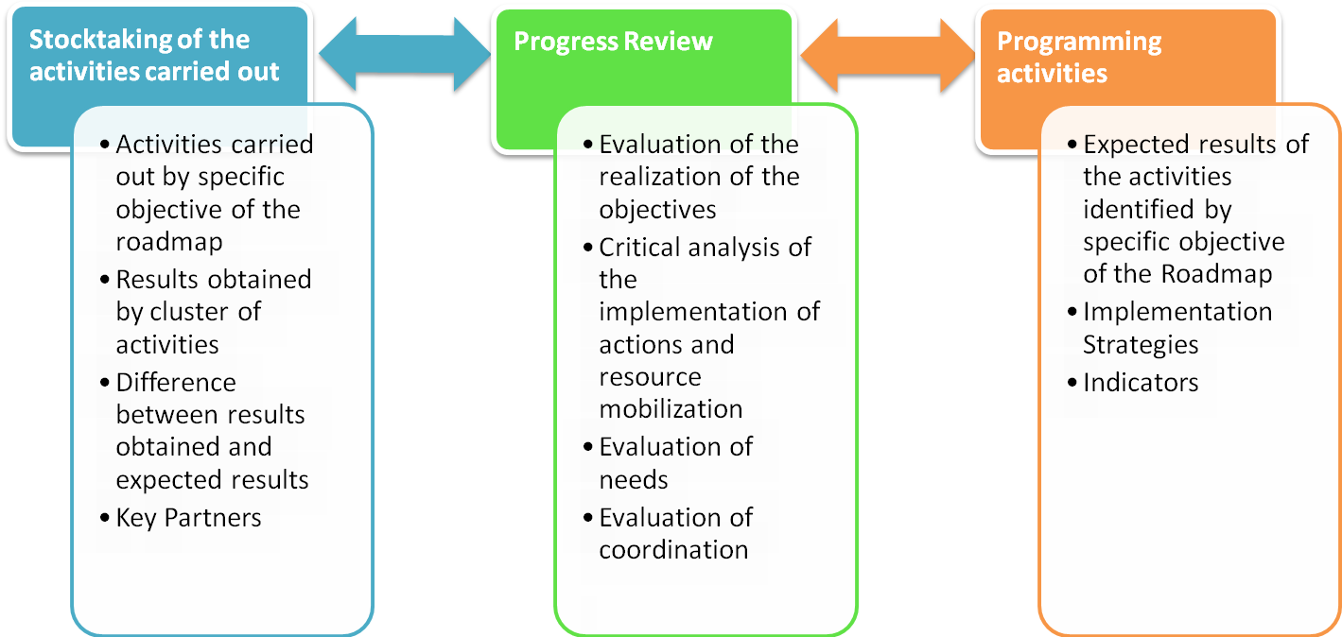

The Monitoring and Evaluation Tool

STATUS OF ACTIVITIES CARRIED OUT  CONTRIBUTING TO THE IMPLEMENTATION OF THE ROADMAP OF THE AFRICAN UNION |  |  |  |  | PROGRAMMING OF THE OF ACTIVITIES  FALLING UNDER THE ROADMAP  AFRICAN UNION ( 2012 – 2015)
SPECIFIC OBJECTIVE | EXPECTED RESULTS | ACTIVITIES REALIZED | EXPECTED RESULTS | EVALUATION | PLANNED ACTIVITES | STRATEGY OF IMPLEMENTATION | RESPONSIBILI-TIES/ PARTNERSHIPS | FUNDING | DEADLINES | INDICATORS

