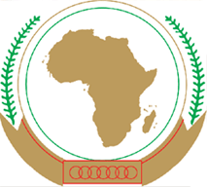  African Union | 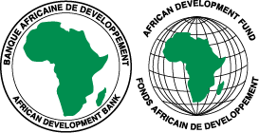  African Development Bank | 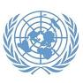  UN Economic Commission for Africa

AU Conference of Energy Ministers of Africa (CEMA)
All-Africa Energy Week (AAEW)
Pan-African Investment Forum (PAIF)

REGISTRATION FORM

Title: (Mr/Ms/Dr/Eng)
First Name
Last Name
Function
Institution/Organization
Country
Address
Tel
Email
Fax
Passport Information
number
Country
Issuing/Expiring date
Date of birth
Would you like to participate in
AAEW (12-14 Nov)
PAIF (12-14 Nov)
Business Consultation (13-14 Nov)
Ministerial Round table (15 Nov)
Ministerial Expert Meeting (14-15 Nov) (subject to clearance)
Ministerial Meeting (16 Nov) (subject to clearance)
Exhibition (12-16 Nov)
Registration as
Official Country Delegate (Y/N)
Official Regional Delegate (Y/N)
Exhibitor (Y/N)
Would you require a letter of Invitation? (Y/N)
Would you require a VISA? (Y/N)

Please fill this form and return it to:

Mr. Philippe NIYONGABO
Head of Energy Division
Department of Infrastructure & Energy
African Union Commission,
Tel.:+251-11-518 2414
Fax: +251-11-518 2450
E-mail : niyongabop@africa-union.org

Ms. Miriam Araya
Secretary
Department of Infrastructure & Energy
African Union Commission,
Tel.: +251-11-518 2412
Fax: ++251-11-518 2450
E-mail: miriama@africa-union.org

