|  |  |  |  |  |
| --- | --- | --- | --- | --- |
|  | United Nations |  | African Union | |
| _unlogo | **Economic and  Social Council** |  |  | **African Union** |
| E/ECA/CM/50/1  AU/STC/FMEPI/MIN/1(III)  Distr.: General  8 February 2017  Original: English |
| **Economic Commission for Africa**  **Conference of African Ministers of Finance,**  **Planning and Economic Development**  Fiftieth session | |  | **African Union**  **Specialized Technical Committee on Finance, Monetary Affairs, Economic Planning and Integration**  Third session | |
| **Tenth Joint Annual Meetings of the African Union Specialized Technical Committee on Finance, Monetary Affairs, Economic Planning and Integration and the Economic Commission for Africa Conference of African Ministers of Finance, Planning and Economic Development**  Dakar, 27 and 28 March 2017 | |  | | |

Business Plan

for an African Inclusive Markets Excellence Centre (AIMEC)

December 2016

Content

Figures and Tables 3

Acronyms 4

1 Executive Summary 6

1.1 The need for AIMEC 6

1.2 The design of AIMEC 7

1.3 The organisational structure 8

1.4 Next steps 9

2 Introduction 10

2.1 History of the concept 10

2.2 Methodology overview 10

3 Value proposition 12

3.1 Inclusive markets contribute to inclusive growth and regional economic transformation 13

3.2 AIMEC as a driver of regional integration 15

3.3 AIMEC supports existing frameworks 16

3.4 AIMEC closes gaps in the existing ecosystem 17

3.5 AIMEC catalyses the replication of best practices 18

3.6 Key design principles to catalyse best practice 19

4 Strategy 20

4.1 Vision and mission 20

4.2 Theory of change 21

4.3 Key Outputs and Activities 24

4.3.1 Pillar 1: IDENTIFY 24

4.3.2 Pillar 2: FACILITATE 27

4.3.3 Pillar 3: REPLICATE 28

4.3.4 Demand driven activities of AIMEC 32

4.4 Thematic and sectoral scope 32

4.5 Target clients and their benefits 34

5 Organisational Structure 35

5.1 Success factors and criteria for determining organisational setup 35

5.2 Organisational structure: AUC owned Centre 36

5.3 Governance and management 37

5.4 Staffing 37

5.4.1 Director profile 38

5.4.2 Analysts profile 39

5.4.3 Support staff 39

5.4.4 Volunteers 39

6 Partners 39

6.1 Partner network 39

6.2 Partner support 45

7 Operations 46

7.1 Measuring performance 46

7.2 Communication 49

8 Funding and financing 49

8.1 Income & Funding 49

8.2 Cost of AIMEC 50

9 Risks and mitigation measures 52

10 Conclusion and next steps 53

11 Annex 56

11.1 Annex 1: List of interview partners 56

11.2 Annex 2: Detailed activities 58

11.3 Annex 3: Results of feasibility study 59

# Figures and Tables

Figure 1: Overview of AIMEC design process 11

Figure 2: Perceived gaps in inclusive business ecosystems by 100 surveyed African institutions 17

Figure 3: Examples of best practices in IB & IM policies and programmes 19

Figure 4: Three pillars of AIMEC 21

Figure 5: AIMEC’s Theory of change 22

Figure 6: Overview of activities of AIMEC 24

Figure 7: Overview of IB case studies per sector 33

Figure 8: Ecosystem actors are willing to partner in multiple ways 45

Figure 9: Member States can imagine partnering in multiple ways 45

Figure 10: Proposed implementation timeline 54

Table 1 The role of government and development finance institutions (DFI) in Africa 15

Table 2: SWOT analysis 52

Table 3: Operational risks and mitigation measures 53

# Acronyms

|  |  |
| --- | --- |
| ACTESA | Alliance for Commodity Trade in East and Southern Africa |
| AIMEC | African Inclusive Markets Excellence Centre |
| AIR | African Institute for Remittances |
| AU | African Union |
| AUC | African Union Commission |
| AU IBAR | African Union Inter-African Bureau for Animal Resources |
| BMZ | German Federal Ministry for Economic Cooperation and Development |
| CAMEF | Conference of African Ministers of Economy and Finance |
| CEO | Chief Executive Officer |
| CIAT | International Center for Tropical Agriculture |
| COMESA | Common Market for Eastern and Southern Africa |
| CoE | Centre of Excellence |
| CSO | Civil Society Organisation |
| DFID | UK Department for International Development |
| DFI | Development Finance Institution |
| EC | European Commission |
| IB | Inclusive Business |
| IDB | Islamic Development Bank |
| ICT | Information and Communication Technology |
| IFAD | International Fund for Agricultural Development |
| IM | Inclusive Markets |
| PACCI | Pan-African Chamber of Commerce and Industry |
| PANVAC | African Union Pan-African Veterinary Vaccine Centre |
| REC | Regional Economic Community |
| SADC | Southern African Development Community |
| SDC | Swiss Development Cooperation |
| SDG | Sustainable Development Goal |
| SSA | Sub-Saharan Africa |
| UNDP | United Nations Development Programme |
| WFP | World Food Programme |

# Executive Summary

The African Union (AU), supported by the United Nations Development Programme (UNDP) and other development partners, aims to set up an **African Inclusive Markets Excellence Centre** (AIMEC). The AIMEC aims to become the premier pan-African regional platform for thought leadership and action on inclusive business (IB) and inclusive markets (IM), identifying, facilitating and replicating best practice and innovation in IB and IM policy, programming and public-private collaboration. Ultimately, this will foster inclusive growth and regional economic integration in Africa.

|  |
| --- |
| Box 1: Defining inclusive business and markets |
| Inclusive businesses (IB) include the poor on the demand side as clients and customers and on the supply side as employees, producers and business owners at various points in the value chain. Inclusive markets (IM) expand choices and opportunities for the poor and other excluded groups in their role as producers, consumers, entrepreneurs and employees. |

This business plan is **based on the results of a separate feasibility study**, which took into account the views of a wide range of stakeholders, including African Union Commission (AUC) and Member State representatives as well as international experts on inclusive business and inclusive markets. The feasibility study included 27 **key informant interviews,** 50+ responses in **online surveys, as well as a mapping of institutions and programmes** in the AIMEC space and a **benchmarking exercise that looked at other Centres of Excellence** (CoE). For further information, please refer to the feasibility study which is available as a separate addendum.

## The need for AIMEC

The need for AIMEC is based on the premise that supporting the development of inclusive markets is **fundamental for both inclusive growth and sustainable development** by generating employment and income for low-income groups, providing them with affordable services and goods and thus enhancing their choices and opportunities. A key principle underlying the AIMEC concept is therefore that the proposed Centre will be focused on supporting the development of more inclusive markets and businesses in Africa, thus **facilitating job creation, income generation, poverty reduction and inclusive growth**. In the context of the AU, AIMEC should be seen as a key part of the implementation of existing strategies and plans such as the AU’s **2014 – 2017 Strategic Plan,** the African Union’s **Agenda 2063** andtheachievement of the **Sustainable Development Goals** (SDG)**.** The pan-African focus of AIMEC means that it is able to work at the regional level, through close cooperation and partnerships with Regional Economic Communities (RECs).

Today, the **support landscape** for inclusive business and the creation of inclusive markets across the African continent **lacks coordination** and **best practices from one country or region are replicated only rarely in others**. There is also a lack of implementation ready policies on national and regional level which would feed into reaching for example the aims of AU’s Agenda 2063.

The feasibility study, in particular the landscape mapping exercise, revealed a demand for a Centre that addressed **three key gaps in the inclusive business and inclusive markets landscape that AIMEC should work towards filling:**

1. **Thematic gap**: Few institutions specifically target inclusive business and inclusive markets and regional value chains, although some institutions work in related areas. In particular, there is little consideration of the role of governments and policy in creating IB and IM. This suggests a need for an institution to support the development of inclusive policies and successful practices in creating inclusive markets.
2. **Geographic gap**: While some relevant initiatives exist at the sub-regional or country level in Africa, there are very few initiatives which take a continental perspective and can support continent-wide replication and dissemination of best practice. This suggests a need for an institution with a pan-African focus.
3. **Service gaps**: There is little coordination, collaboration, public-private dialogue and exchange of knowledge and best practice on inclusive markets and inclusive business in Africa. AIMEC can therefore play an important role in coordinating regional initiatives in conjunction with the relevant RECs, and by facilitating linkages between the private and public sectors.

## The design of AIMEC

The **mission of AIMEC** **is to become the recognised pan-African public-private platform on inclusive business and inclusive market policy and programming,** identifying, promoting and facilitating the replication and development of best practice in policy and programming across the entire continent. In order to achieve this mission, AIMEC will need to undertake a range of activities, which are grouped into three pillars:

* **Pillar One: IDENTIFY** and analyse best practice policies and programmes in IB and IM by collecting existing knowledge and evidence on what works and what does not. This will include conducting a detailed mapping of IB and IM policies and programmes, developing analytical products and case studies, and disseminating information via a flagship annual publication and online information platform.
* **Pillar Two: FACILITATE** the replication, adoption and development of this best practice by acting as a platform for coordination and collaboration between stakeholders: brokering linkages and organising dialogue forums and by hosting an annual conference that brings together key players from across the continent.
* **Pillar Three: REPLICATE** best practice by providing financial incentives for the scaling of existing IB/IM programmes and for the piloting of innovative solutions where existing approaches are not effective. This will be done through the establishment of a Catalytic Fund which will competitively award grants aimed at policy makers, development actors and the private sector.

Within these three pillars, AIMEC will work across all relevant sectors in a demand-based manner without a specific sector mandate. However, it is recommended that AIMEC select a thematic sector or topic to focus on, on an annual basis. This chosen sector will then become the focus of both the flagship annual publication and of the Catalytic Fund.

AIMEC will start with a focus on policies and programmes and will target both **public and private sector stakeholders.** Including private sector stakeholders is key to success as inclusive markets need participation and buy-in from businesses. Specifically, the following three stakeholder groups will be targeted:

1. Target clients in the **public sector and their affiliates** are the African Union Commission (AUC), the AU’s Member States national and local government, and Regional Economic Communities (RECs).
2. **Private sector** clients will include companies, both MSMEs and multinationals of African origin or those with significant operations in Africa; and regional business or trade associations.
3. **Other development actors,** such as bi- and multilateral development partners or foundations, as well as civil society organisations.

## The organisational structure

AIMEC is planned as an AUC owned centre hosted by one member country. The Centre can be set up as either a project/initiative of an existing AUC unit, or a trust/foundation and can be turned into a different legal structure after some years of operation.

* While achieving financial sustainability is a key aim for AIMEC, a realism around funding and financing options in the pan-African public-private space is warranted, and so it is recommended that AIMEC be funded through a mix of **core funding** (regular contributions from Member States, bi- and multilateral donors, UN agencies, private companies, foundations and other partners), **project funding** from partners looking for specific support (e.g. development actors seeking implementation support), and **fees** for service (e.g. training or conferences, or private companies or government agencies requiring specific consulting or technical assistance services).

It is estimated that the costs of AIMEC will be in the region of USD 2.2 million per year, including an amount for the catalytic fund (starting at around USD 350,000).

## Next steps

In order to move towards the implementation and establishment of AIMEC, the following sequential steps need to be taken. Firstly, a host country needs to be selected and a host agreement needs to be signed. Once this is completed, funding needs to be secured. This will determine the final scope of activities that AIMEC will be able to undertake, as well as the staffing required. When there is certainty on the operational design and the availability of funding, then AIMEC can move towards an operational phase.

In the operational phase, staff will need to be recruited, beginning with the director of the Centre. The first task of AIMEC will be to turn this business plan into an operational plan that focuses on the first year of activity. As the pillars of AIMEC are designed to build on one another in a sequential way, implementation will start with Pillar 1. It is estimated that the first fund grants will be issued within 18-24 months of the Centre being established.

# Introduction

The African Union (AU), supported by United Nations Development Programme (UNDP) and other development partners, aims to set up an **African Inclusive Markets Excellence Centre** (AIMEC). The AIMEC aims to become the premier pan-African regional platform for thought leadership and action on inclusive business (IB) and inclusive markets (IM), identifying, facilitating and replicating best practice and innovation in IB and IM policy, programming and public-private collaboration. Ultimately, this will foster inclusive growth and regional economic integration in Africa.

## History of the concept

The AU and UNDP have been collaborating on developing AIMEC since the Private Sector Forum in Abidjan, Côte d’Ivoire in 2012. As a result, the first concept note on AIMEC was drafted in April 2014.[[1]](#footnote-2) In parallel, the UNDP report “Realizing Africa’s Wealth”, published in May 2013, recommended the set-up of such a Centre of Excellence (CoE).[[2]](#footnote-3)

At the Conference of African Ministers of Economy and Finance (CAMEF) in April 2016, the Joint Committee made the recommendation to the AUC to commission an independent consultant to carry out a feasibility study. It was supposed to consider various options for making the African inclusive markets Centre of excellence operational and financially sustainable, and the findings of that study should then be presented to member States for due consideration.[[3]](#footnote-4)

## Methodology overview

This business plan is **based on the results of a separate feasibility study**, which took into account the views of a wide range of stakeholders, including AUC and Member State representatives as well as international experts on inclusive business and inclusive markets. Figure 1 summarises the research process, which has culminated in the writing of this business plan.

Figure 1: Overview of AIMEC design process

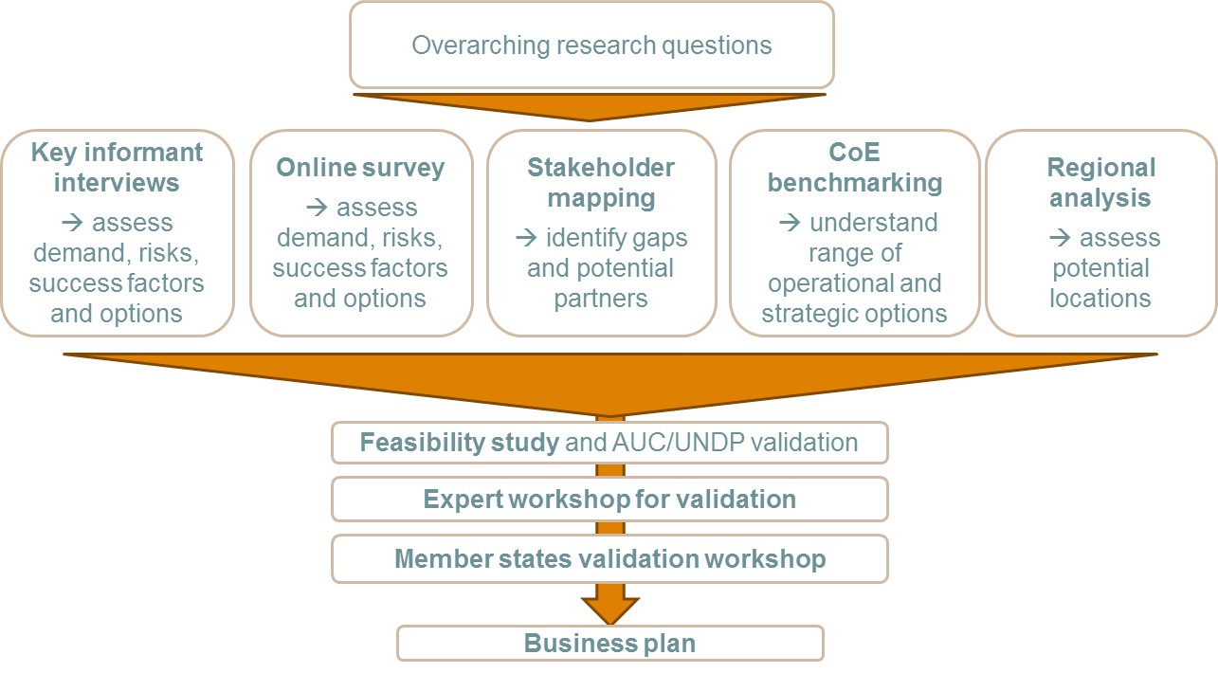

Source: Authors

The feasibility study consisted of the following parts:

* 27 **key informant interviews**: the partners interviewed included representatives of existing Centres of Excellence serving governments; experts on inclusive business and inclusive markets; and representatives from AUC and RECs with central information on institutional requirements.
* 50+ responses in **online surveys**: Respondents to the online survey included AU member state representatives from various ministries (economics, finance, trade, industry, etc.) as well as experts on IB/IM in Africa.
* **Mapping of institutions & programmes** in the AIMEC space: the mapping of 80 institutions and programmes helped to understand gaps in the landscape and identify partners for collaboration; emphasis was laid on African and global institutions and programmes in IB with a focus on agribusiness and energy.
* **Benchmarking of Centres of Excellence:** the aim was to understand the design options for a CoE. The 30 Centres examined all serve governments.
* **Comparative analysis of Africa’s sub-regions**: Comparison of all AU member countries and sub-regions on quantitative facts like number of airports, number of universities and ranks in indices like the Ease of Doing Business Index or World Bank’s Worldwide Governance Indicators.

The feasibility study provided important insights into likely challenges and success factors for establishing the AIMEC. It facilitated the business plan development with a view to **maximising AIMEC’s utility to all stakeholders** in the long run. The feasibility is included as a separate addendum to this report, with the list of key stakeholders included as Appendix 1 of this document.

**Box 1: Definition of Inclusive Business and Inclusive Markets**

**Inclusive businesses** include the poor on the demand side as clients and customers, and on the supply side as employees, producers and business owners at various points in the value chain. **Inclusive markets** expand choices and opportunities for the poor and other excluded groups in their role as producers, consumers, entrepreneurs and employees. While AIMEC will focus on inclusive businesses and inclusive markets, these will both lead to more **inclusive growth**, i.e. economic growth that increases access to sustainable socio-economic opportunities for a broader number of people, countries or regions, while protecting the vulnerable. AIMEC should therefore be seen as contributing towards more inclusive growth by strengthening the inclusivity of markets and supporting the development of inclusive businesses.

To overcome the challenging market conditions characteristic of low-income communities, inclusive businesses need a supportive environment. An **inclusive business ecosystem** refers to a network of interconnected, interdependent actors whose actions make it possible for inclusive businesses to succeed and generate impact at increasingly large scales. This include for example conducive regulations or the availability of financing.

# Value proposition

The AIMEC aims to become the premier pan-African regional platform for thought leadership and action on inclusive business (IB) and inclusive markets (IM), identifying, facilitating and replicating best practice and innovation in IB and IM policy, programming and public-private collaboration. Ultimately, this will foster inclusive growth and regional economic integration in Africa. This will fill a gap in the support landscape and facilitate the work of existing actors, programmes and policy makers.

## Inclusive markets contribute to inclusive growth and regional economic transformation

African countries have seen real GDP growth rates of an average 3.3. percent a year between 2010 and 2015. The International Monetary fund predicts that Africa as a whole will be the world’s second-fastest growing economy to 2020. Yet, there are huge regional differences and the recent study of the McKinsey Global Institute “Lions on the Move II” mentions that African governments and companies will need to work harder to make the most of its potential.[[4]](#footnote-5)

**Markets play a fundamental role in the day-to-day lives of low-income groups in Africa**. These markets, and the private sector companies and entrepreneurs involved in them, generate jobs and incomes and provide goods, services and solutions for women and men with low incomes. In most countries, markets are central in determining whether growth occurs and whether it is inclusive or not.

Inclusive businesses have proven effective in creating opportunities for low-income populations and contribute to economic transformation. For example, the mobile money service M-Pesa offers financial services to more than 25 million customers, most of whom had no access to bank accounts before (see more information in Box 2 below).

**Box 2: Enabling financial transactions for consumers and businesses: Safaricom’s M-PESA mobile money service**

In 2007, Safaricom, Vodafone’s local affiliate in Kenya, launched [M-PESA](http://safaricom.co.ke/index.php?id=250), a SMS-based money transfer system that allows customers to transfer and make payments using a mobile phone. This has transformed financial services by making transactions cheaper, faster and more secure. M-PESA has reduced the barriers to financial transactions for consumers and businesses alike. In the past, those without bank accounts could seldom transfer funds cost-effectively or quickly. Instead, people usually paid in cash, often had to travel long distances to make payments, with the risk of losing money or getting it stolen. M-PESA has made paying, receiving, or storing money much easier for individuals. Businesses are benefiting from its positive impact on cash flow, as many have now adopted M-PESA to offer B2B services. For example, suppliers are now able to collect payments via M-PESA. Today, more than 25 million people use the services in Kenya.

Source: WBSCD

Inclusive business has also a large potential for including the informal sector in value chains. The African Development Bank estimated in 2013 that the informal sector contributes about 55 percent of Sub-Saharan Africa’s GDP and 80 percent of the labour force. Even though the informal sector is an opportunity for generating reasonable incomes, most informal workers are without secure income and social protection. This explains why informality often overlaps with poverty. For instance, in countries where informality is decreasing, the number of working poor is also decreasing and vice versa.[[5]](#footnote-6) Inclusive businesses that include informal structures in formal value chains show a way out of poverty as shown in the case study below. Inclusive business does not necessarily decrease the informal sector in the short term but rather promotes more of the linkages with markets and ensures that the informal sector gets access to public and private services from which they are often excluded.

**Box 3: Heineken empowers smallholder farmers**

As a large buyer of crops and a manufacturer and brewer in Africa, Heineken plays an important role in the economic empowerment of hundreds of thousands of farmers. Heineken currently sources around 46 percent of its agricultural raw materials from local farmers. The latter benefit from assistance with modern farming techniques, training programmes and access to financing. The company on the other side secures the expansion of good quality production and a sustainable supply of raw materials.

Source: Heineken

However, **in many countries in Africa a variety of barriers make markets difficult to access for large sections of the population, and rarely benefit the poorest and most vulnerable in society. Markets do not always provide access and benefits to the poor and vulnerable**. The challenge is therefore to remove these barriers to enable markets to be **more inclusive**, resulting in expanded choices and producing outcomes that benefit low-income groups. Inclusive businesses are critical actors in inclusive markets and have a key role to play in supporting inclusive growth, job creation and poverty reduction.

Supporting the development of inclusive markets is **fundamental for both inclusive growth and sustainable development** by generating employment and income for low-income groups, providing them with affordable services and goods and thus enhancing their choices and opportunities. A key principle underlying the AIMEC concept is therefore that the proposed Centre will support the development of more inclusive markets and businesses in Africa, thus **facilitating job creation, income generation, poverty reduction and inclusive growth** and directly contributing to achieving the SDGs.

Inclusive businesses struggle with challenging conditions. As key market enablers, **African governments and international development finance institutions can play** an important role in providing support to more inclusive businesses:

Table 1 The role of government and development finance institutions (DFI) in Africa

|  |
| --- |
| ../../../Desktop/Bildschirmfoto%202016-09-06%20um%2013.16.42.png |

Source: UNDP (2016)

## AIMEC as a driver of regional integration

Markets do not only operate at the national level, and many important value chains cross international borders in Africa. These regional value chains are increasingly recognised as playing a critical role in supporting regional economic integration, as they encourage cross-border linkages, cooperation at a policy level and transnational business. The pan-African focus of AIMEC means that it is able to work at the regional level, through close cooperation and partnerships with Regional Economic Communities (RECs), to incorporate best practice in promoting inclusive markets in regional value chains. The strengthening of these regional value chains directly contributes towards regional economic integration.

There are several examples of successful regional value chain programmes of the kind that would be supported and promoted by AIMEC, for example, the UNDP supported *Groundnut Integrated Value Chain Project* in Zambia and Malawi, and the *Sahelian Onion Productivity and Market Enhancement Programme* in Ghana and Burkina Faso.

## AIMEC supports existing frameworks

The importance of inclusive business and markets is recognised in several interconnected plans and frameworks that aim to help overcome poverty and ensure inclusive growth in Africa.

Today, the support landscape for inclusive business and the creation of inclusive markets across the African continent lacks coordination, and best practices from one country or region are replicated only rarely in others. There is also a lack of implementation ready policies on national and regional level, which would feed into reaching existing development frameworks’ objectives.

Three development frameworks are of relevance to the AIMEC concept:

* *The AU’s* ***2014 – 2017 Strategic Plan*** defines eight priorities and seven outcomes, of which Outcome 3 in particular focuses on inclusive growth: “Infrastructure development and environment for inclusive economic development, industrialization, private sector-led intra-African Trade and sustainable utilization of natural resources created”. In addition, Outcome 2 focuses on “Policies and institutions for sustainable development, increased agricultural production, food and nutrition security, expanded value addition and market access, and sound environmental management implemented”.
* *The African Union’s* ***Agenda 2063*** was set up as a strategic framework to facilitate socio-economic transformation of the continent. Consisting of seven aspirations, the first aspiration explicitly refers to inclusive growth and sustainable development, calling for a “prosperous Africa based on inclusive growth and sustainable development”.[[6]](#footnote-7) Moreover, the Agenda’s first ten-year implementation plan calls for the development of human capital and infrastructure for social and economic transformation, based on inclusive growth and sustainable development as an indicative strategy to achieve its targets.
* *The United Nations 2030 Agenda for* ***Sustainable Development* contains** a set of 17 **Sustainable Development Goals** (SDGs) to end poverty, fight inequality and injustice, and tackle climate change by 2030. These SDGs are closely linked to the AU’s Agenda 2063, with SDG 8 focusing on the promotion of “sustained, inclusive and sustainable economic growth”.

The AU is a key stakeholder and driver of inclusive business and inclusive markets on the continent.[[7]](#footnote-8) The establishment of AIMEC is designed to support the frameworks and plans described above. AIMEC should therefore be seen as part of the implementation of existing strategies, and it is for this reason that the AU’s Department for Economic Affairs, with technical support from UNDP, embarked on the process to design the AIMEC.

## AIMEC closes gaps in the existing ecosystem

While the need for making African markets more inclusive is clear, there is also a recognition that there are **significant gaps in the inclusive business ecosystem**. The 2013 report *Realizing Africa’s Wealth* by UNDP included a survey of 100 African institutions, which showed a widespread perception that there were crucial gaps across the dimensions crucial for a vibrant IB ecosystem. These included Incentives, Investment, Information and Implementation Support (see Figure 2 below). These perceived gaps are particularly large in terms of incentives and investment.

Figure 2: Perceived gaps in inclusive business ecosystems by 100 surveyed African institutions

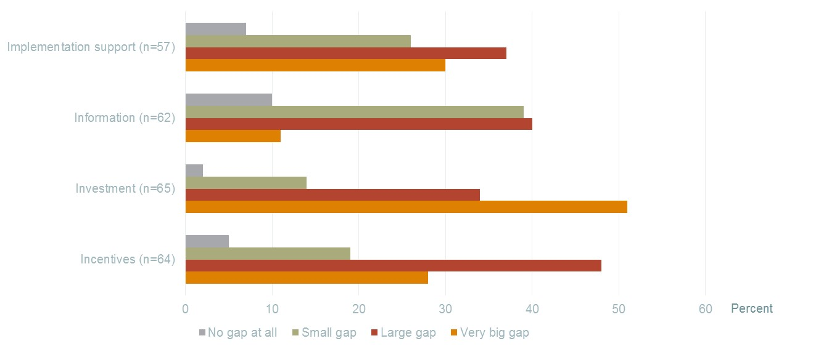

Source: Realizing Africa’s Wealth (UNDP 2013)

The same report identified the **need for a Centre of Excellence for inclusive business and inclusive markets, which would play a role in** building and sharing knowledge on successful existing ecosystem initiatives, and to incubate new initiatives.

These findings were reinforced by the feasibility study underpinning this business plan, with the landscape mapping exercise revealing **three key gaps in the inclusive business landscape:**

1. **Thematic gap**: Few institutions specifically target inclusive markets and regional value chains, although some institutions work in related thematic areas. Examples are the African Enterprise Challenge Fund and the African Centre for Economic Transformation (ACET). In particular, there is little consideration of the role of governments and policy in creating IB and IM. This suggests a need for an institution to support the development of inclusive policies and successful practices in creating inclusive markets.
2. **Geographic gap**: While some initiatives exist at the sub-regional or country level in Africa, there are very few pan-African initiatives taking a continental perspective and supporting continent-wide replication and dissemination of best practice. This suggests a need for an institution with a pan-African focus.
3. **Service gaps**: There is little coordination, collaboration, public-private dialogue and exchange of knowledge and best practice on inclusive markets and inclusive business in Africa. AIMEC can therefore play an important role in coordinating regional initiatives in conjunction with the relevant RECs, and by facilitating linkages between the private and public sectors.

On the demand side, both key informants and Member State representatives interviewed and surveyed as part of the feasibility study expressed a clear **demand for an institution that was able to fill these thematic, geographic and service gaps**. Several respondents were enthusiastic about the concept of a Centre of excellence dedicated to inclusive markets and business, with one respondent stating that AIMEC “is really a **great initiative which will go a long way in supporting Inclusive Business in Africa**“, and another confirming that AIMEC “seems great in terms of filling a need”.

## AIMEC catalyses the replication of best practices

All over Africa, there are good examples of how IB and IM are implemented and strengthened with policies and programmes. Figure 3 below illustrates some best practice examples from diverse sectors, all of which could be replicated in other countries or sub-regions.

Figure 3: Examples of best practices in IB & IM policies and programmes

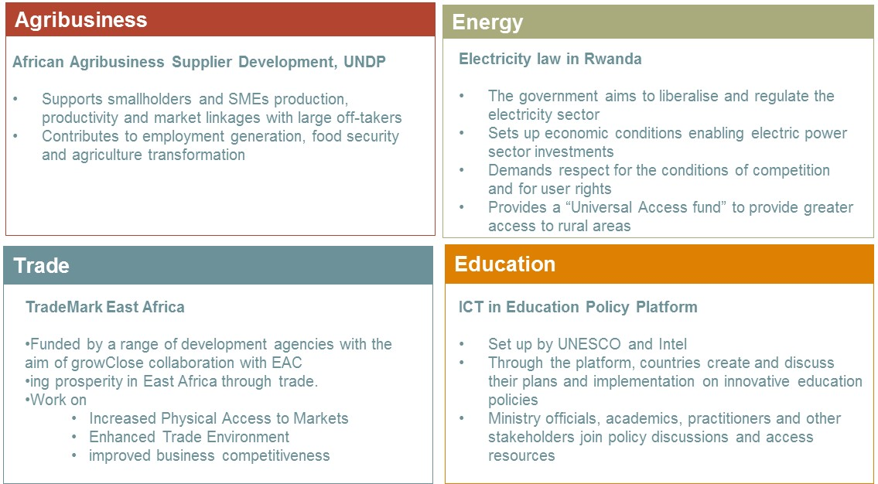

Sources: http://www.epd-rwanda.com/energy-laws-policies-and-enabling-environment-kigali.html, http://www.undp.org/content/dam/undp/library/corporate/Partnerships/Private%20Sector/AFIM%20Brochure%20July%202014.pdf, https://www.trademarkea.com/, http://www.psp4h.com/about-us/

AIMEC will provide added value that complements and magnifies the impact of existing institutions. Several respondents of the feasibility study stressed that AIMEC should take care not to duplicate existing initiatives in geographic, thematic or functional areas. There is however a clear need for a player to act as a platform partner to bring these existing initiatives together. Collaboration with other actors should therefore will be the basic modus operandi for the Centre. The Centre will provide research, knowledge sharing, linkages and trainings as well as a catalytic fund to catalyse the replication of best practices of others. Thus, the Centre will be a facilitator of action, not an implementer of the policies and programmes. By doing so, the Centre will ensure that the work of others is done with better results, in a more coordinated way and in shorter time.

## Key design principles to catalyse best practice

The AIMEC feasibility study both confirmed the need for a Centre of Excellence, and identified several key design principles, which should guide the design of AIMEC in filling the identified gaps.

* ***Ensure a pan-African perspective*.** Related to the above, AIMEC should serve the entire continent and should be careful to avoid any perception that it will serve only certain sub-regions of Africa. In addition, a pan-African perspective means that AIMEC is able to facilitate continent-wide knowledge sharing and replication.
* ***Recognise African diversity:*** AIMEC should recognise the heterogeneity of African countries and contextualise the replication accordingly. It will support countries in understanding the strength of policies and programmes and support the adaptation according to the culture, policy frameworks and economic situation.
* ***Clear African ownership*.** AIMEC should be an African-driven initiative that co-operates with, but is independent from ‘outsiders’ or donors. In addition, there should be a focus on South-South collaboration with-, and learning from-, other developing nations that face similar challenges.
* ***Take an evidence- and results-based approach***. In order to demonstrate impact and to avoid being seen as driving any particular agenda, AIMEC should identify and employ approaches that are backed up by clear evidence and results.
* ***Work with all relevant inclusive market actors*.** AIMEC must ensure buy-in from government, the private sector and from RECs in order to successfully work to strengthen the inclusive business ecosystem across Africa. In particular, the private sector will be a critical partner in ensuring success and AIMEC’s activities should take this into account.

The strategy and the structure of AIMEC that is presented in the following sections take into account the results of the feasibility study and these principles outlined above.

# Strategy

This section outlines the strategy of AIMEC, i.e. it summarises what AIMEC intends to do, why, and for whom. It presents the AIMEC’s mission and vision, the activities required to achieve this vision, and the sectors and actors that will be the focus of these activities.

## Vision and mission

The **long-term vision** of AIMEC is to contribute towards an Africa where all people have access to markets for goods, services and jobs and hence benefit from prosperous and sustainable economic opportunities. This vision will be effectively met by ensuring that best practices in inclusive business and inclusive market policy, programming and partnerships are available and promoted to all stakeholders on the African continent. In doing this, the AIMEC will directly contribute to the relevant priorities of the AU Agenda 2063 and will help accelerate progress towards inclusive growth, regional economic integration, economic transformation as well as the achievement of the SDGs.

The **mission of AIMEC** is to become the recognised pan-African public-private platform on inclusive business and inclusive market policy and programming, identifying, facilitating and replicating best practice in policy, programming and public-private collaboration across the entire continent. It will provide intellectual guidance and facilitate implementation of progressive policies, programmes and partnerships by public, private and other development stakeholders in the IB/IM space.

## Theory of change

The theory of change shows how the activities and outputs of AIMEC, discussed in the next section, will contribute towards the fulfilment of the mission and vision of AIMEC. This holistic view is important, both in guiding the operations of the Centre and in developing indicators to track progress and impact. The theory of change should therefore form the basis of a monitoring framework designed and implemented after AIMEC is established.

At its heart, AIMEC will **collate, review, and analyse existing policies and programmes, and support the replication and development of these** for inclusive businessand inclusive markets in Africa. These activities will be based around three pillars, which are summarised in figure 4 below:

Figure 4: Three pillars of AIMEC

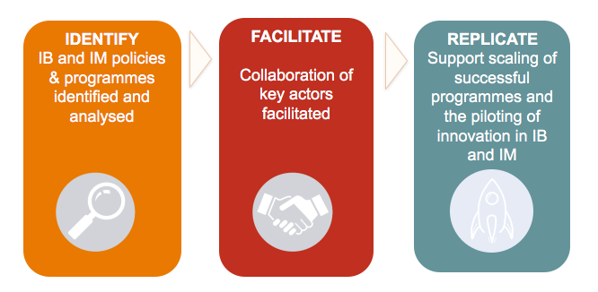

Source: Authors

* **Pillar One: IDENTIFY** and analyse best practice policies and programmes in IB and IM by collecting and collating existing knowledge and evidence: conducting a detailed mapping of the policies and programmes, developing analytical products and case studies, and disseminating information via a flagship annual publication and online information platform.
* **Pillar Two: FACILITATE** the replication, adoption and development of this best practice by acting as a platform for coordination and collaboration between stakeholders: brokering linkages, organising dialogue forums and hosting an annual conference that brings together key players from across the continent.
* **Pillar Three: REPLICATE** best practice by providing financial incentives for the scaling of existing IB/IM programmes and for the piloting of innovative solutions where existing approaches are not effective. This will be done through the establishment of a Catalytic Fund, which will competitively award grants aimed at policy makers, development actors and the private sector.

Figure 5: AIMEC’s Theory of change

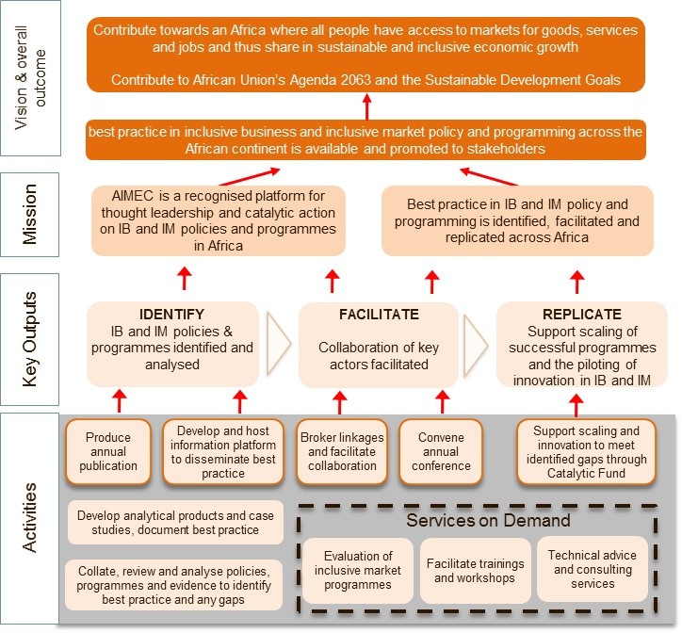

Source: Authors

## Key Outputs and Activities

The following section outlines the full **service offering of AIMEC. It is however important to note that as AIMEC is established, the activities will be incrementally undertaken**, taking into account demand as well as financial sustainability, and not losing sight of the mission and vision and AIMEC’s specific niche in the wider IB/IM space. The grouping of the activities into pillars also indicates that the pillars should be implemented sequentially, as they build on one another. An implication is that a scaled down version of AIMEC could operate solely under Pillar 1, but if Pillar 3 is to be implemented then Pillars 1 & 2 would have to be implemented first. An indicative log frame which attached indicators and targets to these activities and outcomes is included in chapter 7.

Figure 6: Overview of activities of AIMEC

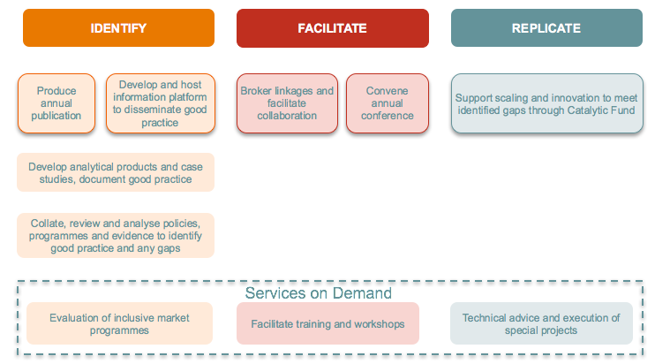

Source: Authors

### Pillar 1: IDENTIFY

As the foundation for all of AIMEC’s work, the first pillar involves the collation, review and analysis of **existing policies and programmes in IB and IM in Africa**, in order to fulfil the aim of bringing together knowledge from all over the continent that can then be **disseminated.**

This pillar will require AIMEC to conduct a detailed mapping of the IB and IM policy and programme landscapes in Africa, as a basis on which to identify successful inclusive business and inclusive markets policies and programmes. AIMEC will pro-actively and systematically scan the landscape for cutting edge input and evidence of “what works”, and then repackage this existing knowledge to make it more user-friendly and in a way that facilitates dissemination.

A first mapping was already done in the course of the feasibility study for the AIMEC. This mapping analysed the extent to which existing institutions work on IB and IM in general, and IB/IM policies and programmes in particular. This can form the basis of a more thorough mapping that the Centre can carry as part of its activities.

This research phase will include developing relationships with regional institutions, multi- and bilateral donors and multilateral institutions in the field to identify the initiatives which show high impact and also discover those which might not have been published widely before.

This activity will position AIMEC as the leading repository of information on IM and IB policies and programmes in Africa, and will provide it with a unique continental perspective on the state of the landscape: understanding which programmes and policies work (and why), identifying all the key relationships between relevant actors and understanding where the gaps are. It is this perspective that will enable AIMEC to issue a flagship publication on the topic of IM/IB policies and programmes in Africa.

The types of activities that will take place under this pillar include:

* *Researching and compiling a comprehensive database* of existing programmes, initiatives and policies around inclusive markets and inclusive business in Africa. As a first step, this will require a detailed mapping of the sector and collection of all relevant reports, papers and case studies that are currently available.
* *Identifying best practice criteria.* In order to identify and promote best practice, it will be necessary to define what is “best practice” and develop a set of key evaluation criteria for impactful inclusive business and market policies and/or programmes. This will be done by evaluating successful programmes and policies in order to identify the key factors and conditions that enabled this success. In addition, key practitioners and existing research will be used to develop the framework. These criteria will be a key output and can be used as a tool by practitioners in developing and assessing policies and programmes across the continent.
* *Developing analytical products*, such as white papers, short reports and case studies. Following the review and assessment of IB/IM policies and programmes across the continent, this information needs to be collated and distilled into easy-to-use formats in order to disseminate the information effectively. A key question to be explored in the analysis is where gaps exist in the current landscape.
* *Researching case studies.* Policies and programmes that illustrate interesting approaches or showcase best-practice examples that emerge during the mapping of the IM/IB landscape will be proactively written up as a series of case studies for publication by AIMEC. The Centre will also consider failure or “bad practice” case to learn from mistakes made in the past.
* *Developing and hosting an online information platform* on inclusive markets and inclusive business policies and programmes in Africa. This platform will be the key dissemination method for the work of AIMEC and will be designed to be the repository of both the work of AIMEC and additional resources produced by other players in the sector. There is no need for a new website, AIMEC could collaborate with existing and well established websites like the Practitioners Hub or also information platforms of the African Union or similar partners. The information platform will be bolstered by a presence on appropriate social media platforms such as LinkedIn, where stakeholders can interact and access information.
* *Developing a flagship publication (either annual or biennial)* on the status of inclusive business and inclusive markets policies and programmes in Africa. This publication will summarise the developments in the field over the preceding period, highlighting new developments and adoption of best practice. It should also have a thematic focus in order to showcase best practice in a particular sector (for example a focus on developments in the energy sector).

**Example of similar approach: Collection of good policies by the International PPP Centre of Excellence**

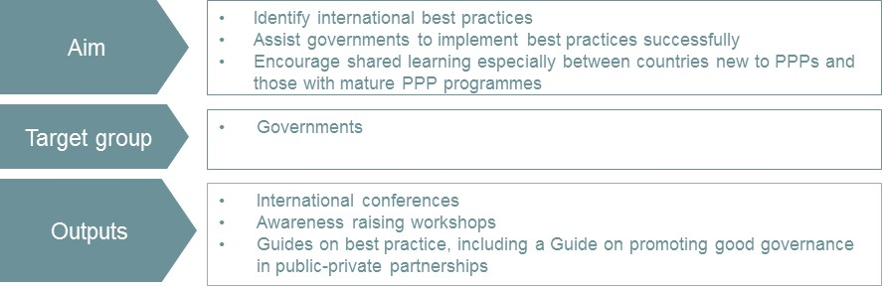

Source: International PPP Center of Excellence

### Pillar 2: FACILITATE

The comprehensive view of the IM/IB landscape that AIMEC will have from the activities under Pillar 1 means that AIMEC will be uniquely placed to provide a **platform for coordination and collaboration**: **brokering linkages between stakeholders to facilitate exchange of best practice** and lessons learned, creating synergies, and supporting replication of best practice. To be able to fulfil this task, AIMEC will develop a network of all relevant stakeholders and will be actively contributing to discussions in this field to gain visibility and acceptance.

An important part of this task will be to promote dialogue and partnership between public and private stakeholders. This will partly begin to happen through an annual conference and trainings organized by AIMEC, but AIMEC should also be capacitated to identify instances where more explicit action might be beneficial. This could take one of two forms:

* *Brokering linkages and facilitating collaboration* among IB/IM actors in Africa through the convening of topic-specific workshops and dialogue forums. AIMEC will be uniquely positioned to identify potential synergies between programmes and so will also work towards bringing these actors together to discuss potential collaboration (for example relevant private sector players and RECs)
* *Convening an annual conference* on inclusive business and inclusive markets policies and programmes in Africa. This conference will bring together key stakeholders from across the continent under the common theme of strengthening IM/IB and will be an opportunity for those in the field to network and share best practice. This conference can also serve as a launch event for the flagship publication produced by AIMEC. In the same way that the report will have a specific sectoral theme, the conference should also focus on specific sector.

**Example of a similar process: Meet & Multiply**

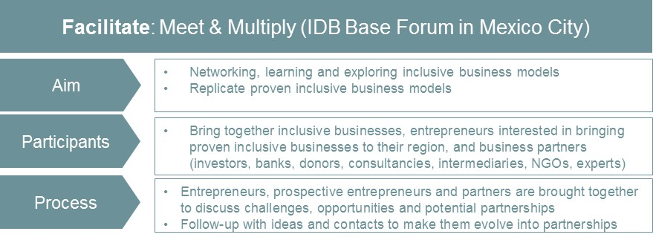

Source: Endeva

### Pillar 3: REPLICATE

AIMEC is designed not only to identify best practice and to facilitate partnerships, but will also work **proactively to replicate this work: through scaling, replication and through supporting the development of new policies and programmes where gaps exist**. The main way in this will be done is through the establishment of a Catalytic Fund that will aim to provide funding to public and private stakeholders to 1) assist in the scaling up of existing activities/programmes and 2) develop or implement innovative approaches where existing approaches are not effective.

This fund will work with similar mechanisms like challenge funds: It awards once-off grants through a competitive, open application process and is designed to overcome the uncertainties that inhibit innovation, research and development, investment and new approaches. The assumption is that without fund support, such activities are either unlikely to happen, or will happen at a later stage. Box 4 provides more detail on the challenge fund mechanism concept.

It is unlikely that a budget sufficient to finance an entire scaling/replication of a programme, or the implementation of a new and innovative approach, will be available for the fund. AIMEC will leverage its initial funding with other players to finance the implementation and roll out of designated programmes. The AIMEC fund will provide grants for project preparation, i.e. for activities that enable the organisation to investigate the feasibility of scaling and to prepare an appropriate business plan (in the case of scaling/replication), and for the adaptation/piloting of a programme (in the case of innovation). In this way, AIMEC will have a catalytic impact and accelerate the development and replication of IB/IM policies and programmes.

*Funding window 1: Scaling and replication*:

During the landscape review conducted under Pillar 1, programmes that embody best practice are likely to be uncovered. In many cases these programmes (whether from the public or private sector) could potentially be scaled up or replicated in other countries or in other sectors. This funding window will therefore call for applications from these projects for funding to explore the feasibility of expanding in this way.

For example, if an organisation in Mozambique was implementing an innovative small-holder agriculture programme in the cassava sector, they could apply for funding that would allow them to investigate the feasibility of using the same model in the maize sector and to construct a feasible business plan for this type of replication.

*Funding window 2: Innovative approaches to IM & IB*.

Part of the activities under Pillar 1 of AIMEC include identifying gaps in the IM/IB landscape, where no effective solutions currently exist. The second part of the fund should therefore be focused on players that are able to either develop or implement innovative approaches. Innovation in this sense could mean a completely novel approach, or the application of an approach that has not yet been tried on the African continent. Thus, AIMEC can also support to learn about best practices from other continents. Like the replication and scaling component of the fund, this funding window can run sectorally-based windows.

For example, if it became clear from the review of the landscape that the financing of small inclusive businesses in the energy sector was a major gap, then the AIMEC fund instrument would issue a call for proposals that would address this. Potential applicants could include banks, microfinance organisations or even donors who could leverage existing experience to develop a solution. Funding from AIMEC could be used to roll out the first pilot in order to assess the feasibility of the approach, along with proper monitoring and evaluation.

The key activities of this pillar therefore include:

* *Identifying sectors in which existing activities could be usefully replicated or scaled.* These sectors would become the focus of a specific fund instrument funding window and a call for proposals would be targeted accordingly. In the same way, gaps in the IM/IB landscape where new approaches are needed should be identified. These gaps would become the focus of the innovation window and a call for proposals would be targeted accordingly.
* For each funding round, a *specific window should be designed*. This “mini-design” process will include the formulation of eligibility criteria (who is able to apply) as well as assessment criteria (the criteria on which eligible applications compete). In addition, grant sizes, any required matching, and a tailored set of impact indicators will have to be developed. This will culminate in a call for proposals
* Once the winning applications have been chosen, *AIMEC will have to oversee the implementation of the grantees* – monitoring progress, making disbursements and conducting an evaluation at the end of implementation. The implementation of these projects will also generate valuable learning which can then be fed back into Pillar 1.

**Example of similar process: Challenge Fund to transform maternal and new-born healthcare in Kenya**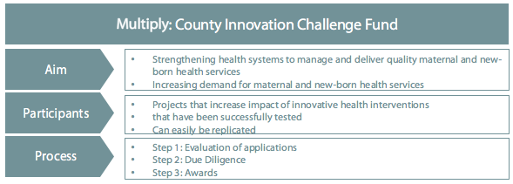  
Source: http://mnhcicf.org

**Box 4: The Challenge Fund Mechanism**

A challenge fund can be defined as “*a financing mechanism that allocates funds for specific purposes using competition among organisations as the lead principle*”. This means that while AIMEC will define the “challenge”, any business, organisations or public sector body will be able to apply to the fund in order to implement a project that solve this challenge. A challenge fund is characterised by the following:

* *Competitive process*: at their core challenge funds are an instrument for competitively awarding matching grants. A challenge is issued in the public domain which is open to all who are willing to compete, bid and achieve. Competitive allocation of funds guarantees that only the best projects are funded. Since challenge funds provide once-off funding, winning companies are free to plan their exit strategies – which are clearly defined and time-bound – minimising any anti-competitive effect.
* *Innovation*: challenge funds require innovation from bidders if they are to win support for their ideas. Applicants are invited to submit potentially transformational business and project plans that can contribute to achieving development objectives. Since an underlying assumption is that innovation carries risk, one of the challenge fund’s main goals is to hedge against loss, promote innovation and, in doing so, to increase access and choice for the poor.
* *Leverage*: challenge funds provide co-financing for successful projects on a grant basis. Successful applicants match a certain percentage of the grant with their own funds. This promotes ownership and commitment, and ensures public funds go further.
* *Partnerships*: challenge funds are useful for bringing together partners from the private, public and not-for-profit sectors in a framework of cooperation for mutual benefit.
* *Local solutions to local problems*: challenge funds encourage bidders to develop ideas that provide local solutions to local problems, stimulating ownership and greater innovation.

*Adapted from Understanding Challenge Funds, ODI, 2013*

### Demand driven activities of AIMEC

As AIMEC matures and establishes itself as a thought leader in the IM/IB space, there will be potential to provide services on a fee-paying basis. This may only come a few years, probably three years, after the Centre is launched but should be a key consideration for AIMEC management, particularly as this will generate income and contribute towards AIMEC’s financial sustainability.

Key activities that could be undertaken on this basis include:

* *Facilitating training and workshops* on IB/IM policy and programme development in Africa. As AIMEC develops a body of work identifying best practice, it will be able to provide targeted training to practitioners on both the development and implementation of these policies and programmes. This training can be regionally or thematically based, as demand dictates.
* *Providing services on demand on a consulting basis.* As AIMEC develops expertise, it will be able to offer customised advice and assistance to public and private sector institutions. This could take the form of technical assistance and strategic consulting support across a number of topics, the provision of specialised training and workshops, and conducting evaluations and social impact assessments of existing programmes and policies. A key area of activity at the national level will be assisting national actors to translate relevant IB/IM continental policies into national action plans.
* *Management and execution of special projects.* As AIMEC develops a profile through its management of the Catalytic Fund, there may be opportunities to manage similar instruments on behalf of other donors, or to implement small programmes that draw on the expertise contained within AIMEC if they fit into the scope of AIMEC’s work. In this way AIMEC can also become an implementation partner.

## Thematic and sectoral scope

Within the three pillars that form the basis of AIMEC’s activities, AIMEC will work across all relevant sectors in a demand-based manner without a specific sector mandate - the thematic scope is simply policies and programmes for inclusive business and inclusive markets in Africa. However, on an operational level it is recommended that AIMEC selects a sector or topic to focus on, on an annual basis. This chosen sector will then become the main focus of both the flagship annual publication and of the Catalytic Fund and so will provide a degree of focus for a defined period.

As far as sectors are concerned, some sectors show more activity (where there are numerous examples of inclusive businesses) within the inclusive business and inclusive markets space than others. These include agriculture and forestry, energy, information and communication technology (ICT) and financial services as shown in Figure 7 below.[[8]](#footnote-9)

Figure 7: Overview of IB case studies per sector

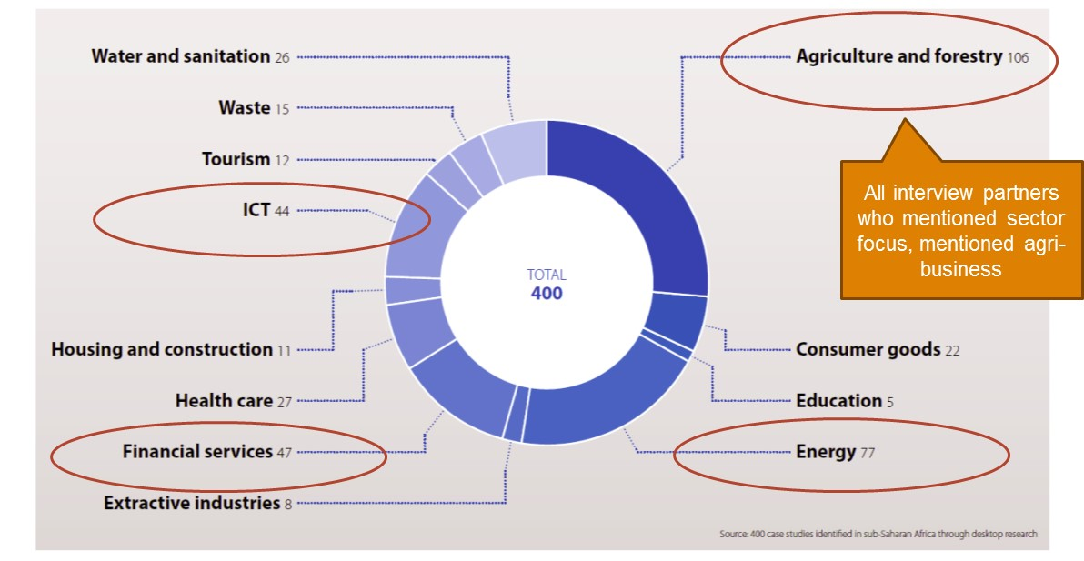

Source: Realizing Africa‘s Wealth, UNDP 2013.  
Numbers are case studies per sector examined in the report; report only focused on sub-Saharan Africa

As it might be too broad, to work in “agribusiness”, AIMEC can even pick sub- and related sectors like “cross border trade in agribusiness” or “fisheries”. AIMEC could also consider cross-cutting topics like “inclusion of informal business”, “inclusion of diaspora in inclusive business”, “business in conflict areas”, “gender/female entrepreneurship” or “youth entrepreneurship”. AIMEC will chose topics and focus areas that are relevant to its main stakeholders like the AUC or the RECs and where it sees a critical mass of best practice in IM and IB policies and programmes.

Some sectors, such as agribusiness, are more labour intensive than others and so are more conducive to thus enabling low-income communities to access tools and resources to grow themselves out of poverty through private sector initiatives. Other sectors like water and sanitation, waste/recycling or renewable energies fall under the category of “green industries”, thus helping low-income communities to mitigate and adapt to the risks of climate change and to build a sustainable future. Some donors indicated that they would like to see work on sectors like health and education included in the scope of AIMEC which have large social impacts on low-income groups.[[9]](#footnote-10)

## Target clients and their benefits

AIMEC will start with a focus on policies and programmes and will target both **public and private sector stakeholders.** Including private sector stakeholders is key to success as inclusive markets need participation and buy-in from businesses.

Specifically, the following three stakeholder groups will be targeted:

1. Target clients in the **public sector and their affiliates** are the African Union Commission (AUC), the AU’s Member States national and local government, and Regional Economic Communities (RECs).
2. **Private sector** clients will include companies, both MSMEs and multinationals of African origin or those with significant operations in Africa; and regional business or trade associations.
3. **Other development actors,** such as bi- and multilateral development partners or foundations, as well as civil society organisations will also be targeted.

These distinct client groups will benefit from AIMEC in different ways. While public stakeholders will benefit from policy and programme advice, private sector stakeholders in particular may benefit from catalytic support for collaboration and incentives for innovation. Development actors will appreciate AIMEC as an information hub and one-stop-shop for analysis as well as a multiplier of their own work in the IB/IM space. All stakeholders may benefit from knowledge exchange and training provided by AIMEC. The design of AIMEC has been aimed at providing relevant services for each of these groups in response to the demand expressed in the feasibility study.

# Organisational Structure

After a brief introduction of general design criteria, this chapter lays out a possible organisational structure for AIMEC identified in the feasibility study along with its implications.

Interview partners, especially the Office of Legal Counsel of the AUC, also helped to gather a list of criteria which should be considered for the hosting option and location of the Centre.

## Success factors and criteria for determining organisational setup

The feasibility study identified some success factors of AIMEC, which have guided the design of the organisational set-up.

The following criteria will guide determination and realisation of the organisational setup:

* ***Clear ownership and leadership***: AIMEC should have a clear owner who is able to drive the implementation of its business plan. In the same way, the Centre will only move forward if there is a dedicated team of committed individuals to drive the ideas of this Centre. The director of the Centre will lead the team and build up networks to connect all relevant actors as well as ensure financing of the Centre.
* ***Flexibility***: The Centre will profit from being able to move quickly into implementation, i.e. be operational within one year, and take operational decisions independently. It should also remain attentive to the potential fluctuating demand of its products and services and adapt accordingly.
* ***Pan-African outlook***: The Centre should be pan-African and not too closely related to one country or one REC to ensure its neutrality.
* ***Ability to attract funding and earn money to ensure sustainability***: The Centre will need to attract investor and donor funding during the set up phase and funding from various sources for the fund instrument in the medium to long term. This will only be possible if the legal form allows investments, donations and grants. At the same time, it needs to be able to earn money through payments for services and so the institutional form chosen needs to allow this.

In terms of determining hosting and location, the following criteria are **essential**:

* The host country is **interested in leading the development of solutions for IB and IM** and will provide **political support and leadership** to the Centre.
* **The host country should supply financial and/or in-kind resources** and political support, at a minimum during the set-up phase. The host country will also be the one selecting the exact physical location for the Centre.
* The Centre should be located **close to relevant institutions** to be able to build up networks and participate in events and meetings easily.
* The location should be **politically stable** to ensure a conducive operational and working environment. As AIMEC will not necessarily organise events, trainings etc. in its own location, it seems less important to select a country that has a conducive policy of handing out visas.
* It will be beneficial if the location has a **high ease of doing business** to enable smooth operations.

The Centre might expand into more African regions overtime and open regional offices if there is funding and a demand for it.

## Organisational structure: AUC owned Centre

AIMEC is planned to be an **AUC owned** Centre. It might be either set up as a project or initiative of an existing AUC unit, or as a trust/foundation. These two options ensure the criteria outlined above are met, and are the only options for a Centre under the AUC to have the chance to be operational within a year. In the long run, AIMEC might be changed into a different legal structure under the auspices of AUC. The operations will be detailed in the hosting agreement made with the AIMEC host-country.

An alternative might be, to set up an AUC trust or foundation. The Assembly of Heads of State and Government makes a decision to establish a trust/foundation. An example is the AU Foundation. The trust/foundation operates as an autonomous entity. Council members, including public and private sector representatives can advise the trust/foundation, and a secretariat is responsible for the day-to-day operations and decisions of the trust/foundation.

To make the institution pan-African, a decision of the Assembly is required requesting the Commission to establish a trust or a project to be hosted by the AU. This institution will then be registered in one of the Member States, following relatively simple procedures.

However, in case AIMEC is hosted by an AU institution, Member States usually worry about the financial implications. In addition, the set up by the AU may take more time to approve the structure, even as an interim structure. In this case, the Centre would take more than a year to be operational. These will be issues which need to be solved in dialogue with member states and the host country.

While all forms of AU institutions may now be able to receive grants and raise fees if these requirements are included in the establishing agreement, all forms of AU institutions other than those outlined above would take more time to be established; Member States need to negotiate an instrument and also to agree on financial and structural implications.

The **hosting** **can be done by any member country of the African Union** which fulfils the criteria mentioned in chapter ‎5.1. The host might be identified in an open process where countries can apply for hosting the Centre.

## Governance and management

To be cost effective and flexible, AIMEC will use a **network structure** with a small core management team supported by a range of associated experts, and linked to a variety of partner organisations and stakeholders. Network partners will play an important role in providing specific services and in implementation support of specific projects (more details on partners in chapter ‎6.1). Partnerships with key stakeholders may be transformed into more formal strategic partnerships over time.

A governing board representing key stakeholder groups including representatives from the AU, the RECs, UNDP, relevant donors, the private sector and an independent expert on IB/IM, will provide guidance. They will support AIMEC in building networks, reaching out to relevant stakeholder and steer key decisions like the annual focus.

## Staffing

Based on the feasibility study and benchmarking with other Centres, AIMEC should be able to start and run as a small organisation staffed with around five people focusing on core activities, with the ability to expand the team as the demand for its services grows.

The recruitment of the team will follow AUC procedures and standards.

Besides a **director** responsible for overall strategy and high-level partner engagement which includes resource mobilisation, **two technical experts** will focus on analysis and dissemination of best practice and the organisation of the annual forum as well as the work around the Catalytic Fund. For this, they will require different technical and research expertise as well as project management skills. The technical experts will also serve as country engagement managers, reaching out to AU Member States to identify needs and best practices. Thus, they also need networking skills. AIMEC could outsource the design of the Catalytic Fund to appropriate experts, but keep a dedicated project manager.

The permanent staff might be supported through **volunteers** of the AU volunteer programme or through **fellows** supported by scholarships. These additional team members will support the core team with research and communication tasks.

They will be supported by **one administrative and finance officer** as well as **a (potentially part-time) staff member responsible for communication**, graphic design and website/network management.

In addition to that, AIMEC will engage with **think tanks and consultancies** for research projects and publications.

During recruitment, attention will be paid to ensuring diversity to the team, balancing gender, languages and geographic background of staff, for example. Priority will be given to African candidates.

Ideally, the people staffing the AIMEC should come from a diverse set of roles and backgrounds, including experience in the private sector and international organisations. Bringing a diverse group of expertise together will give the AIMEC team a broader range of perspectives and a more comprehensive approach to AIMEC’s activities.

### Director profile

The director will be appointed to act on behalf of AIMEC’s stakeholders to lead the day-to-day operations of the business and guide the Centre to fulfil its mission. Twice per year, the AIMEC will hold a steering board meeting at which the director must provide a report to the members on the performance of the Centre as well as report on plans and strategies. In addition to AIMEC’s operational activities, the director deals with the financial sustainability of the Centre. Given the mission and vision of the Centre, the director guides and sets the pace for its current operations and development of future activities. S/he reviews and evaluates the activities and future opportunities and identifies strategic options for the Centre.

The director should have strong leadership and background in developing inclusive businesses or markets, and understand the challenge and the opportunities that come with them. S/he should ideally have worked in the private sector for ten years plus, to understand the demand of inclusive businesses for inclusive markets and have a solid network that the AIMEC can tap into. This will enable the AIMEC to eventually be based on a pull system, where the businesses’ demand for a more conducive environment is communicated to AIMEC, and the Centre can act upon this demand by adapting its services and passing the demand on to policymakers.

### Analysts profile

It is recommended to staff the Centre with two analysts/technical advisors. The analysts/technical advisors will develop the selection criteria of what is “best practice”, work on the knowledge products, conceptualise of the annual forum and manage the Catalytic Fund. They will also provide advice to government on how to replicate programmes and policies as well as conduct trainings. Under the aegis of the director, analysts elaborate conceptual frameworks of the Centre’s activities.

### Support staff

Working in the AIMEC involves dealing with a diverse group of people outside the organisation, as well as communicating AIMEC’s purpose and activities to the outside world. It will thus be important to include a staff member that is able to cover communication tasks and has proven skills in communication. This may include sharing gathered knowledge on a website, in blogs, events etc. The support staff will also support the organisation of events, workshops and trainings. Another task that will be required by support staff is to cover administrative tasks and financial management in order for AIMEC’s operations to run smoothly.

### Volunteers

Volunteers, such as interns, research fellows and secondees in the AU Volunteers programme support the director, analysts and support staff in their day to day tasks and activities and especially in research tasks. As volunteers will join the AIMEC for a limited time period of around six months, they are well positioned to be included on a project basis, such as the specific reports or the annual event.

# Partners

AIMEC will rely and build upon an ecosystem of partnerships. Partners will be fundamental to the Centre’s work: They can enable AIMEC to tap existing networks, support in the dissemination of information, partner in AIMEC’s planned activities and provide funding. Partners will come from a variety of sectors, such as academia, government, business, development actors and think tanks. It will be important to include organisations and associations that represent the Centre’s target group. Many of the actors mentioned in this chapter have been interviewed and thus constitute a preliminary and non-exhaustive list of potential partners, providing insights into the role they could play. The roles also depend on the organisational and legal set-up of the Centre: AIMEC could be hosted by an AUC, or UN, or by an independent institution.

## Partner network

The different roles of AIMEC’s partners are highlighted below. Independent of its partner network, the Centre will rely on several partners for strategic guidance, including the AUC, UNDP, the African Development Bank and the RECs.

**Potential providers of information and knowledge input**

|  |  |  |
| --- | --- | --- |
| Organisation name | Description | Partnering opportunity |
| [BEAM Exchange](https://beamexchange.org/)  (Building Effective and Accessible Markets | A platform for sharing knowledge and learning about how market system approaches can be used to reduce poverty. The aim is to improve the impact and effectiveness of programmes. | BEAM Exchange could provide technical information on how to build market based approaches and assist AIMEC in developing market based solutions. |
| [Investment Climate Facility for Africa](http://www.icfafrica.org/) (ICF) | Initiative through which donors, business, civil society organisations collaborate with African governments and regional organisations to improve investment climate. | AIMEC can benefit from ICF experience in how to work with governments to create an enabling environment for businesses. |
| [Seas of Change](http://seasofchange.net/) | A long-term applied research, innovation and exchange program that helps businesses, governments and NGOs tackle operational challenges and share innovative practices with a focus on inclusive agri-food markets. | Provision of research on how governments can help drive an inclusive approach to agricultural development. |
| [Bertha Centre for Social Innovation](http://www.gsb.uct.ac.za/s.asp?p=389) (University of Cape Town) | First academic Centre in Africa dedicated in advancing social innovation and entrepreneurship. Collaborate with the Social Enterprise Academy for training. | Research partner around social entrepreneurship. |
| [BoP Learning Lab South Africa](http://www.bop.org.za/BoP_Lab/Home.html) | Provides sources of inspiration and acts as a toolbox with which the Southern African corporate fabric can maximize its social impact at the BoP, generating specific action research, disseminates knowledge through workshops, case studies and publications. | Research on IB and IM. |

**Potential partners for the dissemination of findings**

|  |  |  |
| --- | --- | --- |
| Organisation name | Description | Partnering opportunity |
| [Pan-African Chamber of Commerce and Industry](http://www.pacci.org/) (PACCI) | PACCI serves Africa’s business by promoting for public policies that will foster continental economic integration, competitiveness, and sustainable growth. PACCI offers its constituents a wide range of services including advocacy for the creation of the African Economic Community, capacity building, and business networking. | Through its pan-African network, PACCI is well positioned to spread AIMEC’s findings among its members. |
| [IB Accelerator](https://iba.ventures/) | Facilitates the acceleration of impactful entrepreneurship at the Base of the Pyramid by building a structure that supports the delivery of substantial numbers of investment-ready inclusive business plans. | Through its matchmaking platform, IB Accelerator could act as an intermediate to connect governments with inclusive entrepreneurs and thus understand their needs. |
| [Inclusive Business Action Network](http://www.inclusivebusinesshub.org/micro-site/iban/) (IBAN) | Network of inclusive businesses, investors, innovation hubs and global institutions. It aims to highlight existing solutions that support inclusive businesses and promote partnerships by making knowledge easily accessible. | As a network, IBAN could share AIMEC’s findings, thus facilitating access to relevant information. |
| [UNDP Regional](http://www.undp.org/africa/privatesector) Service Center for Africa, Inclusive Growth and Sustainable Development cluster | Core mandate is to engage the private sector to reduce poverty and accelerate progress towards sustainable development by supporting inclusive economic growth and inclusive market development in Sub-Saharan Africa. | The AIMEC could continue and support the center’s ongoing activities. |
| [Pan-African Agribusiness and Agro Industry Consortium](https://www.growafrica.com/organizations/pan-african-agribusiness-and-agroindustry-consortium) (PanAAC): | Private sector-driven platform bringing together agribusinesses and agro industry value chains and support services to enable them to access information, strategic partnerships and financial remediation. | Bringing together agro industry value chains, PanAAC could assist AIMEC in its endeavour to enhance regional integration. |
| [Grow Africa](https://www.growafrica.com/organizations/grow-africa) | Network with the goal to accelerate private sector investment in agriculture, brokering collaboration between governments, international and domestic agriculture companies and smallholder farmers. | With 12 African country members, Grow Africa constitutes of an international network that could spread AIMEC’s findings. |

**Possible partnering activities**

|  |  |  |
| --- | --- | --- |
| Organisation name | Description | Partnering opportunity |
| [African Centre for Economic Transformation](http://acetforafrica.org/) (ACET): | Economic policy institute supporting Africa’s long-term growth through transformation. | Providing analysis, advice and advocacy on economic growth and regional integration, ACET could be a partner to complement AIMEC’s activities. |
| [Southern Africa Business Forum](http://southern-africa-business-forum.org/joomla3/) (SABF) and Southern Africa Trust | Platform for private sector engagement with the SADC Secretariat. One of six working groups focuses on industrialisation and cross boarder value chains.  The Southern Africa Trust offers inclusive business tools, value chains, supplier development programmes, networks in the business sector, government, and business associations. | The SABF could bring in the SADC network, collaborate in research, exchange, and feed into each other’s processes.  The Southern Africa Trust covers similar subjects and has a wide range of regional networks that AIMEC could tap into. |
| [African Enterprise Challenge Fund](http://www.aecfafrica.org/) (ACEF) | Provides funding through competitions with a focus on agribusiness and energy systems. Private sector companies are invited to compete for funds by submitting their new and innovative business ideas. | Collaboration in challenge fund activities. |

**Possible financing partners**

|  |  |  |
| --- | --- | --- |
| Organisation name | Description | Partnering opportunity |
| [Japan International Cooperation Agency](http://www.jica.go.jp/english/) (JICA) | Japanese government development agency | If AIMEC sets its focus area coinciding with strategic areas of donor governments or international funds, AIMEC should be able to mobilise resources from them. In case of the Japanese Government, this should include health. |
| [International Fund for Agricultural Development](https://www.ifad.org/) (IFAD) | Specialised agency of the United Nations | IFAD has 5% discretionary fund so funding is possible, but not significant; up to $1m possibly. But must have good outcomes and must be specific. IFAD could also act as board member. |
| Endowment partners | Private Foundations | Depending on the focus of the AIMEC, foundations can be addressed to co-finance the Centre, especially after the set-up phase. |
| Arab Fund | Based in the State of Kuwait, is an Arab regional financial institution focused on funding economic and social development by financing public and private investment projects and providing grants and expertise. | With 7 of its member countries being African (Maghreb states, Egypt, Sudan), Arab Fund could play a co-financing role. |
| Islamic Bank for Development (IBD) | The purpose of the Bank is to foster the economic development and social progress of member countries and Muslim communities individually as well as jointly in accordance with the principles of Shari'ah i.e., Islamic Law. | The bank provides equity capital, grant loans and financial assistance to its member states and sets up trust funds. IBD could act as co-financing partner. |

## Partner support

Many participants in the online survey showed willingness to support AIMEC as Figure 8 below shows. Most participants offer to share contacts and networks (87 percent), but also offer hosting (53 percent) or even funding the Centre (13 percent).

Figure 8: Ecosystem actors are willing to partner in multiple ways

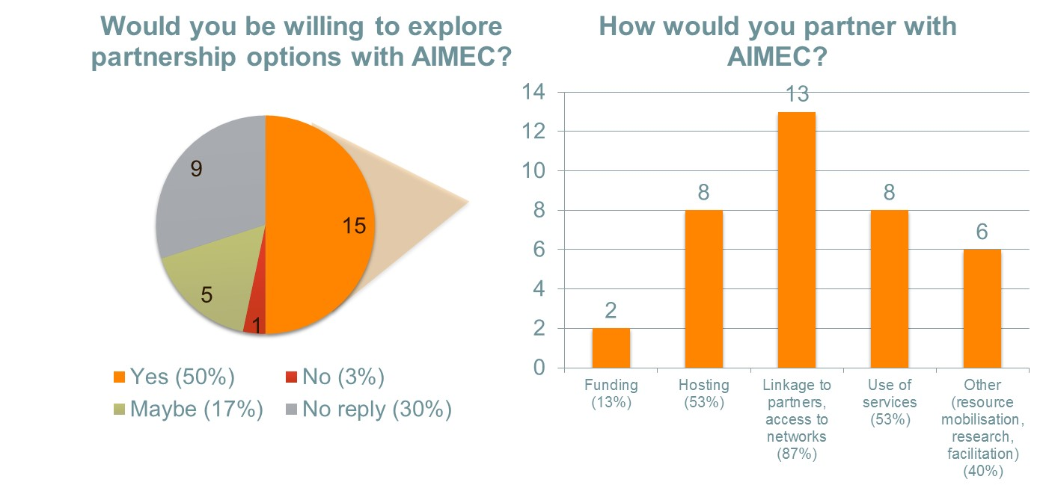  
Source: Online survey

AU Member states which participated in the online survey also showed interest in supporting the Centre as Figure 9 shows. Most countries state that they would use the services of the Centre, 67 percent of the people answering the question can imagine hosting it, and 25 percent would consider contributing financial resources.

Figure 9: Member States can imagine partnering in multiple ways

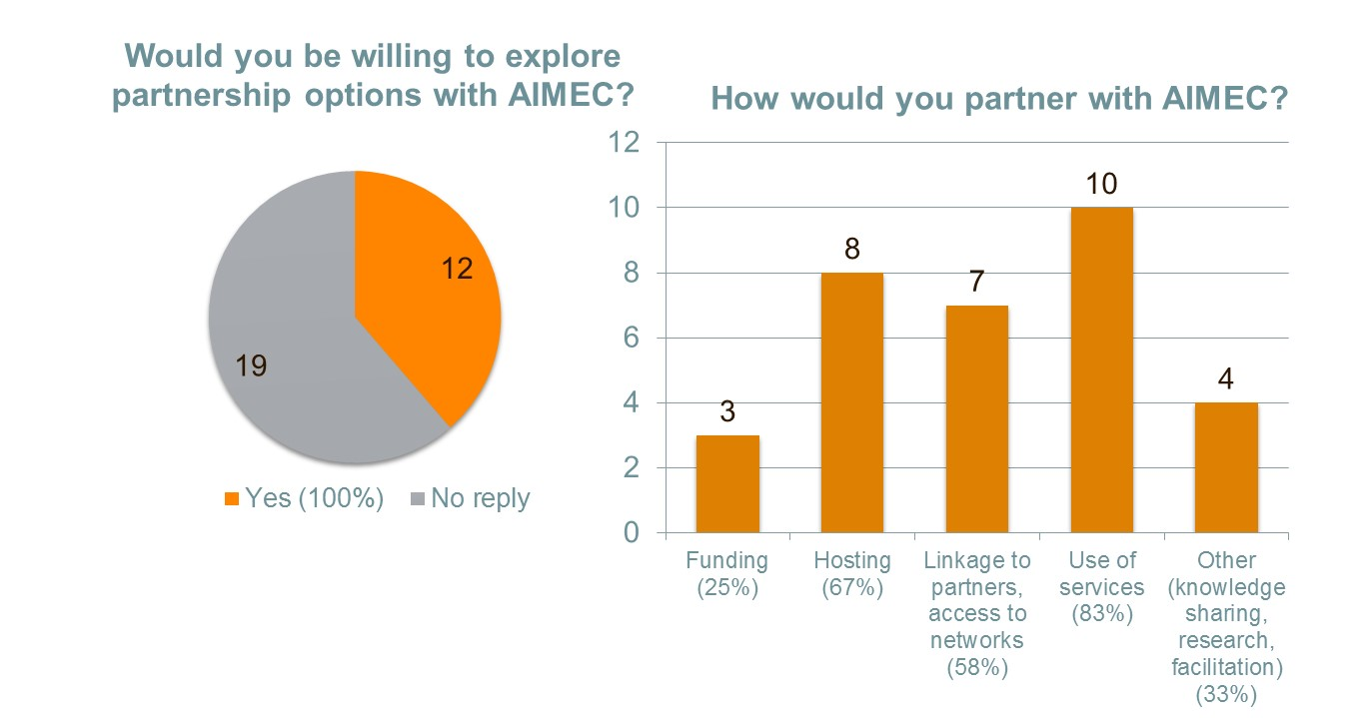  
Source: Online survey

# Operations

This section outlines AIMEC’s approach to set out performance measurement and summarises how AIMEC will engage in communication with key stakeholders.

## Measuring performance

AIMEC should adopt a result driven management approach, and activities, outputs and outcomes should be carefully monitored and analysed as an integral part of its operational activity. To a large extent these indicators will be determined by the budget and approved operational plans, and once AIMEC is established the finalisation of these indicators is a key priority. This set of indicators should be reviewed periodically to ensure they cover AIMEC’s ambition and service portfolio, which may change over time particularly in the early years as AIMEC is taking shape.

Both quantitative and qualitative indicators will be tracked. Attention should be paid to appropriately distinguishing between contribution and attribution of AIMEC, to the extent possible. An indicative log frame, which captures the key output areas, activities and suggested indicators, is contained over the page. This should form the basis of subsequent revisions and refinements during the set up phase of AIMEC.

|  |  |
| --- | --- |
| **OUTCOME** | **INDICATIVE OUTCOME INDICATORS AND TARGETS** |
| **Best practice in inclusive business and inclusive market policy and programming across the African continent available and promoted to key stakeholders**   * AIMEC is a recognised platform for thought leadership and catalytic action on IB and IM policies and programmes in Africa * Best practice in IB and IM policy and programming is promoted, disseminated and replicated across Africa | * Number of policy papers on inclusive business and inclusive market policies adopted by the AU, RECs and/or member states   *Target: two every three-year implementation cycle*   * AU Member states with policies and programmes explicitly supporting inclusive markets and businesses   *Target*: *10% of member states (5) after three years, 20% (10) after five years*   * Percentage increase in number of inclusive businesses in Africa   *Target:15% increase after five years (baseline to be defined)*   * Percentage increase in number of events on inclusive business and inclusive markets in Africa   *Target*: *10% after three years, 25% after five years (baseline to be defined)* |

|  |  |  |  |
| --- | --- | --- | --- |
| **OUTPUT DESCRIPTION** | **INDICATIVE OUTPUT INDICATORS & TARGETS** | **ACTIVITIES** | **INDICATIVE ACTIVITY INDICATORS** |
| **Key Output A: IDENTIFY**  Inclusive business and inclusive market policies and programmes are identified, analysed and documented. | * Number of policies and programmes documented and captured on database in year one.   *Target: 100 in year 1*   * Number of knowledge products (analytical products & case studies) published per year   *Target: 4 per year*   * Annual flagship publication produced and disseminated   *Target: 1 per year* | * Compile comprehensive database of existing programmes, initiatives and policies around IB/IM in Africa * Identify best practice criteria * Develop analytical products * Research case studies * Develop and host an online information platform * Develop a flagship publication | * Number of policies mapped, evaluated and documented * Number of policy papers published * Number of case studies developed * Unique visitors to online information platform * Annual flagship publication produced and disseminated |
| **Key Output B: FACILITATE**  The replication, adoption and development of best practice is facilitated by acting as a platform for coordination and facilitation between key actors | * Number of workshops and/or training sessions held   *Target: 6 per year*   * Number of regions in which workshops and/or training sessions are held   *Target: 4 different regions*   * Number of attendees and organisations attending annual conference   *Target: 50 attendees from 25 organisations* | * Broker linkages and facilitate collaboration among IB/IM actors in Africa by convening topic specific workshops and dialogue forums * Convene an annual conference on inclusive business and inclusive markets policies and programmes in Africa | * Number of workshops and/or training sessions held * Number of dialogue forums held * Annual conference hosted * Number of attendees at annual conference * Number of organisations represented at annual conference |
| **Key Output C: REPLICATE**  Successful inclusive businesses and market programmes are scaled, and innovative solutions where existing approaches are not effective are piloted, thereby multiplying best practice. | * Number of applications to the African Inclusive Markets Challenge Fund   *Target: 20*   * Number of grants awarded annually   *Target: Four grants (2 scaling/replication and 2 innovation piloting)* | * Identify sectors:   + In which existing activities could be usefully replicated or scaled, and   + Where innovative approaches are needed * Design specific windows for each funding round * Run open, transparent and competitive funding window and select winning applications * Oversee grant implementation | * Gap analysis research completed and funding windows designed (two per year) * Number of applications to the African Inclusive Markets Policy Challenge Fund * Number and value of challenge fund grants awarded for i) scaling/replication and ii) innovation pilots * Number of grantees meeting project targets (yearly) * Funds leveraged through matching of grants |
| **Key Output D: Sustainability (longer term)**  Services provided within the IB/IM space on a fee-paying basis, with the goal of contributing towards the financial sustainability of the Centre | *As a longer term goal, time-bound targets are not yet set at this time*   * % of AIMEC operating budget funded by fee-paying services | * Facilitate training and workshops on demand * Provide consulting services * Manage and execute special projects | * Number and value of paid workshops and/or training sessions conducted * Number and value of consulting assignments completed * Number and value of special projects managed or executed |

## Communication

AIMEC will communicate with its partners and clients in a variety of ways:

* Its **website and social media channels** will be a key tool for sharing information and best practice.
* Through **partnerships** with academia, think tanks, multilateral agencies and donor programmes, these institutions’ communication vehicles can be harnessed for communicating the AIMEC brand and value proposition (initially) and disseminating its findings (later on).
* The annual grant **competition** for the Catalytic Fund will be used to communicate with technical experts, donors, policy makers and political stakeholders from across the IB/IM sphere.
* The annual **conference** will also be a tool for communication with engaged audiences.

A detailed communication plan will be developed during AIMEC’s setup phase.

# Funding and financing

Achieving financial sustainability is a key aim for AIMEC. At the same time, realism about funding and financing options in the pan-African public-private space is warranted, and AIMEC will be funded through a mix of:

* **Core funding**, i.e. regular contributions from member states, bi- and multilateral donors, UN agencies, private companies, foundations and other partners.
* **Project funding** from partners looking for specific support, e.g. development actors seeking implementation support,
* **Fees** for service, such as trainings or conferences or from or private companies or government agencies requiring specific consulting or technical assistance services.

## Income & Funding

Results of the AIMEC feasibility study suggest that **fee-based financing will be limited**, given that the services proposed mainly create public goods, which makes it more difficult to charge for them. Moreover, AU member states are typically limited in their resources, which makes it more difficult to raise fees from them. As far as income generation through **consulting services** for the private sector is concerned, it should be noted that a considerable degree of competition exists and there are other considerations such as the consequences of working for specific companies and institutions. Given these constraints, **donor funding** will play an important role in financing the Centre, particularly in the short- to medium-term (preparation and setup stages).

## Cost of AIMEC

Based on the activities outline in chapter 7.1 and in Annex 3, the costs of implementing AIMEC over five years are set out in the **Profit and Loss Statement** below. All values are provided in US Dollars. Please refer the accompanying excel file for underlying cost assumptions.

This financial plan is based on the assumption, that AIMEC will be part of a larger organisation yet will operate rather independently. The differences between the two suggested organisational forms are thus not considered in great detail; thus, the financial plan will need revision once the organisational set up has been decided upon.

|  |  |  |  |  |  |  |  |  |
| --- | --- | --- | --- | --- | --- | --- | --- | --- |
| **Profit and Loss Statement** | | | | | | | | |
|  | **Yr1** | **Yr2** | **Yr3** | **Yr4** | **Yr5** | **Total** |  |
|  |  |  |  |  |  |  |  |
| **Income** |  |  |  |  |  |  |  |
| Subsidies | 2,500,000 | 2,500,000 | 2,500,000 | 1,250,000 | 1,250,000 | 10,000,000 | 92.0% |
| Consulting | 0 | 0 | 50,000 | 100,000 | 125,000 | 275,000 | 2.5% |
| Other income activities | 0 | 0 | 100,000 | 200,000 | 200,000 | 500,000 | 4.5% |
| Total Income | 2,500,000 | 2,500,000 | 2,650,000 | 1,550,000 | 1,575,000 | 10,775,000 | 100% |
|  |  |  |  |  |  |  |  |
| **Expenditure** |  |  |  |  |  |  |  |
| Rental facilities | 35,000 | 38,000 | 42,000 | 45,000 | 51,000 | 211,000 | 2.0% |
| Personnel | 423,000 | 464,000 | 512,000 | 562,000 | 619,000 | 2,580,000 | 24.0% |
| Advisory Boards | 30,000 | 33,000 | 37,000 | 39,000 | 44,000 | 183,000 | 1.7% |
| Phone | 28,000 | 30,000 | 34,000 | 37,000 | 41,000 | 170,000 | 1.6% |
| Internet | 4,000 | 3,000 | 5,000 | 4,000 | 6,000 | 22,000 | 0.2% |
| ICT support & Website development | 6,000 | 4,000 | 5,000 | 5,000 | 7,000 | 27,000 | 0.3% |
| Postage, Photocopying, Stationery and Printing | 21,000 | 22,000 | 25,000 | 27,000 | 30,000 | 125,000 | 1.2% |
| Partnership Meetings | 357,000 | 392,000 | 432,000 | 474,000 | 523,000 | 2,178,000 | 20.2% |
| Training and workshops | 139,000 | 152,000 | 168,000 | 184,000 | 203,000 | 846,000 | 7.9% |
| Catalytic Fund | 356,000 | 391,000 | 431,000 | 473,000 | 521,000 | 2,172,000 | 20.2% |
| Consultancies | 55,000 | 55,000 | 61,000 | 66,000 | 74,000 | 311,000 | 2.9% |
| Publications | 20,000 | 20,000 | 24,000 | 48,000 | 40,000 | 152,000 | 1.4% |
| Service Provision | 71,000 | 80,000 | 88,000 | 98,000 | 106,000 | 443,000 | 4.1% |
| Motor Vehicle Expenses | 14,000 | 15,000 | 17,000 | 18,000 | 21,000 | 85,000 | 0.8% |
| Advertising & PR | 55,000 | 60,000 | 67,000 | 73,000 | 81,000 | 336,000 | 3.1% |
| Accounting, Audit & Legal | 15,000 | 10,000 | 11,000 | 12,000 | 14,000 | 62,000 | 0.6% |
| Insurances | 7,000 | 7,000 | 8,000 | 8,000 | 10,000 | 40,000 | 0.4% |
| Functions, launch, office refreshments | 36,000 | 22,000 | 25,000 | 27,000 | 30,000 | 140,000 | 1.3% |
| Staff Training | 20,000 | 10,000 | 11,000 | 12,000 | 14,000 | 67,000 | 0.6% |
| Depreciation | 22,000 | 21,000 | 22,000 | 21,000 | 22,000 | 108,000 | 1.0% |
| Contingency | 47,000 | 82,000 | 92,000 | 100,000 | 111,000 | 432,000 | 4.0% |
| M&E | 0 | 35,000 | 10,000 | 20,000 | 10,000 | 75,000 | 0.7% |
| **Total Expenditure** | 1,761,000 | 1,946,000 | 2,127,000 | 2,353,000 | 2,578,000 | 10,765,000 | 100% |
|  |  |  |  |  |  |  |  |
| **Trading Profit/Loss** | 739,000 | 554,000 | 523,000 | (803,000) | (1,003,000) |  |  |
|  |  |  |  |  |  |  |  |
| **Cumulative Profit/Loss** | 739,000 | 1,293,000 | 1,816,000 | 1,013,000 | 10,000 | 10,000 |  |
|  |  |  |  |  |  |  |  |

Capital expenditure in the first year to equip the office for the following 4-year period amounts to $110,400 and is made up of a vehicle, office furniture, ICT equipment and office refurbishment costs.

Based on this budget, the following **financial support** is required over a 5-year period:

|  |  |  |  |  |  |  |
| --- | --- | --- | --- | --- | --- | --- |
|  | **Yr1** | **Yr2** | **Yr3** | **Yr4** | **Yr5** | **Total** |
| **Subsidies** |  |  |  |  |  |  |
| Donor 1 | 1000000 | 1000000 | 1000000 | 500000 | 500000 | 4000000 |
| Donor 2 | 1000000 | 1000000 | 1000000 | 750000 | 750000 | 4500000 |
| Donor 3 | 500000 | 500000 | 500000 | 0 | 0 | 1500000 |
| **Total Subsidies** | **2500000** | **2500000** | **2500000** | **1250000** | **1250000** | **10000000** |

This is supported by a **cash flow analysis** based on the activity plan proposed:

|  |  |  |  |  |  |  |
| --- | --- | --- | --- | --- | --- | --- |
|  | **Yr1** | **Yr2** | **Yr3** | **Yr4** | **Yr5** | **Total** |
|  |  |  |  |  |  |  |
| ***Income*** |  |  |  |  |  |  |
| *Donors* | 2,500,000 | 2,500,000 | 2,500,000 | 1,250,000 | 1,250,000 | 10,000,000 |
| Consulting | 0 | 0 | 50,000 | 100,000 | 125,000 | 275,000 |
| Other income activities | 0 | 0 | 100,000 | 200,000 | 200,000 | 500,000 |
| **Total Income** | **2,500,000** | **2,500,000** | **2,650,000** | **1,550,000** | **1,575,000** | **10,775,000** |
|  |  |  |  |  |  |  |
| **Expenditure** |  |  |  |  |  |  |
| Operational expenditure | 1,692,000 | 1,843,000 | 2,013,000 | 2,232,000 | 2,445,000 | 10,225,000 |
| Capital expenditure | 115,000 | 0 | 0 | 0 | 0 | 115,000 |
| Contingency expenditure | 47,000 | 82,000 | 92,000 | 100,000 | 111,000 | 432,000 |
| **Total Expenditure** | **1,854,000** | **1,925,000** | **2,105,000** | **2,332,000** | **2,556,000** | **10,772,000** |
|  |  |  |  |  |  |  |
| **Trading Cash Balance** | **646,000** | **575,000** | **545,000** | **(782,000)** | **(981,000)** |  |
| **Cumulative Cash Balance** | **646,000** | **1,221,000** | **1,766,000** | **984,000** | **3,000** | **3,000** |

It should be noted that this projection includes income generation in Years 3 to 5 of approximately $775,000.

Concerning AIMEC’s income generating activities, the *consulting* component is seen as carrying out paid studies and work for the benefit of donors, governments etc., such as requesting a state of IB report in a specific country. *Other income activities* are seen as raising additional funds for AIMEC activities, such as via applications to donors and foundations for grants, fund raising from approaches to companies supportive of IB, and getting sponsorships for the IB annual report.

Further details are available in an Excel file accompanying this document.

# Risks and mitigation measures

Table 2 provides an initial SWOT analysis of the AIMEC.

Table 2: SWOT analysis

|  |  |
| --- | --- |
| **Strengths** | **Weaknesses** |
| * Pan-African set-up * Political clout * Structures in place if docked to an existing institution * Concrete and pre-defined outputs will steer AIMEC’s success | * Donor dependency for funding * Responsiveness could be limited |
| **Opportunities** | **Threats** |
| * AIMEC covers a gap in the market * AIMEC can act as a platform to consolidate Member States efforts in establishing conducive IB&IM policies | * Changing priorities of donors * Inability to find adequate staff * Attachment to AUC can result in sclerotic organisation * Inability to find ways to raise fees for service |

The AIMEC feasibility study identified key operational challenges and success factors. These are listed in Table 3 below.

Table 3: Operational risks and mitigation measures

|  |  |  |
| --- | --- | --- |
| **OPERATIONAL CRITERIA** | **Risks** | **Mitigation measures** |
| **Staff** | Failure to identify and hire the right set of staff | **Getting the ‘right’ mix of staff and associated experts,** balancing technical skill with vision and commitment |
| **Financial sustainability** | Long-term donor dependence is a risk to sustainability of AIMEC | **Donor support** will be crucial in the short- to medium-term, and likely necessary in the long-term, but **complementary funding** is essential |
| **Ownership** | Fuzzy ownership, lack of buy-in by key stakeholders | **Clear ownership** and stakeholder buy-in strategies for the different stakeholder groups, facilitated by effective communication of AIMEC’s benefits to stakeholders |
| **Governance & management** | Bureaucracy and politicisation | **Balancing political awareness and clout with flexibility** to operate |
| **M&E** | Failure to develop measurable indicators to determine success and assess attribution | Focusing on a **limited set of measurable outcomes** and onassessing contributionrather than attribution |

# Conclusion and next steps

Based on a thorough analysis of the inclusive business and inclusive market actor landscape, AIMEC shows to fill a thematic, geographic and service gap. It will be an essential player in coordinating the landscape and will support other actors to become more efficient in their work. Thus, the AIMEC has the potential to become the recognised pan-African public-private platform on inclusive business and inclusive market policy, identifying, promoting and facilitating the replication and development of best practice in policy and programming across the entire continent.

In order to move towards the implementation and establishment of AIMEC, a number of sequential steps need to be taken outlined below.

Figure **10** provides an indicative implementation timeline, and can be used as a guide for the establishment and operational activities.

**Figure 10: Proposed implementation timeline**



*Finalisation of planning and institutional arrangements*

1. Firstly, the outstanding issues around the design of AIMEC need to be finalised by the relevant stakeholders especially the decision upon a host country. This will allow the business plan to be finalised as the “foundation” document of AIMEC that will guide the remainder of the operationalisation activities.
2. Once this is completed, then initial funding for the first year of AIMEC’s operation (at a minimum) needs to be secured. This initial budget will determine the final scope of activities that AIMEC will be able to undertake, and so will influence the final business plan, including the number and type of staff required.

When there is certainty on the operational design and the availability of funding, then AIMEC can move towards an operational phase and begin the process of establishing itself.

*Establishment phase*

1. As a first step towards the establishment of AIMEC, a board will have to be established in line with the final institutional arrangements agreed. This board is essential to drive the establishment process (and as such it may wish to appoint a secretariat to assist with this process).
2. As a first step, the board should recruit a director for the AIMEC. The director will then be mandated to oversee the recruitment of the remainder of the staff, as well as facilitate the practical steps necessary to establish a physical presence for AIMEC.
3. The first substantive task of the AIMEC team will be to turn this business plan into an operational plan that focuses on the first year of activity. Similar to an inception report, this operational plan should lay out in detail the activities, timelines, budgeting and expected outputs of the first year of operations and will then need to be approved by the board.

*Operational phase*

As the pillars of AIMEC are designed to build on one another in a sequential way, implementation will start with Pillar 1 and will then move onto Pillars 2 and 3. While the precise timing is dependent on the operational plan outlined above, it is likely that the first year of operation will concentrate on Pillar 1 activities, and will culminate in the launch of the first AIMEC publication, along with the launch of the website/information portal and the holding of the AIMEC conference. The first call for proposals for the fund grants are likely to be issued 18 months, with the first grants being awarded after 24 months.

# Annex

## Annex 1: List of interview partners

| Organisation | Contact | Position |
| --- | --- | --- |
| Centres of Excellence | | |
| African Institute of Remittances (AIR) | Amadou Cisse | Interim Executive Director |
| Africa Minerals Development Centre | Paul Msoma |  |
| African Centre for Economic Transformation | Edward K. Brown | Director of Policy Advisory Service |
| African Union Mining Centre of Excellence | George Lwanda | Extractives Policy Advisor, UNDP Africa Regional Service Centre |
| International PPP Centre of Excellence | Geoffrey Hamilton | Chief, Cooperation and Partnerships Section |
| CGIAR/ CIAT | Gian Nicola Francesconi | Researcher and Project Manager |
| Other institutional actors | | |
| ACTESA | Argent Chuula | CEO |
| African Enterprise Challenge Fund | Hugh Scott | Director |
| AUC | Bright Mando | Legal Officer |
| BMZ | Silvia Heer | Desk Officer |
| COMESA | Thierry Mutomobo Kalonji | Director, investment promotion and private sector development |
| DFID | Ian Miller | Programme Manager Business Engagement Hub |
| DFID | Robbie Barkell | Investment Climate Team, Growth and Resilience Department |
| UNECA | Adam El Hiraika | Director MPD for Inclusive Growth |
| EC | Mattias Lindström | Policy Officer Private Sector Development |
| IFAD | Richard Pelrine | Lead Regional Economist West and Central Africa Division |
| NEPAD Business Foundation | Lynette Chen | CEO |
| Pan-African Chamber of Commerce and Industry (PACCI) | Kebour Ghenna | Executive Director |
| SADC | Gainmore Zanamwe | Regional Trade Adviser |
| SDC | Luca Etter | Program Manager Private Sector and Development Finance |
| Southern Africa Trust, Business for Development Pathfinder Initiative | Ullrich Klins | Project Manager |
| UNDP | Lebogang Motlana | Director Regional Service Centre UNDP |
| UNDP | Mansour Ndiaye | Africa Regional Cluster Leader, Inclusive Growth and Sustainable Development |
| UNDP Tokyo | Ai Ohara | TICAD Business Consultant |
| UNECA | Daniel Tanoe | Economic Affairs Officer, Investment Policy Section |
| UNECA | David Luke | Coordinator of African Trade Policy Centre |
| USAID South African Trade Hub | Brian McCotter | Coordinator |

## Annex 2: Detailed activities

The **key activities** that underpin the AIMEC can be summarised as follows:

|  |  |  |  |
| --- | --- | --- | --- |
| **Pillar** | **Outcome** | **Lead Activities** | **Sub Activities** |
| **Pillar 1** | **Identify** |  |  |
|  |  |  |  |
| 1.1 | Knowledge Products | 1.1.1 Creating a comprehensive database of existing programmes | 1.1.1.1 Outreach to donors, known practitioners for sharing of data |
|  |  |  | 1.1.1.2 Mapping of initiatives, focal areas and outcomes and updating of forward business plan/budget |
|  |  |  |  |
|  |  | 1.1.2 Identifying best practice criteria | 1.1.2.1 Analysis of IB activities, findings and gaps identified |
|  |  |  | 1.1.2.2 Consultancy hire for expertise to assist AIMEC in assessing criteria framework |
|  |  |  |  |
|  |  | 1.1.3 Developing analytical products | 1.1.3.1 Packaging of learning into appropriate formats |
|  |  |  | 1.1.3.2 Consultancy hire for development of materials e.g. publications, White Papers etc. |
|  |  |  |  |
|  |  | 1.1.4 Researching case studies. | 1.1.4.1 Case study development of interesting approaches/best-practices (4 per annum) |
|  |  |  |  |
|  |  | 1.1.5. Developing a flagship publication on the status of inclusive business policies and programmes in Africa | 1.1.5.1 Annual review of inclusive business in Africa |
|  |  |  |  |
| 1.2 | Database and user interface | 1.2.1 Sharing of best practice, analyses etc. | 1.2.1.1 Develop formats, databases, blogs, data repository, discussion sites, FAQs etc. |
|  |  |  |  |
| **Pillar 2** | **Facilitate** |  |  |
|  |  |  |  |
| 2.1 | Relationship building and learning | 2.1.1 Development of Pan-African IB network | 2.1.1.1 Identification of African stakeholders; development of value offering; initiation of collaboration |
|  |  |  | 2.1.1.2 Workshops to introduce concepts, gain buy-in, identify interest areas in 4 regions |
|  |  |  | 2.1.1.3 Appoint consultant to develop curricula for training (and add 1 module each year thereafter) |
|  |  |  | 2.1.1.4.Training support for practitioners in 8 regional 2.5 day training sessions |
|  |  |  |  |
| 2.2 | Annual conference | 2.2.1 Annual conference to share learning | 2.2.1.1 Setting up and hosting of an annual conference |
|  |  |  |  |
| **Pillar 3** | **Replicate** |  |  |
|  |  |  | 3.1.1.1 Design a specific window |
| 3.1 | Funding window 1: Scaling and replication: | 3.1.1 Identifying existing activities for replication or scaling in other areas. | 3.1.1.2 Call for applications from practitioners for funding to apply EXISTING approaches in new areas |
|  |  |  | 3.1.1.3 Assessment and award of funds to grantees |
|  |  |  | 3.2.1.4 Management of funds and monitoring and evaluation |
|  |  |  |  |
| 3.2 | Funding window 2: Innovative approaches to IM & IB. | 3.2.1 Identifying innovative approaches to IB that could be mainstreamed | 3.2.1.1 Design a specific window |
|  |  |  | 3.2.1.2 Call for applications from practitioners for funding NEW initiatives |
|  |  |  | 3.2.1.3 Assessment and award of funds to grantees |
|  |  |  | 3.2.1.4 Management of funds and monitoring and evaluation |
|  |  |  |  |

## Annex 3: Results of feasibility study

Please find the results of the feasibility study in a separate document.

1. UN and AU Concept Note (2014). http://www.uneca.org/sites/default/files/uploaded-documents/CoM/com2016/e1600515.pdf [↑](#footnote-ref-2)
2. UNDP (2013). *Realizing Africa’s Wealth.* http://www.undp.org/content/undp/en/home/librarypage/poverty-reduction/realizing-africa-s-wealth--building-inclusive-businesses-for-sha.html [↑](#footnote-ref-3)
3. UN and AU CAMEF Report (2016). http://www.uneca.org/sites/default/files/uploaded-documents/CoM/com2016/e1600569.pdf [↑](#footnote-ref-4)
4. McKinsey Global Institute (2016) LIONS ON THE MOVE II: REALIZING THE POTENTIAL OF AFRICA’S ECONOMIES. [↑](#footnote-ref-5)
5. Website of African Development Bank, <http://www.afdb.org/en/blogs/afdb-championing-inclusive-growth-across-africa/post/recognizing-africas-informal-sector-11645/> (accessed Sep 30th, 2016) [↑](#footnote-ref-6)
6. African Union 2013. http://www.au.int/en/agenda2063/ [↑](#footnote-ref-7)
7. ibid. [↑](#footnote-ref-8)
8. This finding is based on an analysis of 400 IB case studies discussed in Realizing Africa’s Wealth,

   UNDP 2013. [↑](#footnote-ref-9)
9. One bilateral donor mentioned that in order to receive donor money, the sector focus should be aligned with the donors’ agendas. In many cases, “health” would have to be included to make donor funding likely. [↑](#footnote-ref-10)