|  |  |  |
| --- | --- | --- |
|  |  |  |

|  |  |  |  |  |  |  |  |
| --- | --- | --- | --- | --- | --- | --- | --- |
|  | |  | | |  | | |
|  | |  | | |
|  | | United Nations | |  | African Union | | |
| _unlogo | | **Economic and  Social Council** | |  |  | | **African Union** |
| E/ECA/CM/50/1  AU/STC/FMEPI/MIN/1(III)  Distr.: General  8 February 2017  Original: English |
| **Economic Commission for Africa**  **Conference of African Ministers of Finance,**  **Planning and Economic Development**  Fiftieth session | | | |  | **African Union**  **Specialized Technical Committee on Finance, Monetary Affairs, Economic Planning and Integration**  Third session | | |
| **Tenth Joint Annual Meetings of the African Union Specialized Technical Committee on Finance, Monetary Affairs, Economic Planning and Integration and the Economic Commission for Africa Conference of African Ministers of Finance, Planning and Economic Development**  Dakar, 27 and 28 March 2017 | | | |  | | | |

**DRAFT STATUTE**

**OF**

**THE AFRICAN INSTITUTE FOR REMITTANCES (AIR)**

**PREAMBLE**

We, the Member States of the African Union;

**MINDFUL** of the Executive Council Decision EX.CL/ Dec. 683(XX) in January 2012, which acknowledges the establishment of an African Institute for Remittances (AIR) will facilitate remittances leverage for economic and social development in Africa;

**BEARING IN MIND** the resolution (Resolution 892(XLV)) of the 5th AU-ECA Joint Annual Meeting of the AU Conference of Ministers of Economy and Finance and ECA Conference of African Ministers of Finance, Planning and Economic Development, in March 2012, which recognized remittances, if well harnessed and formulated, could contribute to growth and development in Africa;

**ACKNOWLEDGING** the Declaration of the Global African Diaspora Summit, Sandton, Johannesburg, South Africa, 25 May 2012, (Diaspora/Assembly/AU/ /Decl (I)) that adopted the African Institute for Remittances as one of the five Legacy Projects of the African Union;

**RECALLING** our Decision (Assembly/AU/Dec.440(XIX)) adopted during the 19th Ordinary Session in July 2012, which endorsed the establishment of the African Institute for Remittances;

**CONSIDERING** the Executive Council Decision EX.CL/ Dec. 808(XXIV) in January 2014, that accepted the offer of the Republic of Kenya to host the African Institute for Remittances (AIR);

**HAVE AGREED AS FOLLOWS:**

**Chapter One**

**GENERAL PROVISIONS**

**Article 1**

**Definitions**

1. In this Statute, unless the context requires otherwise:

**“AIR” means the African Institute for Remittances**

**“Assembly”** means the Assembly of Heads of State and Government of the African Union.

**“Board”** means the Governing Board of the AIR;

**“Constitutive Act”** means Constitutive Act of the African Union;

**“Commission”** means the Commission of the African Union;

**“Development Partners”** means the multilateral institutions, development agencies, donors, foundations and others that have contributed financially or otherwise to the establishment and continue supporting the Institute;

**“DSA”** means the Department of Social Affairs of the Commission;

**“Executive Council”** means the Council of Ministers of the African Union;

**“Forum”** means the Consultative Forum of the Institute;

**“Host country”** means the Government of the Republic of Kenya;

**“Institute”** means the African Institute for Remittances (AIR);

**“Member State”** means a Member State of the African Union;

**“Policy Organs”** means the Assembly, the Executive Council and the Permanent Representatives Committee (PRC) of the African Union;

**“Private Sector”** means theRemittances Service Providers (RSPs), i.e., Banks, Telecoms, Money Transfer Operators (MTOs), Non-bank Financial Institutions such as Microfinance Institutions, Saving and Credit Cooperatives (SACCOs) and Post Offices;

**“Secretariat”** means the Institute’s Secretariat;

**“Stakeholders”** means organizations, individuals and or anyone who has interest on African Remittances and or on the African Institute for Remittances (AIR)

**“Statute”** means the present Statute of the African Institute for Remittances;

**“STC”** means the AU Specialized Technical Committee on Finance, Monetary Affairs, Economic Planning and Integration;

**“Union”** means the African Union as established by the Constitutive Act;

In this Statute, words expressed in the singular term shall be construed to include the plural and vice versa.

**Article 2**

**Establishment of the African Institute for Remittances**

1. The Institute is hereby established as a Specialized Technical Office of the Commission.
2. The objective, structure, mandate and functions of the Institute shall be defined as herein in the Statute.

**Article 3**

**Objectives**

The objectives of the Institute shall be to:

1. Improve the statistical measurement, compiling and reporting capabilities of Member States on remittances data;
2. Promote appropriate changes to the legal and regulatory frameworks for remittances, payment and settlement systems as well as use of innovative technology so as to promote greater competition and efficiency, resulting in reductions of transfer costs;
3. Leverage the potential impact of remittances on social and economic development of Member States, as well as promoting financial inclusion.

**Article 4**

**Functions and Activities of the Institute**

1. In order to attain the above objectives, the Institute shall function in accordance with the provisions of this Statute;
2. The functions and activities of the Institute shall be to:
3. Assist Member States, remittance senders and recipients and other stakeholders to develop and implement concrete strategies and operational instruments to leverage remittances as development tools for poverty eradication;
4. Provide technical assistance to government institutions (Central Banks, Ministries, financial and non-financial institutions) on establishing and operating the necessary regulatory frameworks on remittances;
5. Promote adoption and implementation of the General Principles for International Remittance Services (GPs) by Member States, including transparency and consumer protection, an accessible payment systems infrastructure, an enabling legal and regulatory environment, a balanced market structure and competition as well as sound governance and risk management;
6. Conduct empirical research on remittance markets, to address the main market inefficiencies and explore best practices in the area of remittances and disseminate findings;
7. Collect and disseminate data on remittances and manage the remittances price database including Send Money Africa (SMA);
8. Engage with private sectors players to address market failure, particularly to act as a catalyst in fostering investment in remittances, innovating in service delivery and promoting technology usage by Remittance Service Providers (RSPs) including non-bank financial institutions;
9. Improve capacities of non-bank financial institutions to strengthen their ability to offer remittance services in rural areas;
10. Foster effective ways of networking, coordination and cooperation among Member States and stakeholders to address remittances issues in a more strategic and programmatic manner;
11. Enable development of content and technology platforms for country-based payment and settlement systems for remittances;
12. Promote policies that improve the development impact of remittances;
13. Establish an Information center on remittances in Africa.

**Article 5**

**Seat of the Institute**

1. The Seat of the Institute shall be in Nairobi, Republic of Kenya.
2. The Seat shall house the Institute’s Secretariat.
3. The Secretariat may authorize the convening of meetings and conferences in the territory of any Member State at the invitation of that Member State.

**Chapter Two**

**GOVERNANCE AND MANAGEMENT OF THE INSTITUTE**

**Article 6**

**Governance Structure of the Institute**

The Governance structure of the Institute shall be composed of the following:

1. The Governing Board;
2. The Consultative Forum;
3. The Secretariat.

**Article 7**

**The Governing Board (The Board)**

1. The Board shall oversee the management of the Institute.
2. The Board shall meet at least once a year in ordinary session in accordance with its rules of procedures and shall also be convened upon request, by one half of its members, or upon the request of:
   1. The policy organs of the Union;
   2. The Secretariat, in the event of a situation that necessitate holding of the Board meeting.

**Article 8**

**Composition**

1. The Board shall be composed of eleven (11) members, as follows:
2. Five (5) Ministers of Finance and Economic Planning representing the five Regions of the African Union nominated by their Regions, failing which they shall be nominated by the STC;
3. A representative of the Commission;
4. A representative of the Host country;
5. Two (2) Governors of Central Banks representing the Association of African Central Banks (AACB);
6. A representative of the African Private Sector;
7. Chairperson of the Consultative Forum;
8. Where applicable, the term of office of members of the Board shall be a nonrenewable period of three (3) years;
9. The Board shall elect from among its members, one of the Five (5) Ministers as its Chairperson, on a regional rotational basis for three (3) years. In the event of the Chairperson vacating his/her position before the expiration of his/her tenure of office for whatever reason, he/she shall be replaced by a Minister to be designated by his/her Region.
10. The Legal Counsel of the Commission or his/her representative, without having a voting power, shall attend the Board meetings to provide legal advice as may be required;
11. The Board may invite such expertise, from relevant professionals, as may be necessary.
12. The Institute’s Executive Director shall act as the Secretary of the Board.

**Article 9**

**Functions of the Board**

The functions of the Board shall be to:

1. Examine and consider the Institute’s plan of action and activities;
2. provide strategic guidance to the Secretariat;
3. Oversee the management of the Institute;
4. adopt its own rules of procedure and the rules of procedure of the Forum;
5. Recommend amendments to this Statute;
6. Ensure that Remittances agenda is integrated with continental, regional and national development strategy;
7. Assist the Secretariat in mobilizing funds;
8. Submit annual reports to the Policy Organs on implemented activities and achievements of the Institute;

**Article 10**

**Quorum and Decision Making Procedures of the Board**

* 1. The quorum for Board meetings and its decisions making procedures shall be adopted in the Rules of Procedure of the Board and that of the Forum.

**Article 11**

**The Consultative Forum (The Forum)**

* 1. The Forum shall serve as an Advisory and Technical Body of the Institute.

**Article 12**

**Composition**

1. The Forum shall be composed of Twenty three (23) members as follows:
2. Two (2) Representative of the Commission;
3. Five (5) representatives from the Diaspora/Migrant organizations representing each of the five Regions of the African Union;
4. Five (5) representatives from development partners;
5. Three (5) representatives from the Private Sector (Banks, Money Transfer Operators, etc.) organizations;
6. Five (5) representatives from the Association of African Central Banks (AACB);
7. A representative from the Host Country;
8. Members of the Forum shall serve for a non-renewable term of three (3) years where applicable;
9. The Forum shall elect its own Chairperson and Vice Chairperson by a simple majority and they shall serve for a nonrenewable term of three (3) years and two (2) years respectively.
10. Executive Director of the AIR shall serve as the Secretary of the Forum;
11. The Forum may invite such expertise from relevant stakeholders as necessary.

**Article 13**

**Functions of the Forum**

The functions of the Forum shall be to:

1. Recommend strategic/activity plans to the Board and the Secretariat;
2. Advise the Board and Secretariat on emerging issues and other related matters on remittances;
3. Advise the Board and the Secretariat on the implementation of decisions by the Policy Organs;

**Article 14**

**Meetings, Quorum, Decision Making Procedures of the Advisory Council**

1. The sessions of the Forum, its quorum, decisions making procedures shall be provided in its Rules of Procedure;

**Article 15**

The Secretariat

1. The Institute shall be managed and administered by an Executive Director.
2. Under the supervision of the Director for Social Affairs of the Commission, the Executive Director shall be responsible for:
   1. the implementation of the decisions of the policy organs of the Union and the Board of the AIR;
   2. the implementation of the Statute of the Institute, as well as, other conventions and decisions of the Governing Board of the Institute;
   3. the preparation of the Annual budget of the Institute;
   4. oversee the recruitment process of staff members, pursuant to the Staff Regulations and Rules of the Commission except for the appointment of the Executive Director as stipulated in this Statute;
3. The Executive Director shall be appointed by the Commission on the approval of the Board; and shall serve for a period of four (4) years and renewable only once;

**Article 16**

**Function of the Executive Director**

The functions of the Executive Director shall be to, inter-alia:

1. Direct and Supervise the overall management of the Institute;
2. Act as authorizing officer of the Institute;
3. Act as the Institute’s official representative;
4. Implement directives from the Board and the Commission as may be applicable;
5. Prepare and submit to the Board and the Commission the annual activity programs, budget, financial statements and operational report of the Institute;
6. Propose to the Board strategic alliances and partnerships for the joint execution of programs and activities with development partners as well as mobilization of funding;
7. Organize the collection and dissemination of remittance related researches;
8. Ensure the production and publication of periodical bulletin of the Institute;
9. Oversee the execution of the Host Country Agreement;
10. Act as Secretary of the Board;
11. Perform any other functions as may be assigned in line with the objectives of the Institute.

**Article 17**

**Code of Conduct**

1. In the performance of their duties, the Executive Director and any other staff of the Institute shall not accept nor receive instructions from any government or any authority other than the Institute.
2. Each member state shall undertake to respect the exclusive nature of the responsibilities of the Executive Director and any other staff member of the Institute and shall not influence or seek to influence them in the performance of their duties.
3. The Executive Director and the other staff of the Institute shall not, in the discharge of their duties, engage in any activity or conduct incompatible with the proper discharge of their duties. They are required to avoid conflict between professional and personal interests or obligations sufficient to influence the impartial exercise of their official duties or responsibilities.
4. Where the Executive Director of the Institute fails to comply with his/her obligations, an ad hoc Committee approved by the Governing Board shall provide an appropriate report and recommendations for its consideration and decision.
5. Where a staff member fails to comply with his/her obligations, the internal procedures referred to in the Statute and Staff Rules and the AU Regulations shall be applied. The staff member concerned shall have the right to appeal in accordance with the Staff Rules and Regulations.

**Chapter Three**

**FINAL PROVISIONS**

**Article 18**

**General provision**

To enable it fulfill its purposes and the functions with which it is entrusted, the Institute shall possess full legal personality. To these ends, it may enter into agreements with members, non-members and other international organizations.

**Article 19**

**Status in Host State**

In the territory of host State, the Institute shall possess full juridical personality and, in particular, full capacity:

a) To contract;

b) To acquire and dispose of immovable and movable property; and

c) To institute legal proceedings.

**Article 20**

**Relation with Member States, Development Partners and Other Stakeholders**

* + 1. In carrying out its functions, the Institute shall dedicate necessary resources to building partnerships aimed at improving the effectiveness of its operations;
    2. Within the African continent, the Institute shall maintain working ties with development partners and stakeholders, particularly with international financial institutions, Diaspora and civil society organizations, Regional Economic Communities (RECs), private sector players and other organs of the Union in pursuit of its purposes;
    3. The Institute shall develop partnerships with Member States’ central banks and shall also coordinate its operations with regional and continental institutions that finance development projects across Africa;
    4. In pursuance of its objectives, the Institute shall closely cooperate with international financial institutions and such cooperation shall strive to ensure synergy and partnership.
    5. The Institute may be requested by the Member States, the RECs, the Commission, other Organs of the Union, and international organizations to provide scientific or technical assistance in any field within its competence.

**Article 21**

**Privileges and Immunities**

* 1. The seat of the institute shall be governed by Host Country agreement negotiated by the Commission with the Host Country and by the General Convention on Privileges and Immunities of the OAU/AU, the Vienna Convention on Diplomatic Relations and Vienna Convention on the Law of Treaties between States and International Organizations or between International Organizations;
  2. The Institute and its staff members shall enjoy the privileges and immunities stipulated in the General Convention on Privileges and Immunities of the OAU/AU, the Vienna Convention on Diplomatic Relations and Vienna Convention on the Law of Treaties between States and International Organizations or between International Organizations.

**Article 22**

**Rules of procedure**

1. The Institute shall adopt its own Rules of Procedure for carrying out its functions.
2. The Rules of Procedure of the Institute shall be approved by the Board and the Commission in conformity with AU rules and procedures.

**Article 23**

**Budget and Contributions**

* + 1. Staff remunerations, administrative expenses and related budget of the Institute shall be covered by the Union;
    2. Programs of the Institute shall be funded by resources from the Host country, voluntary contributions by other Member States, funding from development partners, and resources from the private sector;
    3. The Executive Director may accept, on behalf of the Commission, gifts, bequests and other donations made to the Institute, provided that such donations are consistent with the objectives and principles of the Institute and shall remain the property of the Institute.

**Article 24**

**Budget Period**

* + - 1. The budget period of the Institute shall be the budgeting period of the Commission;
      2. The budget of the Institute shall be drawn and adopted in accordance with the relevant rules and regulations of the Commission.

**Article 25**

**Amendment**

* 1. Provisions of this Statute shall only be amended by the Assembly acting upon the recommendation of the Institute, subject to the prior approval of the Board and Commission;
  2. The amendments to the Statute shall come into effect upon their adoption by the Assembly.

**Chapter Four**

**OPERATIONS OF THE AIR**

**Article 26**

**Working Languages**

The working languages of the AIR shall be same as those of the African Union.

**Article 27**

**Role of Department of Social Affairs**

The Department of Social Affairs as the policy Department on the subject matter shall ensure synergy between the AIR and the Commission.

**Article 28**

**Entry into Force**

The present Statute shall enter into force upon its adoption by the Assembly.

**Adopted by the ….Ordinary Session of the Assembly held in ……….,………in…….2016.**

**Annex 1:** AU Executive Council Decision, January 2012:

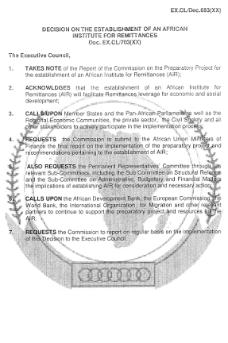

**Annex 2:** 5th Joint AU-ECA Ministerial Conference Resolution on AIR, March 2012:

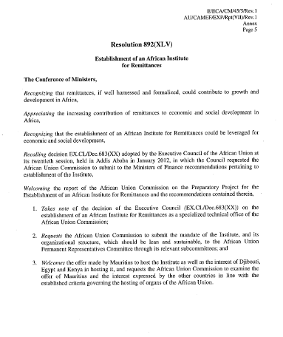

**Annex 3:** Declaration of the Global African Diaspora Summit, May 2012:

**Diaspora/Assembly/AU/ /Decl (I)**

**DECLARATION OF THE AFRICAN DIASPORA SUMMIT**

**SANDTON, JOHANNESBURG, SOUTH AFRICA**

**25 MAY 2012**

**LEGACY PROJECTS**

We further agree to adopt five legacy projects as a way of giving practical meaning to the Diaspora programme and in order to facilitate the post-Summit implementation programme. These are: a) the production of a Skills Database of African Professionals in the Diaspora; b) the establishment of the African Diaspora Volunteers Corps; c) the African Diaspora Investment Fund; d) a programme on the Development Marketplace for the Diaspora, as a framework for facilitating innovation and entrepreneurship among African and Diaspora; and e) The African Remittances Institute.

**Done at Johannesburg, South Africa 25 May 2012**

**Annex 4:** AU Assembly Decision, July 2012:

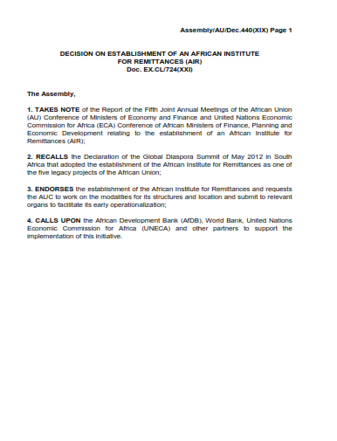

**Annex 5:** Executive Council Decision (EX.CL/Dec.808(XXIV)), January 2014:

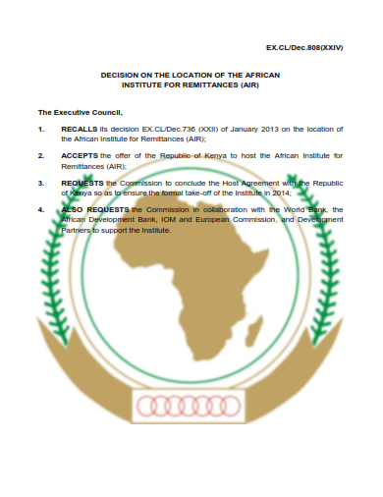

**Annex 6: 9**th Joint AU-ECA Ministerial Conference Resolution on AIR, April 2016:

