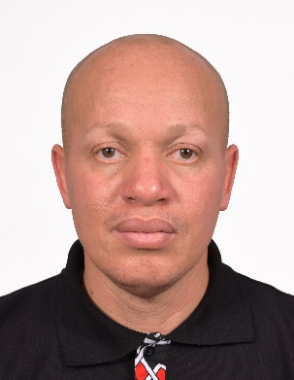  Session 2: “Understanding African Union’s Agenda on combatting corruption” | Apollos Nwafor is the Oxfam International Pan Africa Director. Oxfam Pan Africa programme works with African citizens and Pan African institutions to achieve the African aspirations for justice, equality, sustainable development and stability through improving the formulation and implementation of continental and regional mechanisms and commitments.  Prior to this, he was the Regional Advocacy Manager with Water Aid – West Africa region. His previous experience also includes being a Country Programme Manager for Publish What You Pay, and work with the African Network for Environment and Economic Justice. He is recognised for his strategic support on influencing of Civil society organisations including the “beyond 2015” coalition where he served on the Africa Steering Committee and as an adviser to the President of Liberia as Water Aid’s Goodwill Ambassador for WASH in Africa.  Apollos is recognized as an expert on African policy making processes and institutions, budget advocacy, Human Rights governance and campaigns both at national and international levels.  Apollos holds a USA PHD in Public Policy & Administration (Law & Policy – in view, UK Masters Degree in Public Policy & Management and Bachelor of Science (Ed) degree in Political Science.
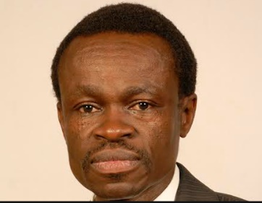  Session 3: Panel Discussion: “Impact of corruption on development, gender equality and women’s empowerment | Prof. PLO Lumumba is the Director and Chief Executive Officer of the Kenya School of Law, Associate Professor of Public Law and Founding Dean, Kabarak University School of Law. He has lectured law at the University of Nairobi, the United States International University (Africa), and Widener University USA (Nairobi Summer School).  He is an advocate of the High Courts of Kenya and Tanzania. He holds Bachelor of Laws and Master of Laws degrees from the University of Nairobi and a LL. D (Doctor of Laws) on the Law of the Sea from the University of Ghent, Belgium. He also holds a Degree of Doctor of Letters (Honoris Causa) from the University of Cape Coast in Ghana. He is a Fellow of the Institute of Certified Public Secretaries of Kenya FCPS (K), a Member of the Kenya Institute of Management (MKIM) and a Certified Mediator.  He has been trained on Humans Rights at the Institute of Advanced Legal Studies University of London in England, Humanitarian Law at the Raoul Wallenberg Institute of the University of Lund in Sweden and on International Humanitarian Law in Geneva, Switzerland  He is a former Secretary of the Constitution of Kenya Review Commission and former Director of the defunct Kenya Anti-Corruption Commission (KACC), (Now Ethics and Anti-Corruption Commission (EACC). He is the Founding Trustee of the African Institute for Leaders and Leadership (AILL) and founding Chairman of the Association of the Citizens Against Corruption (ACAC).  He was Awarded a Lifetime Achievement for Patriotism and Advocacy by the African Forum – 2017 and was recognized by New African Magazine as one of the 100 most influential Africans in 2017.
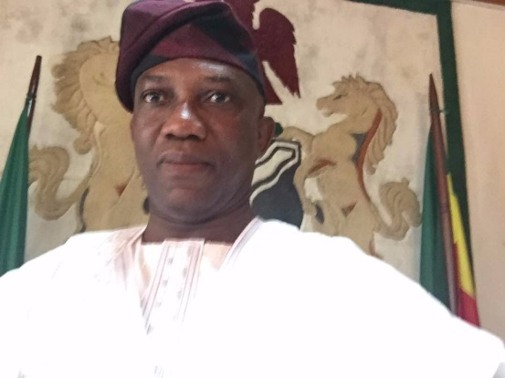  Session 3: Panel Discussion: “Impact of corruption on development, gender equality and women’s empowerment | Ambassador Bankole A. Adeoye is a career Foreign Service Officer of the Nigerian Ministry of Foreign Affairs. He was appointment by His Excellency, President Muhammadu Buharias Ambassador Extraordinary and Plenipotentiary in June 2016 and confirmation in November 2016 by the Nigerian Senate.  Mr. Adeoye is a graduate of Political Science and History from the University of Ife (now Obafemi Awolowo University) Ile-Ife, and a Master of Science in Political Science from the University of Lagos, with specialization in Political Economy and Public Policy Analysis. In addition, Ambassador Adeoye is a Commonwealth/British Council and Chevening Scholar who received the Post-Graduate Diploma in Diplomatic Studies with Distinction from the Foreign Service Programme at the University of Oxford, England from 1990-1991.  During his diplomatic career, Ambassador Adeoye has held several strategic positions in Nigeria's Foreign Ministry and its Diplomatic Missions abroad namely in Cairo and Brasilia and as acted as Senior Counsellor, Nigeria-South Africa Bi-National Commission within the International Economic Cooperation Department (IECD) from 1998-2003.  In 2007, Ambassador Adeoye was appointed as Coordinator of Partnerships & External Relations, to the Office of the Deputy CEO at NEPAD Agency, South Africa. From 2010, he served as the Chief of Staff to the Chief Executive Officer, NEPAD Agency, Midrand, South Africa, till 2013 and as the Director of Corporate Services, of the NEPAD Agency, till June 2015.
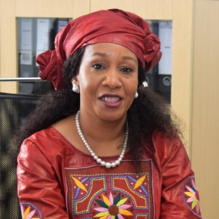  Session 4: AU policy coherence and policy platforms | Lindiwe Khumalo is Technical Advisor to the Chairperson of the AUC. Prior to this position she held several senior executive positions notably as Deputy Secretary to the African Commission on Human and Peoples Rights and Chief Executive Officer of the South African Human Rights Commission. She holds a Master Degree in law, specialising in Human Rights and Democratisation in Africa and a Masters in Public and Development Management.
Session 4: AU policy coherence and policy platforms | DR. OLUMIDE ABIMBOLA AJAYI holds a B.Sc. (Special Honours), M. Sc. (Agric. Economics and Finance) and a Ph.D. in Agric. Economics, Planning and Management from the University of Ibadan. He is currently the Executive Director/CEO of the Africa Leadership Forum (ALF)  He possesses very robust experience in key development areas such as enterprise development and empowerment, gender, conflicts, governance, economic development, Water and SMEs activities. He is an administrator, trainer, mentor and author.  He has written and contributed to some books and scholarly journals. He had in the past consulted in about ten different countries for the United Nations Development Programme (UNDP), United Nations Food and Agricultural Organisation (FAO), United Nations Economic Commission for Africa (UNECA), United Nations Institute for Development and Economic Planning (UNIDEP), African Union (AU), and Economic Community for West African States (ECOWAS),  Dr. Ajayi is a Fellow of the Centre for Applied Studies in International Negotiation (CASIN), Geneva, Switzerland and the International Academy for Leadership, Gummersbach, Germany. He also sits on the board of Business School Netherlands International (BSNI) Nigeria as well as the Executive Board of Femmes Africa Solidarite based in Geneva, Switzerland
Session 6: Preparations for the 10th anniversary of the AU-GPS | Mrs Yankey Simone is a lawyer and a gender and development expert. She is currently a Senior Policy Officer in charge of Girls ‘Education at the AU/Cieffa.(International Center for girls and women’s education in Africa -Based in Burkina Faso) Simone worked as a Senior program Officer for ten years within the AUC -WGDD where she has been coordinating the technical organization of the AU gender pre-summits as well as many other projects on women's rights in Africa. She has extensive experience in the partnership between the AUC and CSO’s, Member States and partners in designing, implementation and monitoring-evaluation of the AU Gender Architecture.
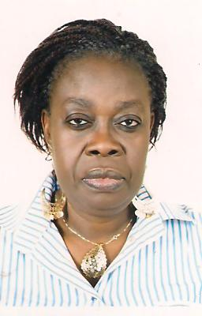  Session 6: Preparations for the 10th anniversary of the AU-GPS | Lawyer and Human Resources manager, Ms. Kuwonu Afiwa Kafui has professional experience and expertise in gender, women's rights in connection with the development and public administration  Ms. Kuwonu held executive positions in public administration for twenty years before finally joining in full time NGO work in 2002. Currently she works as Programme Officer in the WiLDAF Sub Regional Office West Africa. In this position, she plays a leading role in capacity -building activities for women’s rights organizations and other organization working in women’s empowerment projects in the sub region. She heads WiLDAF's advocacy programmes for gender equality, respect and enjoyment by women of their rights. Since 2009, she is the backbone of the implementation of programs of WiLDAF that aim to empower women farmers.  Founding member of GF2D (Group of Reflection and Action, Women, Democracy and Development in 1992, she was the General Secretary of this organization from 2006 to 2010.  She participated in the establishment of WiLDAF-TOGO and was its first president from 1999 to 2003.
Session 6: Preparations for the 10th anniversary of the AU-GPS | Lehau Victoria Maloka is the Head of Division, Coordination and Outreach, in the WGDD of the AUC. She has over 20 years of experience in the fields of human rights, gender, electoral democracy, constitutional practice, conflict resolution and peace-building. Before joining the AUC, Victoria was a Senior Associate at the Centre for Mediation in Africa (CMA), South Africa. She also served as a Secretariat for the Association of African Women Mediators and Director of the Source of the Nile Consulting.  Victoria served as a Human Rights Officer in the Regional Office for Southern Africa of the Office of the United Nations High Commissioner for Human Rights (OHCHR) in the Southern Africa region. She was also Director of the Human Rights Advocacy Programme/ Education and Training Centre of the South African Human Rights Commission. She worked as a Senior Programme Officer at the University of Cape Town’s Centre for Conflict Resolution (CCR) and acted as a Principal Planner for the Department of Provincial and Local Government (DPLG) where she assisted with policy development and technical support on constitutional and legislative matters.  A lawyer by training, Victoria holds BIuris and LLB Degrees from the University of Limpopo, and an LLM in Human Rights and Constitutional Practice from the University of Pretoria. She has contributed publications on conflict management, peace-building, human rights, constitutionalism and democratisation. Victoria is co-editor of a book titled “National Human Rights Institutions in Africa: Defenders of Human Rights, Managers of Conflict, Builders of Peace.”

