AFRICAN UNION | 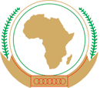 | UNION AFRICAINE
 |  | UNIÃO AFRICANA

Addis Ababa, Ethiopia P. O. Box 3243 Téléphone : 5517 700 Fax : 5511299
website : www. africa-union.org
DIRECTORATE OF INFORMATION AND COMMUNICATION

PRESS RELEASE Nº010/2011

Legal Experts from African Union Member States meet in Yaoundé to Discuss Statute of the African Monetary Fund

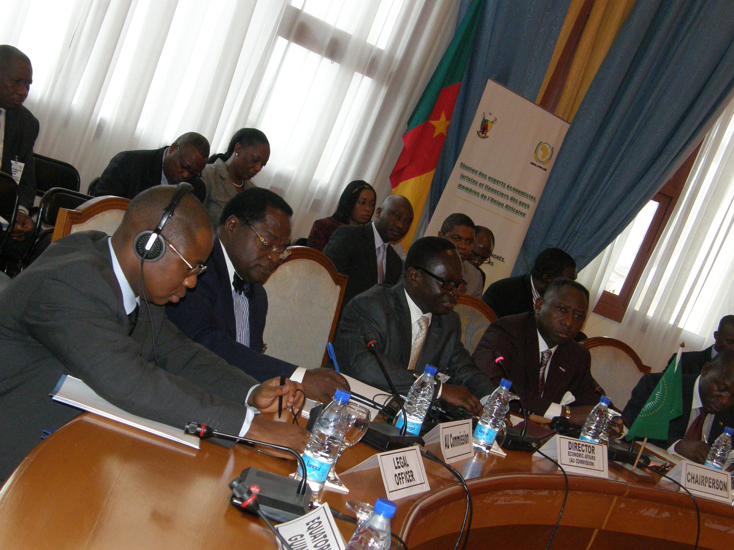
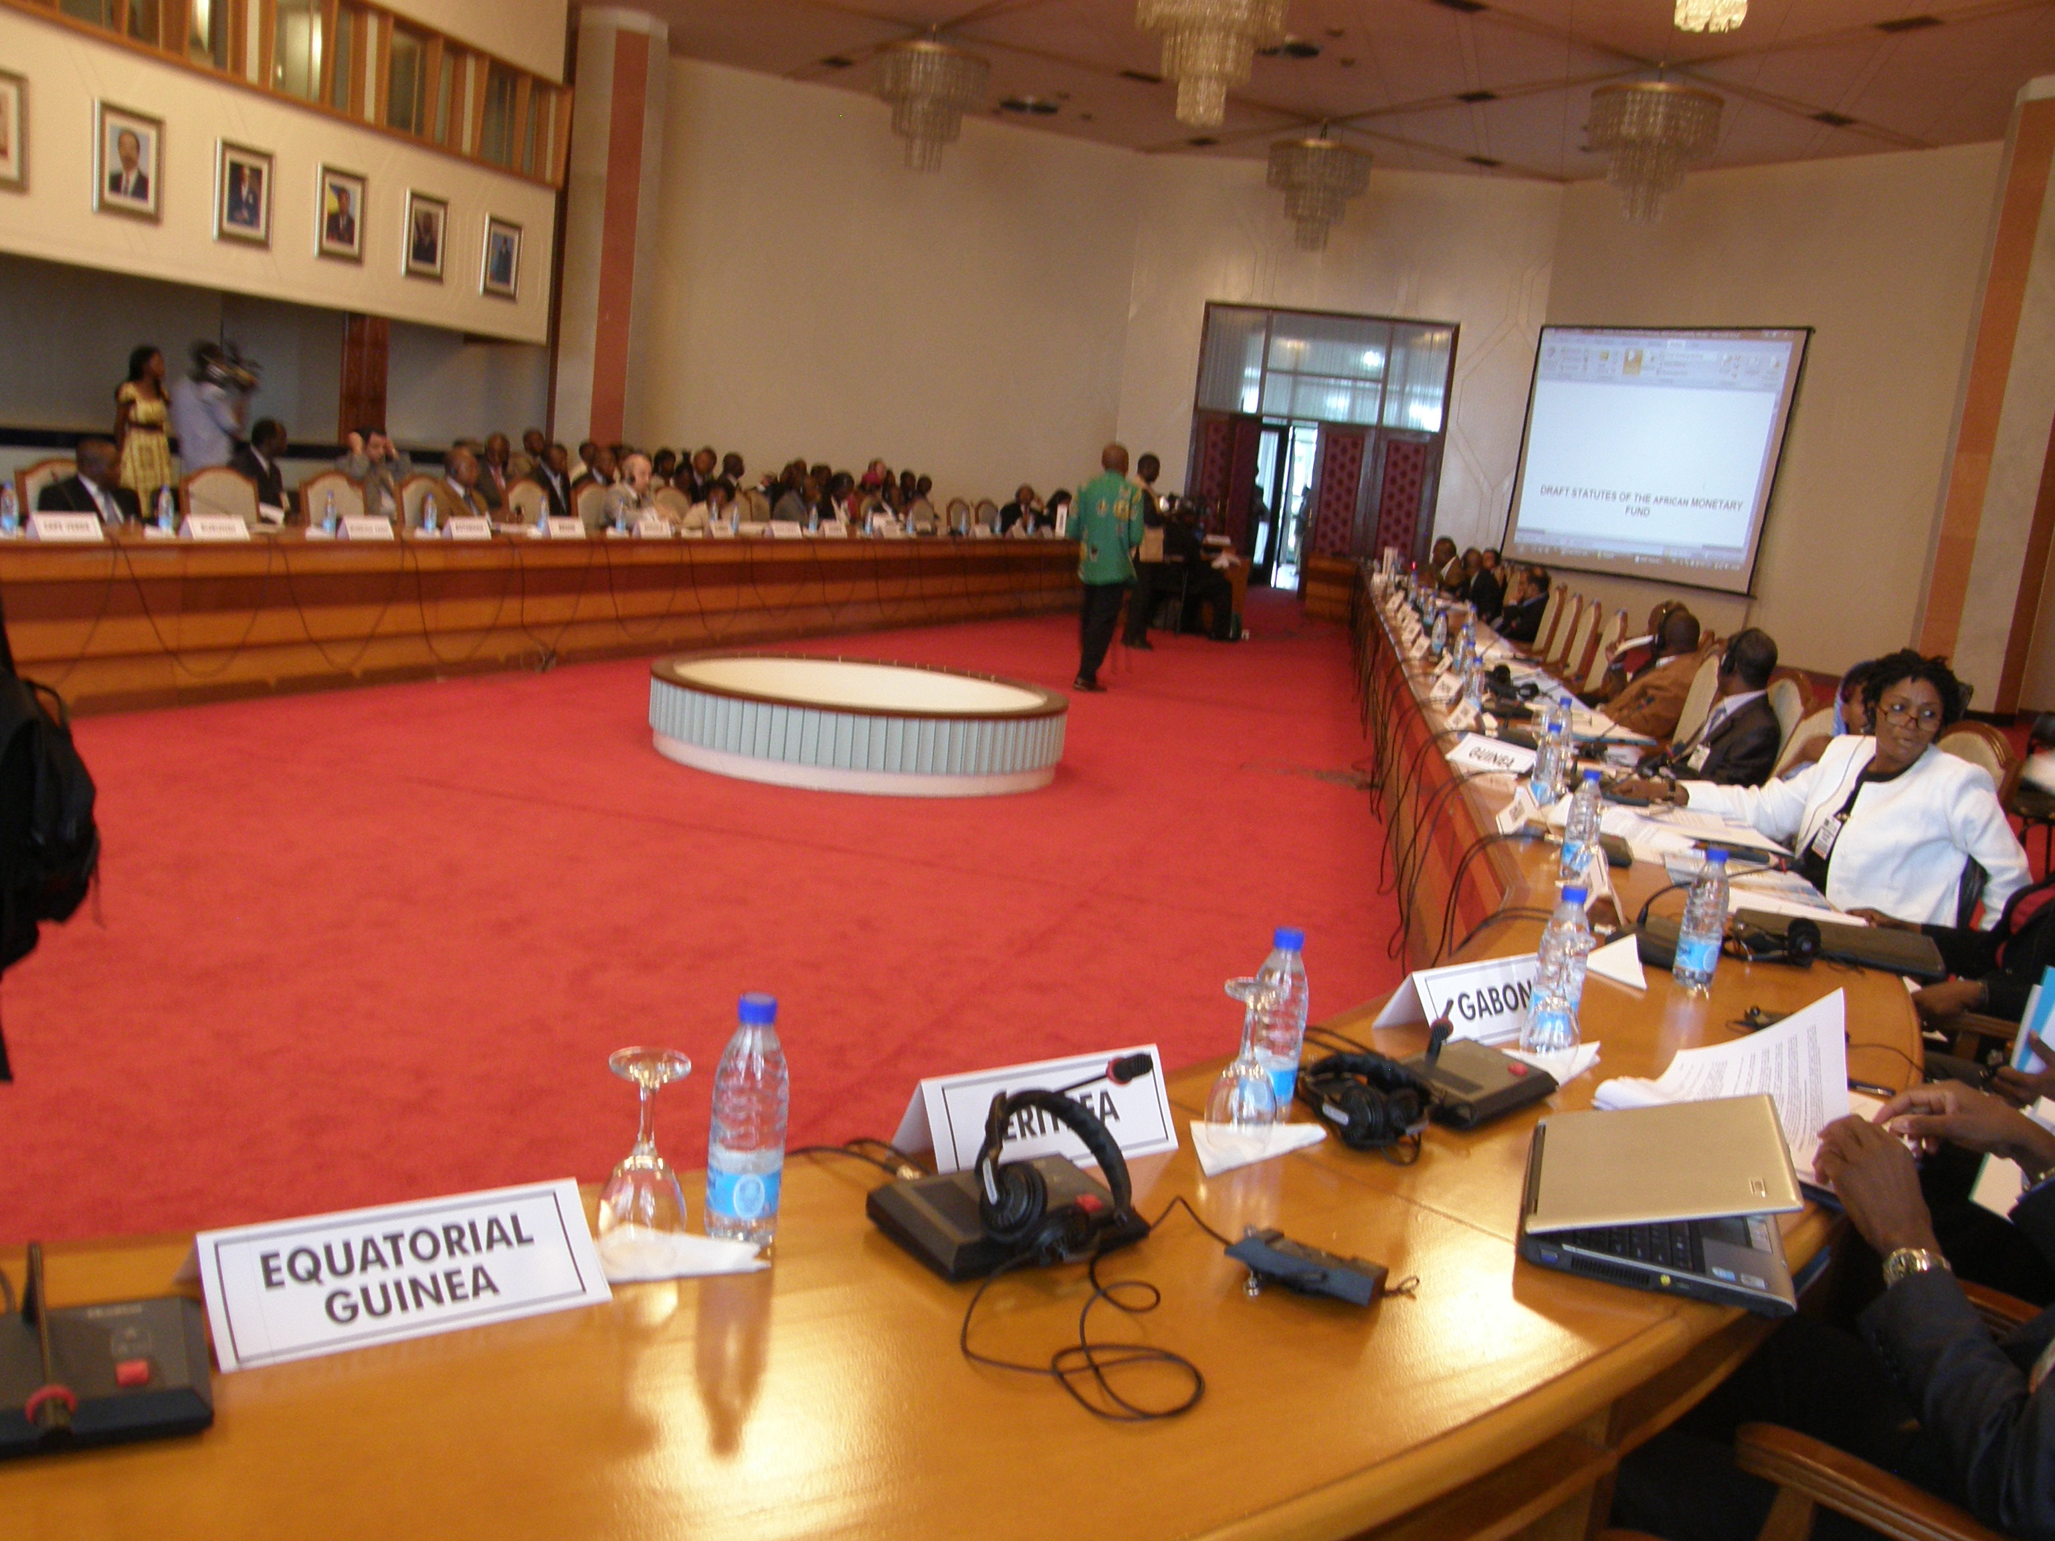
Yaoundé 28 February 2011 – The issue of alternative sources of funding and effective operationalisation of the financial institutions of the African Union have been at the center of discussions of the Conference of Ministers of Economy and Finance lately. As a follow up to the Extraordinary Conference of African Union Ministers of Economy and Finance held from 13 to 17 December in Yaoundé, Cameroon, Experts and jurists in the area of Finance met this day at the Yaoundé Conference Center, to exchange views on the draft Statute of the African Monetary Fund (AMF).

The meeting took place under the chairmanship of Mr. Jean Tchoffo, Permanent Secretary of the Ministry of Finance of Cameroon, in the presence of Dr. Rene Kouassi, Director of Economic Affairs of the African Union Commission (AUC) and Mr. Jean-Marie Ngangkou, Coordinator of FMA.

Addressing the participants, Dr. Kouassi thanked the Cameroon Government for accepting to host the brainstorming meeting which he described as crucial for the effective functioning of the AMF.
The Director for Economic Affairs of the AUC recalled the general context that led to the creation of the three Financial Institutions of the African Union, which are: the African Investment Bank, the African Central Bank and the African Monetary Fund.

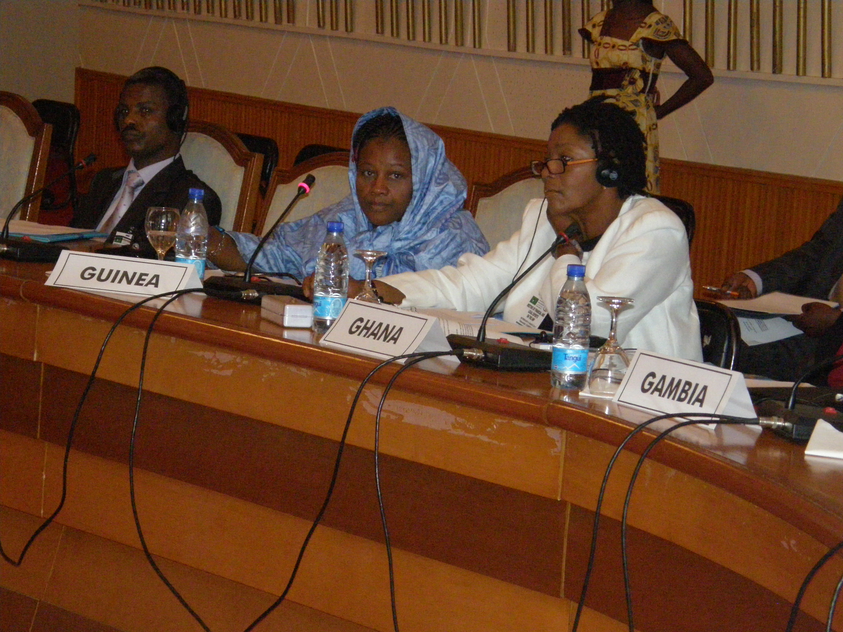
The Permanent Secretary of the Cameroon Ministry of Finance, on his part, reminded the jurist that their contribution to the draft Statute establishing the AMF will be an important step towards the effective putting in place of the Fund.

A presentation of the AMF draft Statute was later done by Professor Ngangkou who highlighted the purpose of the Fund; the functions and activities of the Fund; the Capital and resources as well as subscription of shares of the fund, amongst others.

After two days of brainstorming, the meeting of the Financial and Legal Experts of the AU Member States ended on 1st March 2011, with the adoption of the Annexes to the Statute of the AMF. This document will be given a legal touch by the Conference of AU Ministers of Justice scheduled for mid-March 2011 in Addis Ababa. The text will further be considered by the Conference of AU Ministers of Economy and Finance scheduled for the last week of March 2011 in Addis Ababa, Ethiopia, before submitting for final approval to the Summit of AU Heads of State and Government, at their 17th Ordinary Session billed for June/July 2011 in Malabo, Equatorial Guinea.

For more information, visit the African Union website: www.africa-union.org .

