AFRICAN UNION |  | UNION AFRICAINE
 |  | UNIÃO AFRICANA
P. O. Box 3243, Addis Ababa, ETHIOPIA Tel.: 00251-11-5517700 Cable: AU, ADDIS ABABA Web site: www.africa-union.org
DIRECTORATE OF INFORMATION AND COMMUNICATION
PRESS RELEASE Nº022/2011

AUC AND CORPORATE COUNCIL ON AFRICA FOLLOW UP ACTIVITIES
IN THEIR MOU

Addis Ababa, Ethiopia 22 March 2011- The Vice President of the Corporate Council on Africa (CCA) and Senior Vice President of Seacom Limited, Mr. Haskell Sears has briefed the AU Commission on the progress in relations between the AU and CCA as well as on the Africa Growth and Opportunities Act (AGOA), which offers incentives for African countries to continue their efforts to open their economies and build free markets.

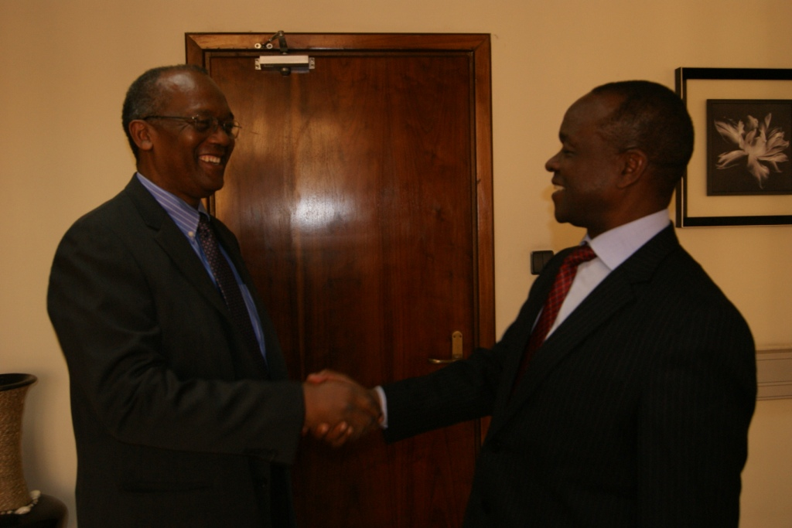
During his visit to the AU Commission in Addis Ababa, Mr. Haskell met the Commission’s Deputy Chairperson Mr. Erastus Mwencha, where the two also discussed progress in identifying and facilitating business opportunities, especially the work being done on the broadband network connecting the eastern part of Africa. This network constitutes part of a vital communications infrastructure for the continent.

In this light, Mr Haskell informed the Deputy Chairperson that the project on Ethiopia has run out of bandwidth capacity and there is need to extend the cable to Europe where there is enough capacity to serve both Ethiopia and the AU.

“This project constitutes a significant component for Africa to move closer to realising our objective of creating the necessary infrastructure for provision of data and voice communications”, said Mr. Mwencha.

Mr Haskell’s visit was within the framework of the Memorandum of Understanding (MOU) signed in Kampala in 2010, between the Chairperson of the African Union Commission, Dr Jean Ping and the CCA Board Chairman, Mr. Michael Dignam. The agreement complements ongoing efforts of the AUC to improve the business climate on the continent by promoting new opportunities to American investors. The MOU stated that activities will first focus on infrastructure, financing, agri‐business and healthcare, though other areas will also be explored.

WZM/

