AFRICAN UNION | 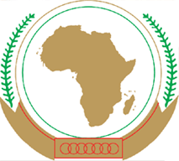 | UNION AFRICAINE
 |  | UNIÃO AFRICANA
P. O. Box 3243, Addis Ababa, Ethiopia Tel.: 00251-11-5517700 Web site: www.africa-union.org
DIRECTORATE OF INFORMATION AND COMMUNICATION

PRESS RELEASE Nº027/2011

Canada and the auC meet to map out priorities for support

The work of the AU Commission is organized around four pillars, out of which 6 programmes were crafted i.e. peace and security; integration; cooperation; development; shared values; and institution and capacity building, under the Commission’s new results based orientation. These programmes form the basis for implementation of the pillars.

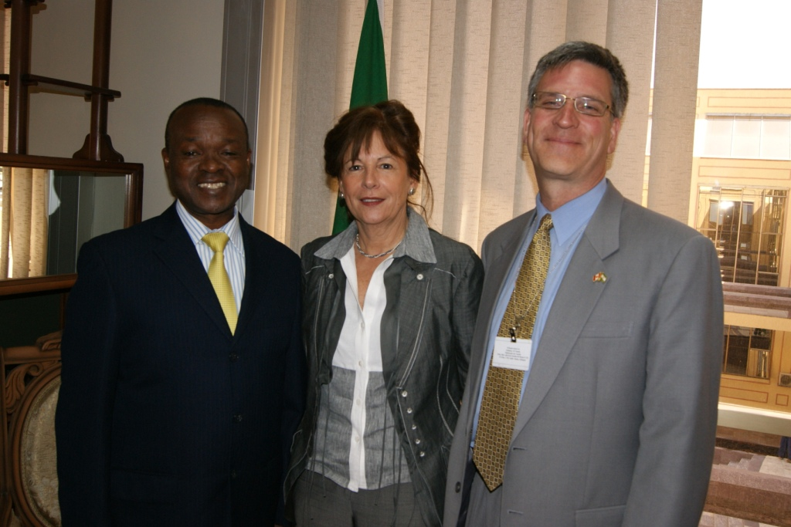
On 22 March, a number of departments, whose work is supported by Canada, had the opportunity to give details on the projects they are working on, under the respective programmes and to identify gaps where support is needed. The briefing took place as part of a meeting held between AUC Commission Deputy Chairperson Mr Erastus Mwencha and Mrs Michelle Levesque, Ambassador of Canada to Ethiopia and to the AU, who was accompanied by Mr Phillip Baker, Regional Director for Southern and Eastern Africa, of the Canadian International Development Agency, CIDA. Canada supports the AU in areas such as the Darfur peace process, capacity building for gender, the NEPAD Agency, the food sector and trade facilitation. AU departments and directorates represented were Infrastructure and Energy; Women Gender and Development; and the Deputy Chairperson’s Office. The meeting was useful in the context of the need to spell out AU priorities to development partners so that support is channeled into those projects that will benefit the continent. Giving an overview of the Commission’s work, Mr Mwencha highlighted that the AU is about integration. It is engaged at a strategic level in undertaking those policy decisions and programmes that need to be done at continental level, to achieve integration. Regarding its work with partners, he said the Union works at both bilateral and multi lateral levels.

Peace and security programme
The Deputy Chairperson noted that, currently, the Union spends 60% of its time on peace and security issues. This is not the ideal situation, he commented, adding that with time, the Union should be able to flip the equation and spend more time on other development programmes. However, the prevailing circumstances demand this much attention to peace and security, he said, and as such, the AU is creating the necessary African peace and security architecture (APSA). One of its components is the African Standby Force (ASF), which is mandated to undertake peace support operations, as well as intervention missions, including in cases of genocide, war crimes or crimes against humanity, in conformity with the Constitutive Act of the AU. Mr Mwencha elaborated that the AU is working with the Regional Economic Communities (RECs), who can implement programmes on a long term basis. He mentioned also the 15-member Peace and Security Council, a decision-making organ for the prevention, management and resolution of conflicts. It is also a collective security and early-warning arrangement to facilitate timely and efficient response to conflict and crisis situations in Africa.

On the operational side of the peace and security programme, Mr Mwencha highlighted some of the areas where the AU is involved. These include; escorting Sudan through the process of separation after its referendum and development of the two states; and finding solutions to the situations in Cote D’Ivoire and Libya. On Libya, Mr Mwencha commented that the AU is worried about the economy being left in bad shape as a result of the aerial attacks associated with the enforcement of the no fly zone. “People are dying” he observed, further calling for an exit strategy. He was however, happy to note that Tunisia is settling down and that Egypt “is on the right track” after the revolutions in the two countries that saw changes in governments.

Development programme
Turning to the development programme, Mr Mwencha said provision of infrastructure is vital to integration. Mr. Aboubakari Baba Moussa, Director of Infrastructure and Energy provided an insight into some projects under the development programme. He spoke about the Programme on Infrastructure Development in Africa (PIDA), which aims to promote socio-economic development and poverty reduction in Africa through improved access to integrated regional and continental infrastructure networks and services. Other projects highlighted include the Dakar-Djibouti corridor; the Djibouti- Libreville corridor; the Beira- Lobito corridor; the Cotonou- Niamey - Ouagadougou rail project and the Gambia project.

Food security was mentioned by Mr Mwencha as another important component of the development programme, and the Comprehensive African Agriculture Development Programme was given as a framework through which Africa seeks to achieve food security and economic development. In addition, it was mentioned that the AU is working with the RECs to realise Free Trade Areas.

Another important project under the development programme is human resource development where Mr Mwencha highlighted the Pan African University framework, which will establish centers of excellence in different fields, necessary to drive African development. He also talked of efforts to make sure that excess human resource capacity is distributed in an equitable manner to those areas that have deficits.

Shared values programme
Under Shared values, particular emphasis was placed on the African Women’s Decade, 2010- 2020). Mrs Leila Ben Ali, representing the Women, Gender and Development (WGD) directorate said the decade has ten themes and this year, the focus will be on maternal mortality and HIV/AIDS. She said a special fund for African women had been created to assist implementation of projects at country level. The WGD is also integrating Information and Communication Technology into its work, so as to facilitate communication between patients and rural health centers. An African Gender Observatory is being set up to allow for collection of data, to follow conditions of women and the different projects being undertaken to promote women’s development on the continent.

Institution and capacity building
The Deputy Chief of Staff in the Bureau of the Deputy Chairperson, Mr Anthony Okara highlighted the work being done under the institution and capacity building programme. He said compilation of data on previous efforts in this direction has been completed and a blue print for efficiency has been done, in a drive to move the Commission away from an activity based to a results-based operational framework. As an example, he pointed out that the Commission has successfully managed to whittle down the number of projects from over 200 in 2008, to 40 this year, of which 12 are flagship projects. He said progress is being made in results based budgeting. The Commission is building capacity in planning, using the logical framework. Performance management has been introduced and 100 champions have been trained to make sure the process is implemented properly. The Commission is also aiming at improving service delivery, financial management and accounting in order to raise its credibility. The SAP system was brought in to aid in this process. Mr Okara also highlighted the need for the Commission to cultivate and maintain good relations with the over 40 partners supporting different projects, saying that internal communication is necessary in this regard. A partners’ dialogue slated for April should assist in establishing best practices in relations with partners. He also talked about the Commission’s efforts to establish Joint Financing Agreements (JFAs) as the Commission gradually moves away from individual project funding by partners towards increased programme funding and ultimately direct budget support.

The meeting identified capacity and resource gaps in the areas that Canada is supporting. These AU priorities, among others, will form the basis for further cooperation between the AU and Canada. Ambassador Levesque summed it up by saying the meeting would inject “renewed dynamism” into implementing results based programmes.

WZM/

