AFRICAN UNION |  | UNION AFRICAINE
 |  | UNIÃO AFRICANA
P. O. Box 3243, Addis Ababa, ETHIOPIA Tel.: 00251-11-5517700 Cable: AU, ADDIS ABABA Web site: www.africa-union.org
DIRECTORATE OF INFORMATION AND COMMUNICATION

Au commissioner receives international recognition

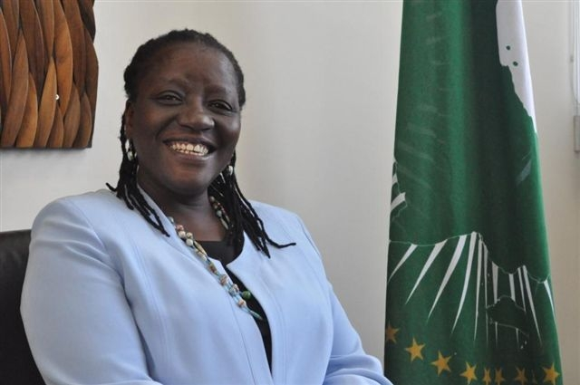
AUC Commissioner for Social Affairs Advocate Bience Gawanas has been honoured as one of the world’s top 100 most inspiring people delivering for women and girls, especially for her work in mobilizing Africa to support women’s health and equality.

The honour was bestowed by Women Deliver, a US based organisation that works globally to generate political commitment and financial investment for fulfilling Millennium Development Goal 5, i.e. to reduce maternal mortality and achieve universal access to reproductive health.

Commissioner Gawanas was selected from among hundreds of names, to join the coveted list of the top 100, that also includes Ngozi Okonjo-Iweala, Nigeria- Managing Director of the World Bank; Wangari Maathai, Kenya, Founder of the Green Belt Movement, Recipient of the Nobel Peace Prize; Graça Machel, Mozambique- Founding Member of the Elders, President of the Foundation for Community Development in Mozambique, Former Minister for Education and Culture in Mozambique; Michelle Bachelet, Chile, Executive Director of UN Women, Doctor, Former President of Chile; Ban ki Moon- Secretary General of the United Nations: and Hilary Clinton- US Secretary of State.

As Commissioner of Social Affairs, Advocate Gawanas has worked to advocate for, harmonize and coordinate regional and continental policies and programmes relating to social development. Her Department has developed policy instruments, projects and programmes on social development, including the Social Policy Framework, the Maputo Plan of Action on Sexual and Reproductive Health and Rights, the Declaration on Universal Access and an African Common Position presented at the UN High Level Meeting on Universal Access. She was also responsible for monitoring the progress of their implementation by Member States and reporting to the Assembly of Heads of State. Other pioneering activities include the renewed Campaign on Malaria Eradication, the AU Campaign Initiatives on Human Trafficking (AU.Commit) and the Campaign on the African Cultural Renaissance; the launch of the AU Award of Children’s Champions; and the Campaign on Accelerated Reduction of Maternal Mortality in Africa (CARMMA), which has refocused attention on women and their health.

Commissioner Gawanas has served on various international taskforces and committees; and is a member of the Commission on Accountability and Information of the WHO, and the UNAIDS Global Steering Committee on Universal Access.

The Commissioner has also served as Public Service Commissioner in her native Namibia and as the country’s first black ombudswoman. She is a long standing women’s rights activist. Her involvement in supporting people with disabilities led to her role as Patron of the National Federation of Persons with Disabilities in Namibia. As a law reformer, Advocate Gawanas was instrumental in drafting and enacting laws to guarantee gender equality, such as the Married Person’s Equality Act, which granted equal status to married women, and others that provide protection to rape victims, abused women and children—such as the Combating of Rape Act.

The Directorate of Information and Communication (DIC) caught up with Commissioner Gawanas to learn more about this great honour.

DIC: What does this award mean to the African Union?
BG: I am only an individual operating within an institution so I believe the award creates visibility for the AU. People outside the organization will see that the AU promotes social development, and that it is not focused just on peace and security. This is a recognition for the AU’s social development agenda

DIC: What motivates you to promote the social agenda?
BG: Firstly, growing up under apartheid in Namibia, I saw a lot of what happens when there is racial and ethnic division. My brother was murdered and I had to sit in a court of law where everyone was white. I decided then, in 1976, that to bring social justice I had to become a lawyer. I was a fighter in Namibia’s liberation struggle for independence.
Another factor is that I grew up in a family of 11 and my parents never discriminated against any of their children. I was the first child in my family to go to university. I always believed that women do not need to be inferior or subordinate to men. So my upbringing, my family, the society in which I grew, and my role in the struggle for liberation helped to motivate me.

DIC: Who inspires you?
BG: I am inspired by people who are principled, who strive to achieve results, and who build up something big from small ideas

DIC: Have you received any other awards?
BG: I was also nominated for the 2007 U.S. Secretary of State First Annual Award for International Women of Courage.

DIC: You are a role model for many young people. What have you got to say to them?
BG: I was on plane once and a young flight attendant came to me and said: “I just wanted to tell you how much I have admired you since the day you were appointed as ombudswoman”. I felt obliged to tell her, which I did, that people who achieve things are not aliens. “I was where you are today, and you can become great in your own right”

WZM/

