AFRICAN UNION |  | UNION AFRICAINE
 |  | UNIÃO AFRICANA

Addis Ababa, ETHIOPIA P. O. Box 3243 Téléphone : 5517 700 Fax : 5511299
Web site : www. au.int

DIRECTORATE OF INFORMATION AND COMMUNICATION

Press release No. /2011
Africa Trade Forum (ATF) 2011
“Accelerating Intra-African Trade and Enhancing Africa’s participation in Global Trade”

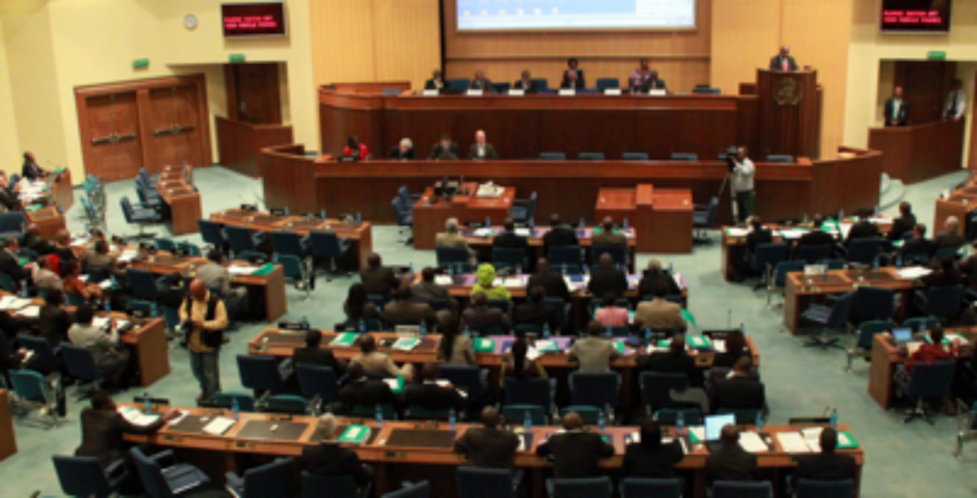
Addis Ababa, 22 November 2011 – The inaugural Africa Trade Forum (ATF) 2011 started at the United Nations Conference Centre (UNCC) in Addis Ababa today with the strategic objective of promoting multi-stakeholder policy dialogue on trade issues in Africa, by mobilising all the different trade constituencies across Africa and the world in general, to debate and exchange views on all the key issues relating to intra-African trade, and Africa’s trade with the rest of the world.

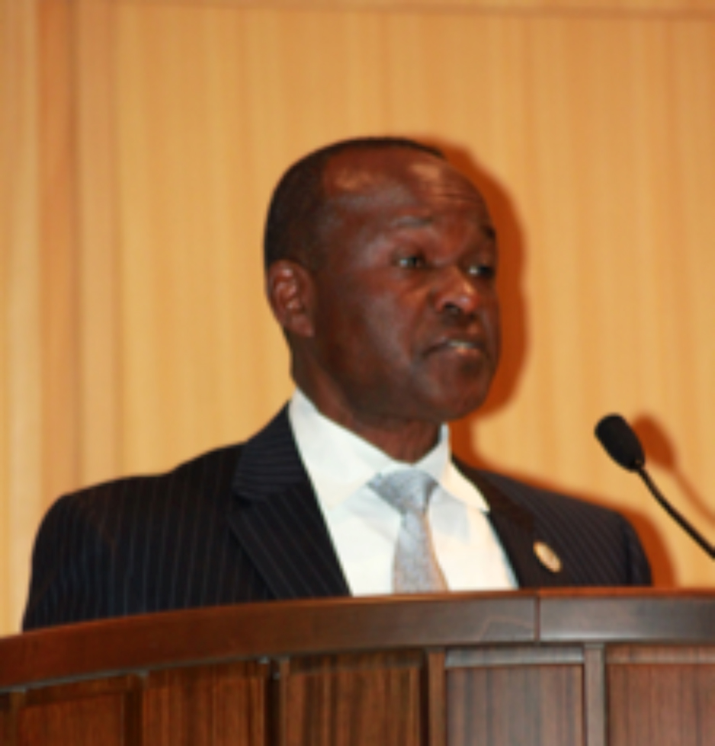
One of the specific objectives of the Forum is to discuss and agree on specific inputs into the African Ministerial Conference on Trade, as well as the African Union Heads of States Summit scheduled for January 2012, on the theme “Boosting Intra-African Trade”.

In his opening remarks the Deputy Chairperson of the African Union Commission, Mr. Erastus Mwencha, recalled the determination of African Trade Ministers at their meeting in Kigali, October last year, to fast track the Continental Free Trade Area. He further recalled the decision of the Heads of States to dedicate their January 2012 Summit to boosting intra-African Trade. Mr. Mwencha underscored that the Forum is a rare opportunity that brings together a large multi-sector stakeholder base, to discuss critical issues of intra-African trade. He assured that “the AUC is keenly looking forward to the outcomes of the Forum, which will provide guidance on shaping the work programmes of both the AUC and UN Economic Commission for Africa (ECA) in trade and integration matters.”

The UN Under-Secretary-General and Executive Secretary of ECA, Mr. Abdoulie Janneh, in his opening remarks underscored that “with intra-Africa trade at just about 11% of total trade as compared to 72% in Europe and 52 % in Asia, it is evident that there is a lot of scope for expansion in regional trade.” He further stated the importance of the inaugural forum, which he said provides an opportunity to build on the success stories in intra-African trade in spite of various constraints.

The Resident Representative of the African Development Bank, Mr. Lamin Barrow, on his part stated that what is needed to improve intra-African trade has already been agreed upon in the context of numerous trade agreements and protocols spearheaded by the Regional Economic Communities but what is missing is vigorous implementation of these agreements and protocols.

The Minister of Industry of the Federal Government of Ethiopia, Mr. Mekonnen Manyazewal, advised that to improve Africa’s share and benefit from the global trade, the continent has to address the supply side constraints on four major fronts: move forward from trading primary products to manufacturing products, invest in human capital, improving infrastructure & logistics and institutional capacity building. He further stressed and suggested that these should be the major discussion points of the Forum.

The Forum is organized by the African Trade Policy Centre (ATPC), an initiative of the United Nations Economic Commission for Africa with funding support from the Canadian International Development Agency (CIDA), in collaboration with the African Union Commission (AUC), African Development Bank (AfDB) and other partners.

Participants to the Forum are drawn from policy makers and high level government officials, private sector operators, civil society, parliamentarians, development partners, academia and researchers, RECs, development corridor management institutions, export promotion agencies, and the media.

The inaugural Africa Trade Forum (ATF) 2011 will end on November 24.

For more information, please visit the AU Website www.au.int and the UNECA website www.uneca.org

