PAN-AFRICAN PARLIAMENT | 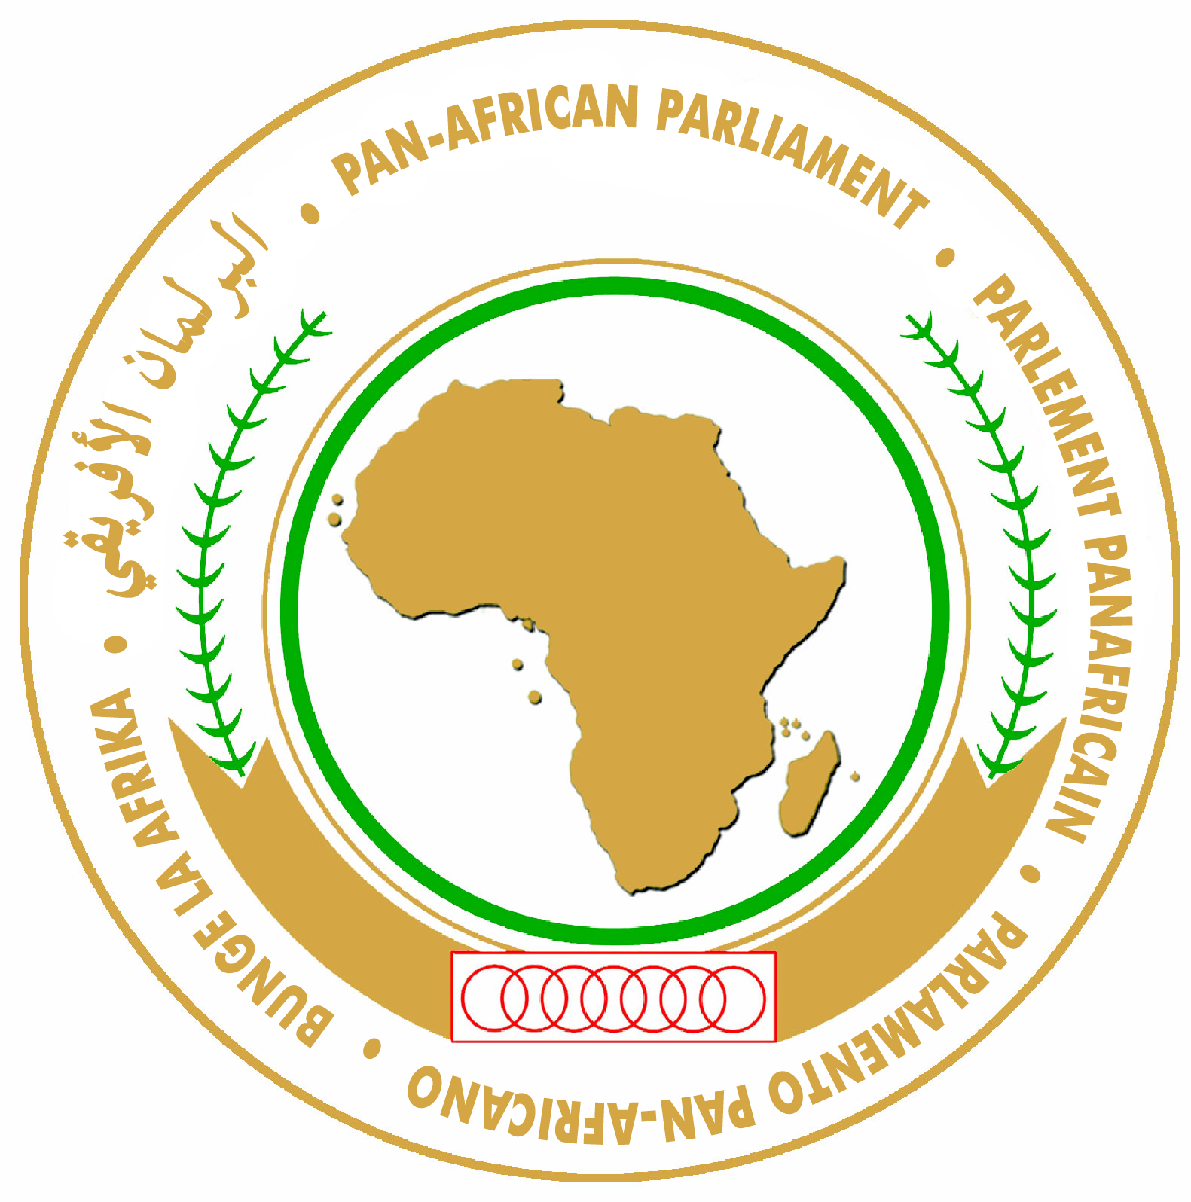 | PARLEMENT PANAFRICAIN
البرلمان الأفريقي |  | PARLAMENTO PAN-AFRICANO

PRESS RELEASE
January17, 2012

Pan-African Parliament Debates State of the African Union Commission

Addis Ababa, Ethiopia – The Pan-African Parliament (PAP) today considered the State of the African Union Commission (AUC) address by its Chairperson, H.E. Dr Jean Ping, read out on his behalf by H.E. Elham Ibrahim, Commissioner for Infrastructure and Energy.
In his address, Dr Ping spoke about theme of the upcoming AU Summit, which is, “Boosting Intra-African Trade”. He noted that intra-African Trade was a significant contributor to African integration. But, he equally noted that peace and security was a pre-requisite to all development and integration endeavours.
In this regard, he noted the successes of the AU on the continent. Sudan and Somalia were good examples were the AU had made inroads towards achieving some level of improved security.
However, he stated that the events that swept North Africa during 2011 had compelled the AU to “re-visit (its) instruments that will ensure that sovereignty rests with the people, who....should always be the source of legitimacy and custodian of political power”.
The Chairperson requested the Pan-African Parliamentarians to assist in getting their countries to “sign, ratify and effectively domesticate all the existing normative frameworks of the AU”. He reiterated that it was “not the time to contemplate on drafting new AU instruments and frameworks. It is time to adhere to the Shared Values that AU Member States have already agreed to”.
He also added that the quest for African solutions to African problems needs to be matched the timely provision of necessary resources. “If we are to legitimately claim ownership and leadership of all peace efforts on the continent, we equally need to ensure that African peace efforts should ideally be funded from African resources”, he said.
The Sixth Ordinary Session of the PAP is expected to continue in Addis Ababa until January 20, 2012.

For more information please contact:
Khalid A. Dahab
Senior Information, Communication and Media Relations Officer
Tel : +(27)11-545 5047 / +(27)11-545 5000
Cell : +(27)76 235 6192
Fax : +(27)86 520 4756 / +(27)11-545 5127
E-mail : khalid.dahab@panafricanparliament.org
Website : www.pan-african-parliament.org

Local Cell in Ethiopia: +251-927 346 583

