PAN-AFRICAN PARLIAMENT | 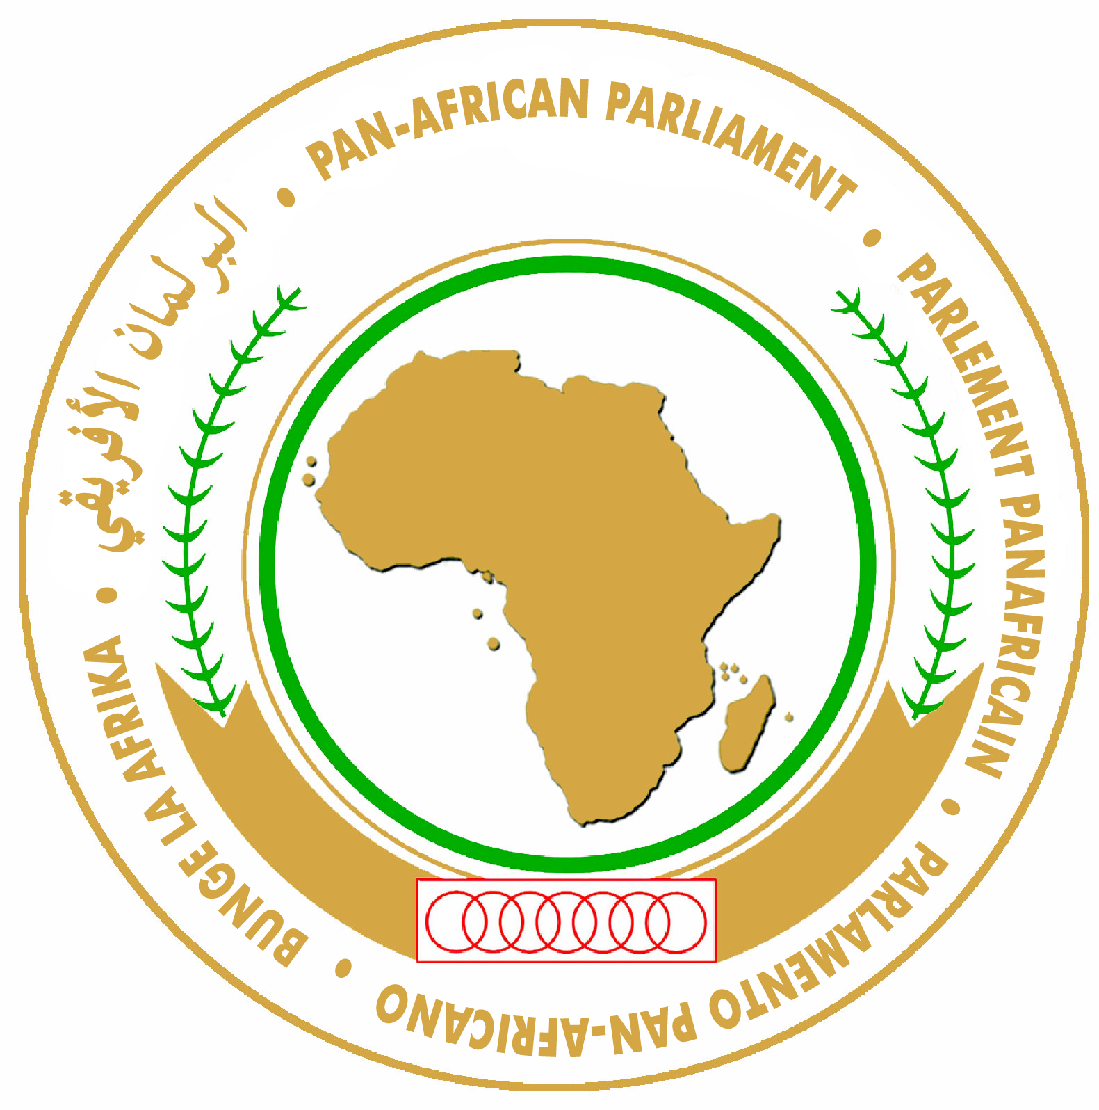 | PARLEMENT PANAFRICAIN
البرلمان الأفريقي |  | PARLAMENTO PAN-AFRICANO

PRESS RELEASE

January16, 2012

Pan-African Parliament Opens Sixth Ordinary Session with Calls to Support Full Legislative Powers

Addis Ababa, Ethiopia - The Sixth Ordinary Session of the Pan-African Parliament commenced in Addis Ababa today with keynote speeches from H.E. Meles Zenawi, Prime Minister of Ethiopia and H.E. Jerry John Rawlings, former President of Ghana. The meeting, which concludes on 20 January, is being held on the theme: “Ready for Transformation”.
It is the first time that the Parliament is holding a Session outside of its normal Seat in Midrand, South Africa since its inauguration in March 2004.
Hon. Dr. Moussa Idriss Ndélé, President of the PAP opened the Session by reminding Members of the need to address Africa’s challenges, including the vision for prosperity and conflict prevention. He underscored that the reviewed Protocol that defines the composition, powers, functions and organization of the PAP, would serve as a tool to advance Africa’s peace and security and “make good on the commitments made to the African people.”
The Pan-African Parliament is expected to evolve into an institution with full legislative powers, whose Members are elected by universal adult suffrage. At present, it exercises oversight and has advisory and consultative powers. In addition, its 235 Members are elected by the legislatures of the 47 of 54 AU Member States rather than being directly elected in their own capacity. The review of the Protocol is part of the process to transform the Pan-African Parliament from being a consultative body into a full legislative body with oversight powers.
In his remarks, former Ghanaian President Jerry John Rawlings reiterated his support for the transformation of the PAP with the legal capacity to “institute policies that would embolden them to play a role of being a common platform for African peoples and their grassroots organizations as enshrined in the Pan-African Parliament Protocol.”
He noted that PAP must enhance its image and reputation by taking strong positions on issues on the continent, such as the unfolding renewed crisis in Egypt, human trafficking and the need to champion the crusade to make Africa truly African and capable of managing her affairs.
He reiterated his support for PAP’s legal empowerment, which he said would allow for “vetting the finances of the AU as all national parliaments are obligated to.”
For his part, H.E. Meles Zenawi, Prime Minister of Ethiopia thanked the PAP for its invaluable contribution and for serving as a unique platform for interaction and exchange between and among the national Parliaments of member States of the African Union. He welcomed the review of the Protocol as an opportunity for “stock-taking and reform.”
Statements and messages of solidarity by various parliamentary representatives from around Africa and the world expressed optimism that the revised Protocol would be adopted by the AU Assembly of the Heads of State and Government.
The Pan-African Parliament is one of the ten Organs of the African Union provided for by its Constitutive Act.

For more information please contact:
Khalid A. Dahab
Senior Information, Communication and Media Relations Officer
Tel : +(27)11-545 5047 / +(27)11-545 5000
Cell : +(27)76 235 6192
Fax : +(27)86 520 4756 / +(27)11-545 5127
E-mail : khalid.dahab@panafricanparliament.org
Website : www.pan-african-parliament.org

