PAN-AFRICAN PARLIAMENT | 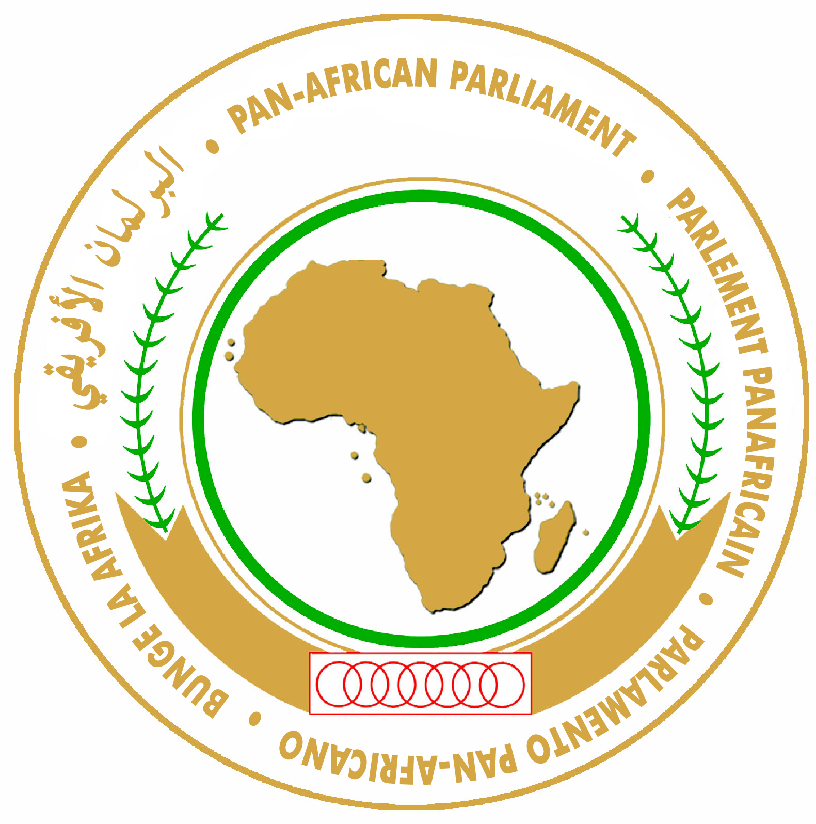 | PARLEMENT PANAFRICAIN
البرلمان الأفريقي |  | PARLAMENTO PAN-AFRICANO

PRESS RELEASE

January 18, 2012

PAP underscores its role in the speedy ratification of the African Charter on Democracy, Elections and Governance

Addis Ababa, Ethiopia - The ongoing Sixth Ordinary Session of the Pan-African Parliament (PAP) dedicated its third day on the African Charter on Democracy, Elections and Governance, adopted by the African Union (AU) during the Eighth Ordinary Session of the Assembly of the Heads of State and Government convened in Addis Ababa, Ethiopia in 2007. The Continental body is meeting on the theme: “Ready for Transformation”.
According to the African Union Commission, the Charter is considered the most authoritative expression of the commitment of the African Union and its Member States to “a set of shared values and aspiration objectives in governance, democracy and elections.”
The day’s debates underscored that the Charter is aimed at enabling Member States to achieve a political culture based on the holding of regular, free, fair and transparent elections. The Charter also emphasizes that competent, independent and impartial national electoral bodies should conduct elections.
Members of Parliament, however, expressed concern over the slow progress of its ratification. Furthermore, where Member States have ratified the Charter, the process of domesticating it at the national level has not been optimal.
The transformation of the PAP into a legislative Organ, Members said, would provide it with legal powers to facilitate national transformation of electoral processes and see to the speedy ratification and domestication of the Charter and other AU instruments.
“PAP should have the capacity to ensure the implementation of the Charter for the benefit of the people as failure of Member States to ratify continues to impede progress in democratic progress and governance,” they underlined.
The meeting emphasized that the Charter cannot be divorced from development and noted that economic emancipation, reduction of poverty and improving the status of women should be seen as “a founding prerequisite for holding fair and free elections.”

Further debates on the current status of democratic governance on the Continent underscored that fewer conflicts and credible elections have increasingly become the norm.
However, there are a number of major challenges that members noted, “continue to trigger crisis that lead to loss of innocent lives.”
They cited among others, the lack of standards for electoral processes and the lack of independent electoral bodies. They also lamented the plethora of constitutional amendments aimed at keeping some despots in power. In addition, the lack of transparency and corruption in electoral processes undermines peace and security in Africa.
It was noted that a transformed PAP could play an effective role in the post-electoral period, where conflict and violence often erupts.
Members applauded H.E. Julia Dolly Joiner, Commissioner for Political Affairs at the African Union for the dedicated efforts made towards the ratification of the Charter by member States.
They also called on Member States to speedily ratify and domesticate the Charter to create the space for effective participation of citizens in their own democratic processes.

Ends.

For more information please contact:
Khalid A. Dahab
Senior Information, Communication and Media Relations Officer
Tel : +(27)11-545 5047 / +(27)11-545 5000
Cell : +(27)76 235 6192
Fax : +(27)86 520 4756 / +(27)11-545 5127
E-mail : khalid.dahab@panafricanparliament.org
Website : www.pan-african-parliament.org

Local Cell in Ethiopia: +251-927 346 583

