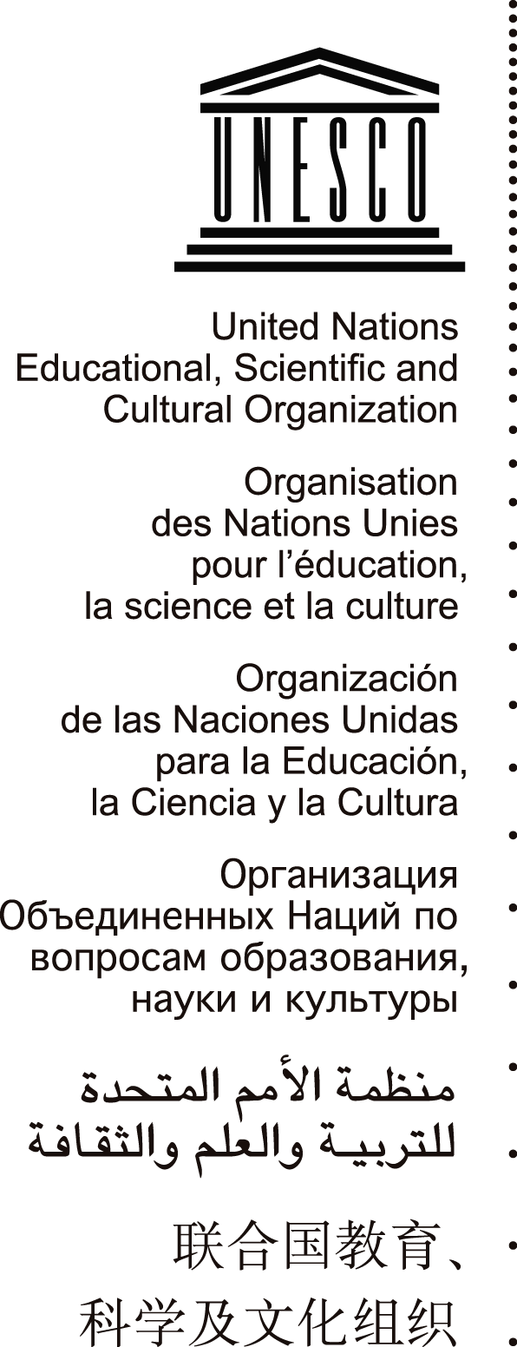

# UNITED NATIONS EDUCATIONAL, SCIENTIFIC AND CULTURAL ORGANIZATION

***Pan-African Conference on the Safety of Journalists***

***and the Issue of Impunity***

Opening remarks

byJānisKārkliņš

Assistant Director-General for

Communication and Information

14-15 September 2012

Addis Ababa, Ethiopia

Thank you, Madam Chairperson (“Mdm. Nkosazana Dlamini-Zuma”?)

Firstly, I would like to thank the Federation of African Journalists (FAJ) for inviting UNESCO to speak in this Conference.

As you know, UNESCO has been working for many years on promoting a safe environment for journalists and fighting against impunity around the world, and more specifically in Africa which is a priority issue for UNESCO. Indeed, we very often work hand-in-hand with many of you present here today. UNESCO has a long-standing partnership with the African Special Rapporteur on Freedom of Expression and Access to Information, including organizing a recent stakeholder meeting on decriminalization of freedom of expression. Furthermore, the African Union Commission and UNESCO have a special agreement in regards to journalism training.

In many parts of the continent, our training programmes for media professionals, model curricula for journalism schools, and advisory work with national authorities on legislative framework have taken place regularly. Many of these initiatives were made possible with the support of the International Programme for Development of Communication (IPDC). And of course the annual *World Press Freedom Day* itself has its beginnings in Windhoek, Namibia almost twenty years ago.

Today’s conference is being organized at a crucial time for safety and the issue of impunity, as we are witnessing an alarming increase in the number of journalists being killed, and at the same time much of these crimes go unpunished. It is also opportune because the United Nations Chief Executives Board has recently endorsed the UN Plan of Action on the Safety of Journalists and the Issue of Impunity.

Very briefly, the UN Plan of Action aims towards the creation of a free and safe environment for journalists and media workers, including social media producers, in both conflict and non-conflict situations, with a view to strengthening peace, democracy and development worldwide. I will be speaking in detail about the UN Plan of Action tomorrow.

Africa continues to be a crucial and strategic partner in our work on promoting a free, independent and pluralistic media. It is my hope that this conference can further strengthen our cooperation in this area.Thank you very much.