AFRICAN UNION | 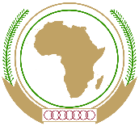 | UNION AFRICAINE
 |  | UNIÃO AFRICANA

Addis Ababa, Ethiopia P. O. Box 3243 Telephone: +251 11 551 7700 / Fax: +251 11 551 7844

Web site: www. au.int
DIRECTORATE OF INFORMATION AND COMMUNICATION

PRESS RELEASE No xxx

Three new Ambassadors have presented their Credential Letter to the AU Commission Chairperson
Addis Ababa, Ethiopia – 09 January 2017: Three new Ambassadors to the African Union presented on Tuesday, 09 January 2018, their letters of Credence to H.E. Mr. Moussa Faki Mahamat, Chairperson of the African Union (AU) Commission during an audience granted by the AUC Chairperson at the AU Headquarters in Addis Ababa, Ethiopia. They are: one new Permanent Representative from Ethiopia and two Non-AU Members States Ambassadors from New Zeeland and the Hashemite Kingdom of Jordan.
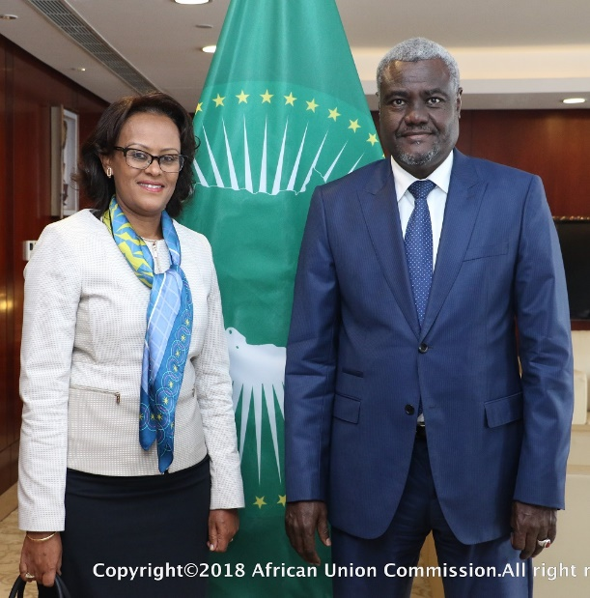
After submitting her credentials, the new Ethiopian Permanent Representative to the African Union H.E. Mrs Woinshet Tadesse, seized the opportunity to express her willingness to pursue, with the same endeavour as her predecessors, the existing close collaboration between Ethiopia and the AU. Amb. Tadesse also congratulated Mr Moussa Faki for his personal commitment to the cause of the continent and especially in the area of peace and security in Somalia and South-Soudan. She briefed the Chairperson on the various area of cooperation between her country and the AU as well as the efforts made by the Government of Ethiopia to continuously improve the living environment/conditions in Ethiopia.
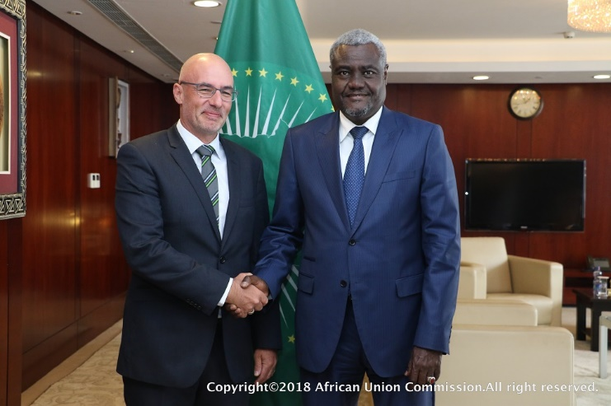
In the same vein, the newly appointed Ambassador of New Zeeland to the AU, H.E. Mr. Mark Ramsden presented his Credentials to the AUC Chairperson. He expressed the necessity to reinforce the bilateral collaboration particularly in Peace and Security and to engage more closely with the AU and its Members States, both actions will be the focus of his mandate. As a tangible expression of the commitment of New Zeeland to the AU, Amb. Ramsden handed an advance copy of the latest AU Handbook produced every year by his country, in collaboration with the AU Directorate of Information and Communication (DIC).
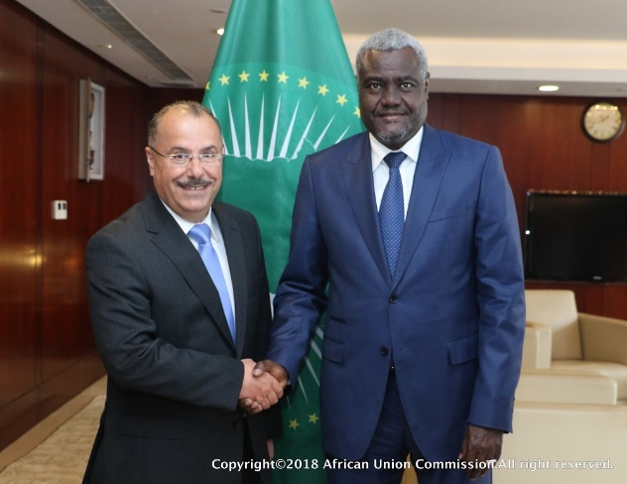
H.E. Dr. Wasfi Ayyad, the new Ambassador of the Hashemite Kingdom of Jordan to the Federal Democratic Republic of Ethiopia and to the African Union, was the third to present his credentials. He conveyed the New Year wishes of the Minister of Foreign Affairs of the Kingdom of Jordan as well as his invitation to the Chairperson to visit the Kingdom. Amb. Wasfi pledged his support to the activities of the AU, as well as strengthening the relationship between his country and the AU. He expressed his gratefulness to the H.E. Moussa Faki for his commitment to International law, Human rights, the resolutions of the UN Security Council as well as those of the AU and the League of the Arab States regarding Palestine.
The AU Commission Chairperson exchanged brief courtesies with each of the newly appointed Ambassadors to the AU, availing his office to work with them and wishing each one of them a successful tour of duty.
For further information contact:
Ebba Kalondo, Spokesperson of the Chairperson |African Union Commission | E-mail: KalondoE@africa-uion.org | Web Site: www.au.int | Addis Ababa | Ethiopia
Christiane Yanrou-Matondo, Principal Communication Officer | Bureau of the Chairperson | E-mail: yanrouc@africa-union.org | Web Site: www.au.int | Addis Ababa | Ethiopia

Follow us
Face book: https://www.facebook.com/AfricanUnionCommission
Twitter: https://twitter.com/_AfricanUnion
YouTube: https://www.youtube.com/AUCommission
Learn more at: http://www.au.int

