AFRICAN UNION | 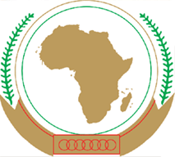 | UNION AFRICAINE
 |  | UNIÃO AFRICANA
Addis Ababa, Ethiopia P. O. Box 3243 Telephone: +251 11 551 7700 / +251 11 518 25 58/ Ext 2558
www.au.africa
PAN AFRICAN TSETSE AND TRYPANOSOMIASIS ERADICATION CAMPAIGN (PATTEC)
PATTEC Coordination Office conducted a consultative meeting with representatives of SADC member states and T&T experts, 7- 9 August 2019

The PATTEC Coordination Office in collaboration with Southern African Development Community (SADC) organized a consultative meeting with representatives of five SADC member states in Gaborone, Botswana on 7 – 9 August 2019. The regional consultative meeting brought together fifteen participants including Tsetse and Trypanosomosis experts from Member States, staff of AU-PATTEC and SADC, and PATTEC Coordinators from the region including Kingdom of eSwatini, Malawi, Mozambique, Zambia and Zimbabwe.
The three days meeting was aimed at reviewing a regional proposal developed in 2007 in view of the developments that have occurred in the T&T domain since its conceptualization and agree on how to split the proposal into phases and incorporate the eastern tsetse belt comprising Mozambique, Kingdom of eSwatini, and South Afirca; and the western tsetse belt comprising Zambia and Angola.

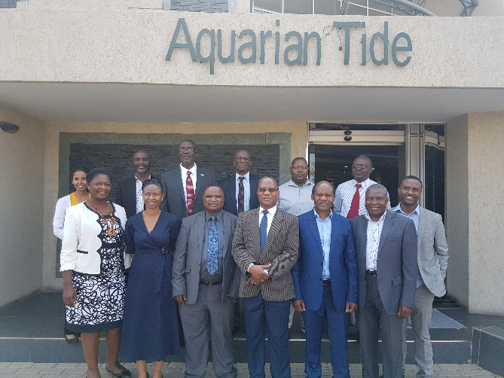

Group photo

The meeting started by welcoming remarks by Dr Gaolathe Thobokwe, Livestock Development Officer, SADC Secretariat of SADC and Dr Gift Wanda, Ag. PATTEC Coordinator.

