**`**

**INFORMATION & COMMUNICATION DIRECTORATE**

**Press Release : 000003456/2023 Date: 5th June 2023**

**Venue: Lusaka, Zambia**

**AU partners with UNESCO in support of the annual African Media Convention**

The African media stakeholders in partnership with the African Union and UNESCO, held the second continent-wide media conference in Lusaka Zambia, from the 11-13th May 2023. This was in commemoration of [World Press Freedom Day 2023](https://www.unesco.org/en/days/press-freedom) under the theme “Shaping a Future of Rights: *Freedom of expression as a driver for all other human rights”*.

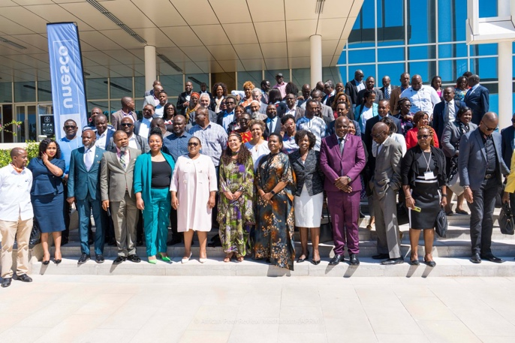

The annual event brought together over 300 delegates from journalists’ associations, civil society, the academia, representatives from four AU organs and bodies, African governments, the UN and other media development partners.

The key outcome of this convention is the [AMC declaration](https://au.int/sites/default/files/newsevents/reports/42708-rp-Final_update-LUSAKA_DECLARATION-2nd_AFRICAN_MEDIA_CONVENTION_2023-13_May_2023.pdf) which among other things, draws the attention of governments in Africa, to pursue equitable sharing of revenues by tech giants to sustain ensure journalism and media sustainability and viability.

Highlight of this year’s convention was the training of the AU media fellows, through a partnership between AU Information and Communication Directorate, UNESCO Addis Ababa Liaison office to AU, GIZ Liaison Office to the AU and WAN-IFRA Women in News. This joint effort was hailed by the participants as a timely and much needed programme by journalists at the conference, as it enhanced their capacity in the use of technology and artificial intelligence, especially in data journalism.

The participants further applauded the AU for establishing the AU Media Fellowship Programme, as a cross-border collaborative platform contributing to the Agenda 2063 aspirations. The AU, its bodies and Regional Economic Communities, were welcomed as co-hosts and requested to provide support for the Annual African Media Convention.

In addition, the delegates also welcomed the AU and its bodies to partner with the Africa media stakeholders, in carrying out the annual assessment of the status of press freedom, access to information and safety of journalists in AU Member States.

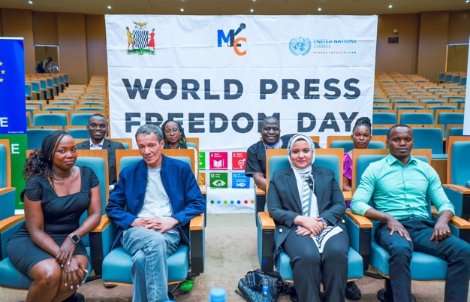

Noting the economic challenges facing the media sector, UNESCO was called upon to lead efforts in creating an African media fund, to finance and enhance media sustainability and viability. This was deemed necessary in protecting the media from political and economic pressures and thus consolidate freedom of the media in Africa.

Furthermore, following the consultations held during this convention on the proposed guidelines for regulating the digital platforms by UNESCO, the organisation was called upon to include in the next version of the Internet for Trust guidelines, a set of obligations for Tech platforms to safeguard, support and advance public interest news and journalism as a public good in society.

To ensure the recommendations emanating from this annual convention are implemented, a steering committee of nine members was established. This will guide the strategic evolution of the annual African Media Convention and also spearhead the development of an annual *Africa Media Review Journal*, to provide in-depth documentation of media developments and the African Media Convention.

More importantly, the African Media Convention steering committee will establish follow-up mechanisms for the implementation of all past, present and future recommendations on press freedom, access to information and safety of journalists on the African continent.

**For further information, African Media Convention, please contact:**

Mrs. Wynne Musabayana, Head of Communication, Information and Communication Directorate Email: [musabayanaw@africa-union.org](mailto:musabayanaw@africa-union.org)

Ms. Lydia Gachungi, Regional Adviser on Freedom of Expression and the Safety of Journalists, UNESCO Liaison Office to AU. Email: [L.gachungi@unesco.org](mailto:L.gachungi@unesco.org)

**For media inquiries contact:**

**Ms. Faith Adhiambo,** Communications Officer, Information and Communication Directorate, Africa Union Commission E-mail: OchiengJ@africa-union.org